CLASSIFICATION OF SKILL IN INFORMATICS OF ARCHITECTS IN VARIOUS PROFESSIONAL JOBS.
Case Study in Manado, Indonesia

Sangkertadi ¹, Syafriny Reny¹

¹Architecture Department, Faculty of Engineering, Universitas Sam Ratulang
sangkertadi@unsrat.ac.id

Abstract.
In the era of industrial revolution 4.0 practitioner in architecture should have enough skill in informatics, including mastering various types of software that commonly used in their professional work. Software development in the field of architecture is not only for art and building design purposes, but also as analytical tool to guarantee the quality of architectural plan and its construction design, i.e software for designing acoustic, lighting, structure, mechanical and electrical of buildings.

The methodology used is descriptive qualitative by distributing perceptive questionnaires to as many as 100 architects who were respondents. The questionnaire contained questions about the level of skill in operating various software. The architects as respondents are expected to be able to assess the ability of themselves at what level in terms of mastery of various computer programs which are commonly used in architectural projects or urban planning. In this case, in the city of Manado, Indonesia, from the results of the questionnaire, the architects in general were quite good in recognizing some software. Even among the software, they claim to be skilled in operating it.

Keywords: Architect, Software, Professional job

- Introduction
In the current 4.0 industrial revolution, the development of information and communication technology is very rapid. We are all expected to master and be able to practice information and communication equipment well. The development of architecture and urban planning is inseparable from the role of informatics experts who have developed various creativities in information and communication technology. Various computer software has been developed to improve the quality of planning, calculation, design and construction industry as well. Many governmental organizations have endeavored to develop a roadmap for the specific purpose of research and development of information technology for the construction industry [3]. Actually, Building Information Modeling (BIM), Augmented Reality (AR), Rapid Prototyping (RP) and Virtual Reality (VR) are some of the new technologies that can strongly contribute to construction industry [4].
Architects in general are artists with additional expertise in construction and planning. Architecture education combines the fields of art, social and engineering. The facts show that innovation in information and communication technology also plays an important role in the development of the arts and social fields, in addition to engineering. Therefore, architects should adapt to advanced technology and follow developments in the field of informatics, so as not loss of information of architectures at recent time.
The jobs of architects may cover various branches of built environment field. Some of them focuses to be professional practitioner in building design, urban planning, landscape planning, construction industry and supervisors of construction. Beside there are also those who are interested in education, research or bureaucracy. Almost all kinds of work experienced by architects require mastery of information and communication technology. The application of information technology in architectural field, among others, is the use of various software as tool aided design. Computer programs are required in solving various problems of design or planning process rapidly and precisely. The use of software in the area of architecture has long been developing since decades ago, and has proven to have shown many advantages over conventional methods (manual or traditional drawing practices), including among others: drawing-precision, animation, budget calculation, calculation of construction-duration, and for compiling building technical data. Computer programs those are generally used in professional practice of architects in general can be divided into three parts from the viewpoint of its purposes:
- General and office purposes: Word processing, Spread-sheet, Report-presentation
- Art, design developments & technical drawing: CAD (Computer Aided Design), Animation, Movie maker
- Scientific & Engineering calculations: Structure, Acoustic, Thermal, GIS (Geographical Information System)
The level of skill in mastering information technology then becomes a measure of the success of someone in his work environment [5]. From an employability perspective, having ICT skills could be seen as a necessary quality in the labor market [2]. Likewise, architects who have ability to operate various computer programs will be advantaged, as they can use it as tool to produce work with better quality and faster relatively.
Manado is the capital of the province of North Sulawesi in Indonesia. The city, which has a population of around 400 thousand people, is currently growing, where construction of buildings and city infrastructures are ongoing. In this city there are more than 500 hundreds of architects who work in various tasks of architectural job. Architecture education has been carried out at universities of the city for about 30 years. To control and accelerate city development, we need a good and appropriate planning and design strategy. The use of computer programs is one of the technical parts of the planning and design strategy. The process or scheme direction that takes place in urban architectural planning and design requires workers and experts who mastery in information technology or can operate computer programs skill-fully. Professionalism in the field of architecture has changed where the use of computer programs has become a design tool that is commonly used. Many people also know that by operating a computer program, it can print pictures of buildings that are also beautiful, precise and attractive. Through this paper, we describe the level of competences of architects in the city of Manado about their skills in operating various computer programs.

- METHODOLOGY
The methodology used is descriptive qualitative by distributing perceptive questionnaires to as many as 100 architects who were respondents. The questionnaire contained questions about the level of skill in operating various software. The architects as respondents are expected to be able to assess the ability of themselves at what level in terms of mastery of various computer programs which are commonly used in architectural projects or urban planning. They filled out or answered the questionnaire by writing down the scale of the ability to master the software, which is stated by the numbers 0 to 10 (Table.1). As reference, the scale of mastery in information technology can be stated measured from the lowest level, which is considered with a scale of 1, medium with a scale of 5, and to highest skills on a scale of 10 [6]. In addition, according to Nur Aisyah [7], Information and Communication Technology skills can be measured in 5 levels, namely from the lowest scale with the value 1 which belongs to the category that is very not mastering, up to a scale of 5 which signifies that is very mastering. The architects as respondents were grouped according to their length of professional work experience, also according to their level of education and to the kind of professional job (Table.2 and 3). Computer programs or software that are subject to questionnaires were also grouped according to the functions and purpose of use (Table.4). The investigation was carry-out in months February and March 2019.
Table.1. Classification of scale and perception of competence in operating software
Scale | Perception | Classification of Competence/ Skill
0 | I Never Heard | bad/low
1 | I Have Heard in Various Discussions | bad/low
2 | I Have Little Information from My Own Search | bad/low
3 | I Have Tried Little and Not Interested or Unable to Continue | bad/low
4 | I'm Pretty Interested, Have Tried the Demo Version | not so good/ middle
5 | I Continue to Practice and Try to Apply for Specific Cases | not so good/ middle
6 | I Am Quite Mastery and Sometimes Apply to Simple Projects | not so good/ middle
7 | I am pretty good at it and sometimes use it for complex projects | good & very good
8 | I Master Well, But Not Always Implement it in My Projects | good & very good
9 | I Master Well, and Always Implement it in My Projects | good & very good
10 | I Master Very Well and may Become Instructor for my Colleagues | excellent

Table.2. Year experiences of respondents
Professional Experiences of Respondents |  | Number of Respondents
 |  | Undergraduate/ Bachelor | Graduated/ Master | Total
A | More than 20 years | 2 | 8 | 10
B | 5 to 20 years | 18 | 12 | 30
C | 0 To 5 years | 60 | 0 | 60
Total number of respondents |  |  |  | 100
Table.3. Professional job of respondents
Professional Jobs |  | Number of Respondents
 |  | Undergraduate | Graduate/ Master | Total
D | Educator/ Research | - | 12 | 12
E | Administrative/ bureaucracy | - | 10 | 10
F | Practitioner/ Consultant/ Construction | 73 | 5 | 78
Total Number of Respondents |  |  |  | 100

Table.4. Grouping of the software
Purpose | Commercial name
General Office | MS-Office: Word, Power Point, and Excel
Technical Drawing and Art Graphical | Auto-CAD, Archi-Cad, Corel Draw, Photo-shop, Sketch Up
Animation | 3D Studio Max, Movie Maker
Scientific and Engineering | SPSS, Energy+, Velux, Dialux, Arc-GIS, Envi-Met, SAP2000

- RESULTS
The results of the questionnaire are compiled in the Table 5, which shows the percentage of the number of respondents according to the classification of skills in operating computer-programs. Skills or competencies in operating software for office and administrative purposes, are generally quite satisfying, where around 50% of respondents master well and excellent, except for mastering spread-sheet (Fig.1). Respondents are less accustomed to using spread sheets, because the scope of their tasks as architects is more dominated by activities leading to art and presentations, rather than quantitative analysis and making graphics, charts or tables.
Respondents, according to their own perceptions, feel that they mastery computer programs for technical drawing with good and excellent skillfully, namely for AutoCAD and SkecthUp software. But there are still those who feel have not mastered computer programs for art drawing purposes (Fig.2). In the curriculum and process of architecture education in Indonesia, students have been introduced to a variety of computer programs for design tools, including Auto-CAD and Google Sketch Up [1]. Likewise in Manado, students and architect practitioners are also familiar with both software.

Table.5. Percentage of respondents who skilled in operating software
Commercial Software | Skills Classification
Commercial Software | Low/ Bad | Not So Good/ Middle | Good & Very Good | Excellent
MS Word | 0% | 31% | 51% | 18%
MS Excel | 14% | 42% | 40% | 4%
MS Power Point | 0% | 31% | 50% | 19%
Auto CAD | 8% | 19% | 53% | 20%
Archi CAD | 37% | 32% | 25% | 6%
Sketch Up | 5% | 24% | 61% | 10%
Photo Shop | 20% | 22% | 44% | 14%
Corel Draw | 40% | 35% | 23% | 2%
3 DsMax | 47% | 33% | 19% | 1%
Movie Maker | 32% | 41% | 25% | 2%
SPSS | 76% | 22% | 2% | 0%
Energy++ | 88% | 12% | 0% | 0%
Dialux | 77% | 14% | 9% | 0%
Velux | 75% | 16% | 9% | 0%
Arc GIS | 67% | 21% | 12% | 0%
SAP2000 | 92% | 8% | 0% | 0%
EnviMet | 89% | 11% | 0% | 0%

Almost all respondents stated that they did not have the skills or very low capacity in operating a number of computer programs for scientific needs (Fig.4). It is understandable, because almost respondents as architect-practitioners do not have the capacity as researchers or experts who for example are usually involved in the matter of construction calculations or mathematical analysis of building performance. The scientific software that were asked to the respondents, are generally used to calculate the structure, lighting, energy, micro-climate and there is also software commonly used for analysis in the geographical mapping process. Respondents who have a master-degree education, in general, have higher skills in using scientific software than those who still have a bachelor's degree. Some respondents even claimed to have the skills in the "good & very good" category in using some software (Fig.5).
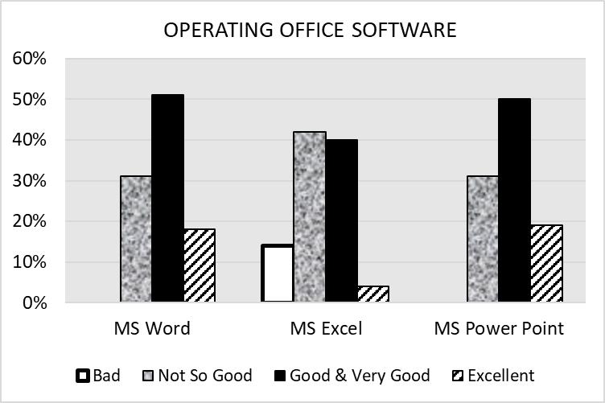
Fig.1. Level of skills in operating office software
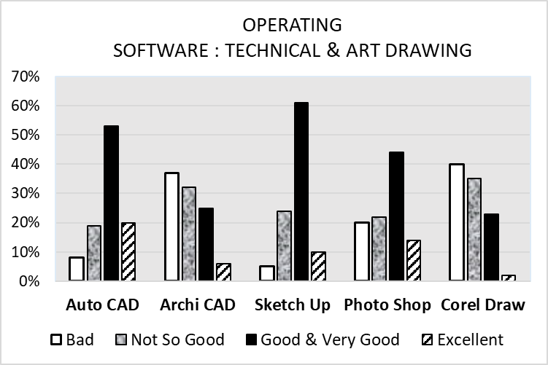
Fig.2. Level of skills in operating software for technical and art drawing
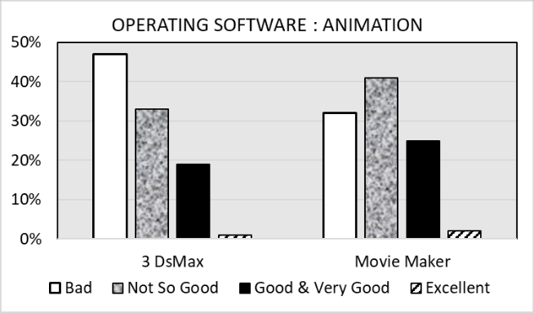
Fig.3.Level of skills in operating software for design animation
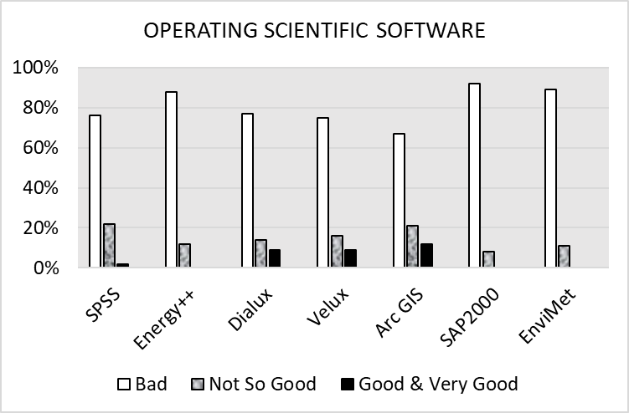
Fig.4. Level of skills in operating software for scientific purposes

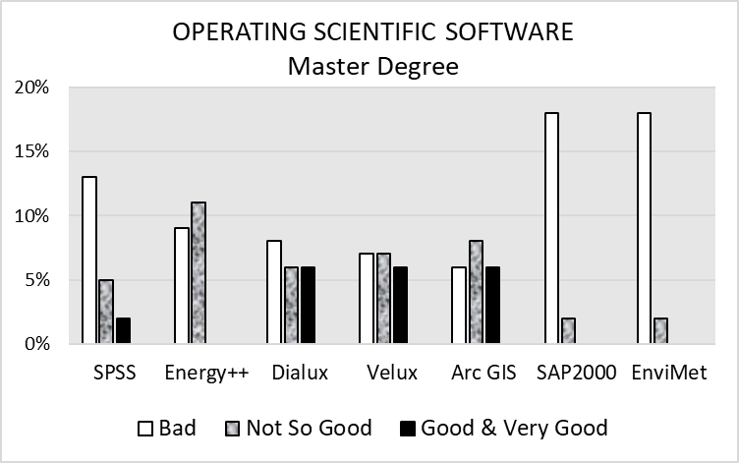
Fig.5. Level of skills in operating software for scientific purposes of those who have master degree education.
- CONCLUSION
There is a linear relationship between the development of information technology and the availability of employment for those who have higher skills in the field of informatics. Professionalism in the field of architecture cannot be separated from the level of information and communication technology skills. Mastery of various software is a way to be able to compete in current employment. In this case, in the city of Manado, Indonesia, from the results of the questionnaire, the architects in general were quite good in recognizing some software. Even among the software, they claim to be skilled in operating it. However, they should not be easily satisfied, because they still need to develop themselves by following the development of information technology that is very rapid. They still have to improve their skills in mastering various types of information technology, software and undergo special training to increase their capacity.
References
[1] Amir M A, Peranan Google Sketch Up dan Autodesk Revit Architecture terhadap pendidikan arsitektur, Skripsi Mahasiswa Jurusan Arsitektur, unpublished, Universitas Indonesia, 2011
[2] De Hoyos M, Green A E, Barnes SA, Behle H, Baldauf B, Owen D, ICT and Employability, European Commission, Joint Research Centre, Institute for Prospective Technological Studies, 2013.
[3] Hosseini, M.R., Chileshe, N., Zuo, J. and Baroudi, B., Approaches for implementing ICT technologies within construction industry’, Australasian Journal of Construction Economics and Building, Conference Series, 1 (2) 1-12, 2012
[4] Leal B.M.F, Salgado, M.S, Silvoso, M.M, Impact of fourth industrial revolution in architecture undergraduate course, Proceeding of ZEMCH 2018 International Conference, Melbourne, Australia, 29th January – 1st February, 2018
[5] Lopez-Bassols V, ICT Skills and Employment, OECD Science, Technology and Industry Working Papers, October, 2010.
[6] Ministr J, Ntevko M, Human Resources Requirements for Porfessional Management of ITSCM Process, Proceedings of IDMT-2010, Information Technology – Human Values, Innovation and Economy 18th Interdisciplinary Information Management Talks, September 8–10, 2010, Jindřichův Hradec, Czech Republic, 2010
[7] Nur Aisyah M, Tingkat penguasaan dan penggunaan ICT pada mahasiswa akuntansi Universitas Negeri Yogyakarta, Jurnal Nominal, Vol II, 2013.
[8] Riel A, Integrated Design – A Set of Competences and Skills Required by Systems and Product Architects, Proceedings of 17th European Conference, EuroSPI 2010, Grenoble, France, September 1-3, 2010.

