**Research on the Mechanism of Innovation and Entrepreneurship Education in Higher Vocational Colleges: The Case of Zhejiang Province**

**Hongbo Ma[1][2]，Lanfang Shang2, Mingchang Wu1**

**Abstract:**

Innovation and entrepreneurship education play an important role in development of higher vocational colleges, employment of students, and social service. On December, 2017, the state council published *Several Opinions About Deep Integration of Industry and Education*, which means it’s a positive signal to higher vocational colleges. In this article, we introduce the status quo and issues of innovation and entrepreneurship education of higher vocational colleges in China. Then, according to Basil Bernstein’s theory of the pedagogic mechanism, we analyze the mechanism of innovation and entrepreneurship education from four aspects in Zhejiang province. Major findings of this study include: (1) In the instructor training, Zhejiang Department of Education invests lots of resources to train a large number of entrepreneurial mentors whether is from undergraduate or vocational colleges;

(2) In student training, higher vocational college students must complete 2 credits of IEE courses and can apply for SYB courses free of charge; (3) After five years of development, the popularity of innovation and entrepreneurship competition has been increasing and the participation of higher vocational colleges has doubled; (4) After a decade of exploration and development, mass innovation space has evolved from the early 1.0 hardware version, which only provided sites and equipment, to the 2.0 and 3.0 software versions with capital docking and government support.

**Keywords:**

Higher Vocational College, Innovation and Entrepreneurship Education (IEE), Innovation and Entrepreneurship Competition (IEC), Internet+, Zhejiang Province

1. **Introduction**

Different from the other three industrial revolutions, industry 4.0 is an era in which information technology is used to promote industrial transformation. Internet technology reduces the information asymmetry between production and sales, and accelerates the mutual contact and feedback between them. Faced with the challenge of industry 4.0, the role of universities has also changed, not only allowing students to study high-tech majors, but also cultivating innovation and entrepreneurship ability. Higher vocational college students have strong practical operation ability. Once systematic innovation and entrepreneurship education and training, they can quickly develop Internet business operations. In the 1950s, the United States began to implement project-based innovation and entrepreneurship education (IEE). The IEE system in the United States is relatively complete, which generally includes courses such as marketing, financial management and business plan development, and links IEE with the degree. Some universities even offer bachelor's and master's degrees in innovation and entrepreneurship (Sun, & Zhao, 2017; Xie, 2019).

In the Chinese traditional concept, the training of applied talents only exists in higher vocational colleges, while the education of undergraduate colleges and universities should focus on theory and strengthen the scientific research (Liu, 2018). Therefore, China's

IEE started relatively late, and only in the 21st century began to pay attention to IEE, and has issued a series of policies to encourage innovation and entrepreneurship (Xie, 2019). "Mass Entrepreneurship and Innovation" comes from premier Li Keqiang's speech at BBS summer DAVOS in September 2014. At the 2015 National People's Congress, the government elevated mass entrepreneurship and innovation to a new engine of economic growth. In March 2015, the general office of the state council issued guidance opinions, which encouraged college students to carry out innovation and entrepreneurship activities. In May 2016, the general office of the state council issued the implementation *Opinions on Building Demonstration Bases for Mass Entrepreneurship and Innovation*, and systematically deployed the construction of demonstration bases for mass entrepreneurship and innovation. On September 18, 2018, the state council issued the *Opinions on Promoting High-quality Development of Innovation and Entrepreneurship and Creating an Upgraded Version of Mass Entrepreneurship and Innovation.*

Zhejiang higher vocational education IEE has developed rapidly and ranked first in China. In 2018, Zhejiang department of education organized the selection of exemplary entrepreneurship colleges in Zhejiang, among which there were 13 vocational colleges. Some of these higher vocational colleges are setting up entrepreneurship colleges and some are setting up entrepreneurship parks. Most vocational colleges in Zhejiang started to establish entrepreneurship colleges after 2010, and accordingly entrepreneurship colleges have issued relevant policies to encourage innovation and entrepreneurship activities, including flexible credit system and financial support policies for students' entrepreneurship. And, Yiwu Industrial and Commercial College is the first college to establish entrepreneurship college since 2008 in Zhejiang.

The research of IEE is still a new research direction in China, which scholars rarely do research from the prospective of pedagogy and higher vocational colleges. According to Basil Bernstein’s theory of the pedagogic mechanism, there are three fields: knowledge production field (Ⅰ), recontextualization field (Ⅱ) and remanufacturing field (Ⅲ). In the field of knowledge production, different groups try to turn their knowledge into thinkable knowledge. In the recontextualization field, different groups transform thinkable knowledge into educational discourse and construct a legitimate educational practice. In the reproduction field, different groups compete to identify and realize the educational code type embodied in the legal education practice, so as to facilitate the reproduction (Bernstein, 2000; Wang, 2018). This article is aimed to analysis the mechanism of IEE in Zhejiang province. Based on the current local government policies, we try to build the mechanism from four aspects: instructor training, student training, three levels’ competitions and mass innovation space.

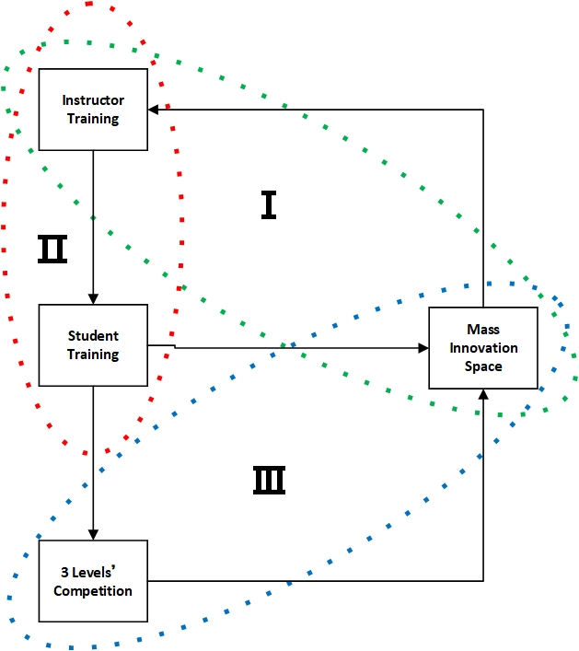

Figure 1. The mechanism of IEE in Zhejiang province based on Basil Bernstein’s theory

1. **Instructor training**

Zhejiang provincial education department set up the implementation guidance office of entrepreneurship instructor cultivation project. From 2016, our province will fully organize and implement "Cultivation Project" in colleges and universities of the whole province, according to the tasks and requirements put forward in the policy. By 2020, Zhejiang will arrange a provincial training program for 5,000 entrepreneurship instructors. There are 1737 entrepreneurship instructors from the higher vocational colleges. And, There’re two types of entrepreneurship instructor training in colleges and universities. First is universal training focusing on improving the implementation of IEE. Second type is integrated training with deep professional integration. The biggest difference between the two is the difference between the trainees, who are more professional than the former. The training period is 5 fulltime days.

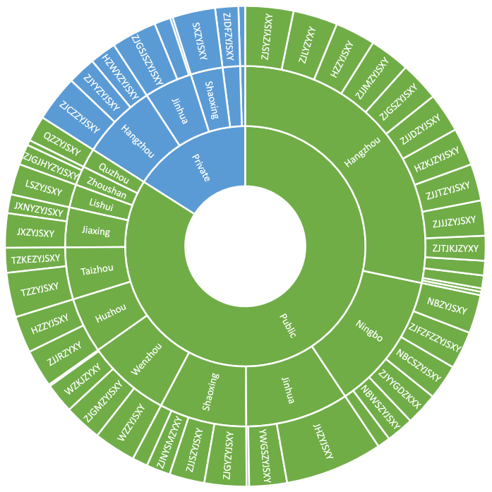

Figure 2. The regional population distribution of higher vocational colleges in "Cultivation Project"

Through the Cultivation Project, Zhejiang government will foster a sufficient number of high-quality team of entrepreneurship mentors. Zhejiang try to build a long-term mechanism of training entrepreneurship mentors, professional development, and the hiring to promote in-depth development of college students' innovative entrepreneurial education. After setting the overall goals, we will create entrepreneurship instructors selected training mechanism, create entrepreneurship instructor talent pool, create a group of instructor studios and instructor teams, organize activities to match the industry, carry out multiple forms of IEE training and mentoring activities, and create the management platform of instructor training and curriculum resource. According to their own actual situation, every colleges or universities can make the implementation plans of "cultivation project".

1. **Student training**

In the Chinese traditional concept, the training of applied talents only exists in higher vocational colleges, while the education of undergraduate colleges and universities should focus on theory and strengthen the scientific research (Liu, 2018). Therefore, higher vocational colleges have an earlier and stronger working institution to promote IEE. Li, Cui, Li, & Xiong (2019) found that colleges and universities in Zhejiang all have clear talent training goals, which are oriented to cultivating innovative and entrepreneurial talents. However, they vary according to different types and positions of schools. Most of higher vocational colleges have established institutions such as entrepreneurship colleges, especially Yiwu Industrial and Commercial College, which operates in the first place, has its own faculty resources and is directly enrolled in the students. By 2020, no less than 2% of the students in all universities will receive special training on innovation and entrepreneurship every year, and the number of college students in the province will reach 20,000.

All higher vocational colleges have courses in innovation and entrepreneurship. 2 credits for required courses are included into the undergraduate training program. At the same time, higher vocational colleges actively explore the embedded courses of knowledge based on professional knowledge (Jiang, 2019). They have not only the whole college, the basic innovation and entrepreneurship courses, but also the unique and interdisciplinary courses of innovation entrepreneurship (Li et al., 2019). Based on college of economic or management, many entrepreneurial basic courses are opened, such as management, accounting, marketing and other aspects. Based on the engineering training base, many innovative courses are opened, such as mechanical arm operation, CNC machine operation, 3D printing, and other advanced manufacturing courses. These courses aim to help students to understand the basic concept of innovation and entrepreneurship and to prepare for their next phase of future.

On the other hand, labor employment service centers of prefecture-level cities in Zhejiang province organize SBY training for higher vocational college students. SYB (Start Your Business) is an urban employment training program jointly run by the international labor organization and the ministry of labor and social security of China. Since its pilot in 1998, the project has helped countless unemployed people to find their own jobs and start their own businesses (Zheng, 2005). SYB training has three textbooks: *Entrepreneurship Awareness Training Booklet*, *Entrepreneurship Plan Training Booklet* and *Business Plan* (Yu, 2014). These training courses integrates the entrepreneurial process into 10 steps, adopts the teaching method of participatory classroom, and enables students to improve their business plan through complete and systematic practical training as a hypothetical entrepreneur, so as to establish and maintain a profitable enterprise (Sun, 2019).

The SYB training program consists of 10 steps and consists of two parts. (1) SYB entrepreneurship training (the first 2 steps). This includes educating participants on the characteristics of successful entrepreneurs and the risks involved in starting a business; evaluate their suitability to start small businesses; estimate the resources needed to start a small business; choose a project that suits you. (2) SYB business plan training (the last 8 steps). This includes market research and forecasting, corporate recruitment and team building, selection of appropriate legal forms and legal responsibilities, prediction of start-up capital requirements, formulation of cost, profit and cash flow plans, determination of whether your business can survive and start a business (Ren, 2005; Fei, 2007).

1. **Scholastical, provincial and national competitions**

China ‘Internet +’ College Students’ Innovation and Entrepreneurship Competition (IEC) is a national entrepreneurship competition under the guidance of the Ministry of Science and Technology, the Ministry of Finance, the Ministry of Education, the Cyberspace Administration of China and the All-China Federation of Industry and Commerce since 2015. The IEC adopts the three levels’ competition system of school-level preliminary competition, provincial-level semi-final competition and national finals. The school-level preliminary competition shall be organized by colleges and universities. Provincial second round shall be organized by all provinces. National final shall be selected and recommended by all provinces according to the quota which is determined by the competition committee. This committee allocates the quota of the national finals, taking into account the number of teams from different provinces, the number of participating colleges and universities, the development of IEE and so on. In the first session, more than 57,000 teams from 1,878 universities signed up for the competition, submitted more than 36,000 projects, and attracted more than 200,000 students (Wu, Hou, Hao, Zhan, Wang, 2017).

Table 1. China ‘Internet +’ college students’ IEC system over five years

|  |  |  |  |  |  |
| --- | --- | --- | --- | --- | --- |
| Year | 2015 | 2016 | 2017 | 2018 | 2019 |
| Host University | Jilin University (North China) | Huazhong University of Science and Technology (Centre China) | Xidian University (West China) | Xiamen University  (South China) | Zhejiang University  (East China) |
| Project  Field | ‘Internet +’  Traditional Industry, New Form of Industry, Public Service, Technical Support Platform | ‘Internet +’  Modern Agriculture, Manufacturing Industry, IT Service, Technical Support Platform, Commercial Service, Public Service, Social Entrepreneurship | ‘Internet +’  Modern Agriculture, Manufacturing Industry, IT Service, Cultural and Creative Service, Commercial Service, Public Service, Social Entrepreneurship | ‘Internet +’  Modern Agriculture, Manufacturing Industry, IT Service, Cultural and Creative Service, Social Service, Social Entrepreneurship | ‘Internet +’  Modern Agriculture, Manufacturing Industry, IT Service, Cultural and Creative Service, Social Service |
| Objects Type Participated | Creative Group, Practice Group | Creative Group, Start-up Group, Growth Group | Creative Group, Start-up Group, Growth Group, Employment-oriented Entrepreneurship Group | Creative Group, Start-up Group, Growth Group, Employment-oriented Entrepreneurship Group | Creative Group, Start-up Group, Growth Group, teacher-student co-creation group |
| Quota of Final | 300 | 600 | 600 | 600 | 1200 |

Data source: retrieved from the notices of annual IEC announced by Ministry of Education.

The first China "Internet +" college students' IEC was held in 2015. However, local provinces did not know the competition system and there was no precedent to follow, so provincial education departments did not openly organize provincial competitions in that year. In 2016, the education department of Zhejiang province began to hold the first "Internet +" college student IEC, with 97 participating universities, including all undergraduate and vocational colleges. With the promotion of the popularity of the competition, the average annual growth rate of the declared projects is as high as 93.40%. Similarly, universities do not know the provincial competition system, so they did not officially organize the university-level competition until 2017. Taking the no.1 vocational college in Zhejiang province as an example, the average annual growth rate of the declared projects is as high as 225%, which is much higher than the average level of the whole province.

Table 2. Zhejiang province IEC results over five years

|  |  |  |  |  |  |
| --- | --- | --- | --- | --- | --- |
| Year | 2015 | 2016 | 2017 | 2018 | 2019 |
| Universities Participated | - | 97 | - | 99 | Hold in Jul. |
| Projects Declared | - | 2033 | 4488 | 7452 | Hold in Jul. |
| Projects of Final | - | 139 | 200 | 214 | Hold in Jul. |

Data source: retrieved from the results of annual IEC announced by Zhejiang education department.

Table 3. Jinhua polytechnic college IEC results over five years

|  |  |  |  |  |  |
| --- | --- | --- | --- | --- | --- |
| Year | 2015 | 2016 | 2017 | 2018 | 2019 |
| Students Participated | - | - | 500 | 1270 | 6100 |
| Projects Declared | - | - | 100 | 200 | 900 |
| Projects of Final | - | - | - | 17 | 31 |

Data source: retrieved from the news of homepage of Jinhua polytechnic college.

1. **Mass innovation space**

China's IEE service institutions were first established in the 1980s. There were incubators, university science parks, accelerators, entrepreneurship nursery and so on, which formed a service mode dominated by entrepreneurship incubation (Xie, &Liu, 2018). The mass innovation space is a new word extracted by the ministry of science and technology after conducting research on the maker space, incubator base and other IEE service institutions in Beijing, Shenzhen and other places. In terms of expression, mass innovation space is a word with Chinese characteristics, which can also be said to be the product of local maker space. Different from the traditional maker space, it is mainly reflected in the enhancement of entrepreneurship incubation function. Therefore, it can be understood that mass innovation space = maker space + entrepreneurship incubation (Wang, &Ye, 2015).

Table 4. The construction and evolution of China’s mass innovation space ecosystem

|  |  |  |  |  |  |
| --- | --- | --- | --- | --- | --- |
| IEE institutions | Incubator | University science park | Accelerator | Entrepreneurship nursery | Mass innovation space |
| Year | 1987 | 2000 | 2007 | 2009 | 2015 |
| Phases | Introduction period | Growing period, maturation period | Maturation period, decline period | Initial period | Full period |

Source: Collated from Xie, & Liu (2018: 581)

In Zhejiang province at present, there are two modes of mass innovation space. One is Characteristic Village, which is rooted in the local original characteristic industry base and to build a complete industrial ecosystem, such as Hangzhou dream village, cloud village, Shaoxing rice wine village, E-games village (Chen, Xiang, & Yu, 2015). Different from internationally renowned towns such as Beppu in Japan and Silicon Valley in the United States, although Characteristic Villages are named after towns, but they are not first-level administrative divisions. Characteristic Villages are municipal development platforms based on economic goals and resource endowment（Chen，& Huang，2016）. The other is the incubator model, build by the venture capital institutions (such as Silicon Paradise, Puhua Capital, and Zheshang VC), well-known enterprises (such as Alibaba, Netease), and universities (Chen, Xiang, & Yu, 2015). Taking Zhejiang Industry Polytechnic College (ZJIPC) as an example, we built a provincial mass innovation space-Yue Mass Innovation Space, which is based on the campus of the national demonstration public training venues and teachers’ resources. In the early stage, students from the school of design and art, the school of mechanical engineering, the school of electronic engineering and the school of transportation, were mainly provided with industrial robot, PLC control system, CNC machine tools and other instruments, so as to provide the students' innovative and entrepreneurial team with the opportunity to develop experimental products. At the same time, students can also apply for the computer workstation in the training site of the school of design and the school of business, to promote and display products and teams. There are 49 teachers in ZJIPC who have participated in Zhejiang cultivation project and can provide consulting services such as road show, company registration and capital docking.

Thus, it can be seen that the development mode of mass innovation space mainly has three levels: first, the primary mode of version 1.0: build physical space that can promote communication and realize technology sharing by integrating idle resources, and provide hardware support mainly for entrepreneurs' office space; second, the upgrading mode of version 2.0: except hardware support, also provide software support, such as to conduct entrepreneurship education and training guidance, capital docking services and so on. The profit model of this version is relatively single, and the profit cycle is long. Third, the 3.0 version with comprehensive entrepreneurial ecosystem: mainly guided by government support and operated in the way of corporate management, relying on university parks or industrial bases. It provides supporting services of various preferential policies and one-stop services for start-up enterprises, and has its own resource advantages and service features to build an entrepreneurial ecosystem（Lu, 2018）.

1. **Conclusions**

The per capita income of Zhejiang province has reached the standard of middle developed countries. And, the development of each industry also tends to reach mature period. How to carry out industrial upgrading and transformation? How to join the list of developed countries? The reserve of innovative talents is the key, especially for college students. The government invests a huge amount of money to push the cultivation project, which aims to help college teachers realize the importance of IEE for social development, and make higher vocational education closer to the actual needs of the industry. In the form of IEE, all sectors of society are involved and make concerted efforts to put the reserve of innovative talents into practice. After the instructor training, teachers are able to develop the IEE courses inserted to the specialty courses and conduct the SYB training. Students choose IEE courses according to personal interests, organize team and submit business plan to IEC. Excellent and award-winning teams can also apply mass innovation space, obtain various resources inside and outside the university, and smoothly carry out the commercial operation of their project. Finally, the pedagogic mechanism of Basil Bernstein's theory is realized by appointing the well-run project leader as the lecturer in the cultivation project.

**Reference**

Bernstein, B. (2000). *Pedagogy, Symbolic Control and Identity*. Lanham, MD: Rowman & Littlefield, P. 116.

Chen, S., Xiang, L. Y., Yu R. J. (2015). Co-maker space entrepreneurship ecosystem: Features, structure, mechanism and strategy–Case study on Hangzhou dream town. *Journal of Business Economics*, 289(11), 35-43.

Chen, Y. F., Huang, G. (2016). Zhejiang practice of supply-side structural reform with characteristic town layout. *Journal of Zhejiang provincial party school of CPC,* 5, 28-32.

Fei, L. Y., Fan, M. Y., & Huang H. (2007). A Probe into the SYB Project and Its Implementation in College. *Journal of Jiaxing University*, 19(4), 63-67.

Li, L. J., Cui, W., Li, J. F., & Xiong, X. C. (2019). A Brief Analysis on the Path Research of Innovation and Entrepreneurship Talent Cultivation in China Three Gorges University- Based on the Investigation Report of Six University, Including Zhejiang University. *Education Teaching Forum*, 5, 85-86.

Liu Z. X., & Fu M. L. (2018). Construction and Development of Innovation and Entrepreneurship Education Ecosystem in Universities with Industry Characteristics - Taking Zhejiang University of Communication as an Example. *Higher Education Forum*, 6, 86-89.

Lu, Q. P. (2018). The research on the “Three in One” model of college entrepreneurship education—Based on the viewpoint of the development for the maker space in Zhejiang. *Special Zone Economy*, 352(5), 54-56.

Jiang, Y. F., & Ke, Y. N. (2019). Entrepreneurship Education – the Remarkable Mystery of Zhejiang University. *China Education Daily*, 001, 1-2.

Ren, H. Q., & Sun, S. M. (2005). Student Employment and SYB Training. *Chinese Vocational and Technical Education*, 217, 53-55.

Sun, Y. (2019). A study on the Optimization of SYB Training Mode in Higher Vocational Colleges. *Journal of Zhenjiang College*, 32(2), 63-66.

Sun, T. & Zhao, Y. H. (2017). The Innovation and Entrepreneurship Curriculum System in American Colleges and Universities: Construction and Enlightenment. Vocational Education Research, 8, 82-86.

Wang, J. H. (2018). Pedagogic Discourse and Practices: The Study of Basil Bernstein’s Pedagogic Device. *Sociology of Education in Taiwan*, 18(1), 1-39.

Wang, Y. M., Ye, A. M. (2015). From maker space to crowd maker space: Function model and service path based on innovation2.0. *E-education Research*, 271(11), 5-12.

Wu, A. H., Hou Y. F., Hao J., Zhan Y., & Wang K. (2017). The reform of innovation and entrepreneurship education in colleges and universities with the Internet + entrepreneurship and innovation competition. *China University Teaching*, 1, 23-27.

Xie, X. F., & Liu, Q. L. (2018). Ecological model of mass-innovation space in the era of innovation2.0: Comparison and enlightenment at home and abroad. *Studies in Science of Science*, 36(4), 577-585.

Xie, Y. H. (2019). Research on the Course System Construction of Innovation and Entrepreneurship Education in Higher Vocational Colleges of Zhejiang Province. *Science Tribune*, 11, 31-32.

Yu, J. P. (2014). Research on the Significance and Countermeasures of SYB Training for College Students. *Journal of Changchun Education Institute*, 30(5), 120-121.

Zheng, X. G. (2005). The Development of Entrepreneurship Training in China. Chinese Technological Research, 5, 114-118.

1. National Yunlin University of Science and Technology, 123 University Road, Section 3, Douliou, Yunlin 64002, Taiwan
2. Zhejiang Industry Polytechnic College, 151 Qutun Road, Yuecheng District, Shaoxing, Zhejiang, China

   This article was supported by two grants. One is about philosophy and social science research 13th five-year plan (135J080) from Shaoxing Philosophy and Social Science Planning Awards Leading Group Office. The other is the key research project (2018SJZD06) from Commerce Economy Association of Zhejiang.