Perception and Behaviour Towards Hospital Website among Indonesian

Badra Al Aufa

Health Science Department, Vocational Education Program, Universitas Indonesia
email : badra@vokasi.ui.ac.id

Abstract. Hospital website plays a vital role in engagging patients. Research on behavior of patients in using hospital website is still less published in Indonesia. This study aimed to describe Indonesian perception and behaviour towards hospital website. This quantitative research using cross-sectional method. The data has been collected during February – March 2019 that recruited 160 respondents using consecutive sampling method. Online questionnaire has been used to data collection. Data of the research were analyzed by using SPSS Version 21. Most of respondents were 27 years old (12.5%) with mean of age 31 years old. 71.9% of respondents visited the hospital’ website to see the available facility and the schedule while 70.6% of respondents see the doctor’ schedule. 74.4% of respondents stated that information on the hospital website was available but not complete while another problem was website information was not up to date. In the role of website in assisting respondent to choose hospital, 79.3% respondents stated that hospital’ website assisted them in choosing hospital. Hospital manager should arrange adequate resources to provide and maintain hospital’ website in order to provide up to date, complete and accurate information in the website so that could assist patients to use the hospital service.

Keywords: Hospital Website, Patient Perception, Website Usage, Indonesia

1 Introduction
As the result of developing of private sector as well as the expansion of government to build new hospital, the hospital numbers in Indonesia is rising during the last decade [1]. Quality improvement is needed to be performed by hospital in order to sustain in the very extreme competitive envrionement [2]. Information Technology (IT) plays significant role in improving healthcare quality [3, 4].
In this decade, consumer uses internet for grasping health information is growing [5]. That condition is spesifically strong for teens and young adults, as these demographics show the highest rate of internet usage both in general and specifically for health information [6]. Therefore, the Hospital managers should take into account internet use in their hospital operation spesifically for marketing purpose.
Research in United States stated that hospital website has a benefit to explore customer feedback and opinion, build effective communication channels for customers, create creative promotion and communication for customers’ need and personalize service encounters [7]. Using website is one of the ways to use internet as medium to promote the hospital so that the hospital can expand the market leverage [8]. Patient engagement that made during the initial contact may be developed by visiting the social media and web presence of hospital [9]. Failing to make a first positive impression through the hospital’ website and social media results consumer to explore other alternatives [10]. Consequently, the hospital website plays a key role on the hospital marketing.
Eventhough, the importance of hospital website and social media is acknowledgeded, the research result of its social media and website performance is still not satisfying. An evaluation of 157 children’s hospital website in the United States revealed that there are no website dimensions (accessibility, content, marketing, technology, usability) that met a perfect score [10]. One research performed in Indonesia stated that content and ease of use degree of the hospital website were significantly associated with the satisfactoin of the patient [11]. Another research in Kediri, Indonesia revealed that usability of the hospital’ website for its functioning as online registration is affected positively by learnability, memorability, errors and user’s satisfaction [12].
In spite of some researches have been performed in Indonesia to evaluate the use of the hospital’ website using information system usability approach, yet, research of hospital’ website as marketing media remains less. This research is aimed to analyze behavior and expectation of Indonesian women in using hospital’ website. By performing this research, it is expected to gain the insight regarding the information that needed and should be existed in the hospital’website which in turn could provide additional evidence for hospital manager and hospital administrator experts in building hospital website.
2 Methods
This quantitative research using cross-sectional method. The population of this research is women aged 20-64 years old. The age range was chosen based on the assumption that these group ages is still using and actively using hospital website as the source in seeking hospital service information. This research was conducted using online questionnaire. The number of respondents participated in this study was 160 respondents. The samples were chosen using quota sampling technique.
Prior to data collection, respondents have been explained the research aim and the procedure to fill the questionnaire. The women who agreed to participate in the study signed consent form. anonymity and confidentiality had been ensured.
The questionnaire consisted of three parts. First part is to know the respondent characteristics (age, level of education, working status, marriage status, number of children, economic status). The second part was designed to explore the behaviour of women in using hospital’ website such as time visiting the website, what information that been looked for by women. The third part is the perception of women in using the hospital website. The third part of questionnaire explores whether the website condition has met their expectations or not. Also, the common problems that they met when accessing hospital website is explored in the third part of questionnaire. Data of the research were analysed by using SPSS Version 21. Descriptive statistics was used in order to describe the demographic status, perception and behaviour in using hospital’ website.
3 Results
The number of respondents is 160 people. The majority of respondents came from the age group 26-45 years 112 (70.0%) with female sex 110 (68.8%). More than a third of respondents had an education level of S1 / S2 / S3 143 (89.4%). The majority of respondents work at private company (50%) and earn more than 10 million per month. 105 respondents were married and the majority of respondents had 1-2 children 72 (45%) (Table 1).
Tabel 1. Visiting website behaviour based on respondents socio-demographic characteristics
 | Total | Always | Frequently | Occasionally | Never
Total | 160 (100.0) | 21 (13.1) | 28 (17.5) | 70 (43.8) | 41 (25.6)
Age, years
<=25 | 40 (25.0) | 0 (0.0) | 1 (0.6) | 4 (2.5) | 3 (1.9)
26 – 45 | 112 (70.0) | 16 (10.0) | 19 (11.9) | 53 (33.1) | 24 (15.0)
>= 46 | 8 (5.0) | 5 (3.1) | 8 (5.0) | 13 (8.1) | 14 (8.8)
Sex
Female | 110 (68.8) | 14 (8.8) | 22 (13.8) | 47 (29.4) | 27 (16.9)
Male | 50 (31.2) | 7 (4.4) | 6 (3.8) | 23 (14.4) | 14 (8.8)
Education
Senior High school | 17 (10.6) | 0 (0.0) | 4 (2.5) | 5 (3.1) | 8 (5.0)
University | 143 (89.4) | 21 (13.1) | 24 (15.0) | 65 (40.6) | 33 (20.6)
Occupation
Private employee | 80 (50.0) | 15 (9.4) | 11 (6.9) | 35 (21.9) | 19 (11.9)
Civil servant | 24 (15.0) | 2 (1.3) | 4 (2.5) | 14 (8.8) | 4 (2.5)
Entrepreneur | 16 (10.0) | 0 (0.0) | 5 (3.1) | 4 (2.5) | 7 (4.4)
Student | 18 (11.3) | 0 (0.0) | 3 (1.9) | 7 (4.4) | 8 (5.0)
Housewife | 16 (10.0) | 1 (0.6) | 3 (1.9) | 9 (5.6) | 3 (1.9)
Does not work | 6 (3.8) | 3 (1.9) | 2 (1.3) | 1 (0.6) | 0 (0.0)
Income (Rp)
< 5 million | 42 (26.3) | 3 (1.9) | 3 (1.9) | 24 (15.0) | 12 (7.5)
5 – 10 million | 46 (28.7) | 5 (3.1) | 10 (6.3) | 23 (14.4) | 8 (5.0)
> 10 million | 72 (45.0) | 13 (8.1) | 15 (9.4) | 23 (14.4) | 21 (13.1)
Marital status
Single | 54 (33.3) | 8 (5.0) | 9 (5.6) | 19 (11.9) | 18 (11.3)
Married | 105 (65.6) | 13 (8.1) | 19 (11.9) | 50 (31.3) | 23 (14.4)
Divorce | 1 (0.6) | 0 (0.0) | 0 (0.0) | 1 (1.4) | 0 (0.0)
Child possession
0 child | 65 (40.6) | 10 (6.3) | 13 (8.1) | 24 (15.0) | 18 (11.3)
1 – 2 children | 72 (45.0) | 10 (6.3) | 11 (6.9) | 36 (22.5) | 9.4)
>= 3 children | 23 (14.4) | 1 (0.6) | 4 (2.5) | 10 (6.3) | 8 (5.0)

The behavior of visiting the hospital website before visiting the hospital is presented in Table 1. The majority of respondents claimed to do this sometimes (43.8%) and 28 respondents said they often visited the hospital website before they visited the hospital. In term of age group, it is known that the group that most often visited the hospital website before they visited the hospital came from the age group 26-45 years (11.9%). In terms of income, groups that often and always visit hospital websites are dominated by groups with income of more than 10 million rupiah (8.1% and 9.4%).
Table 2 shows the respondents' perceptions of the hospital website. The majority of respondents answered that the existence of the hospital website helped respondents in choosing hospitals (n = 127, 79.4%). In terms of providing information about hospital services, more than a third of respondents agreed that the hospital website helped in providing information about services in the hospital. Only 5 (3.1%) respondents stated that the ownership of a website by a hospital was of little importance. 75 respondents (46.9%) respondents will choose hospitals that have good websites than those who do not have a website.
Tabel 2. Persepsi Responden dalam Pemanfaatan Website Rumah Sakit
 | n | %
Hospital website helps in choosing a hospital
Very helpful | 65 | 40,6
Helpful | 62 | 38,8
Unhelpful | 33 | 20,6
Hospital website can provide info about hospital services
Very helpful | 56 | 35,0
Helpful | 84 | 52,5
Unhelpful | 20 | 12,5
Hospital website can provide health informations
Very helpful | 33 | 20,6
Helpful | 70 | 43,8
Unhelpful | 57 | 35,6
Hospital website can help patients make reservations
Very helpful | 43 | 26,9
Helpful | 69 | 43,1
Unhelpful | 48 | 30,0
Hospital Website Ownership
Very important | 110 | 68,8
Important | 45 | 28,1
Unimportant | 5 | 3,1
Choosing a hospital with a good website
Yes | 75 | 46,9
Maybe | 78 | 48,8
No | 7 | 4,4

More than 70% of respondents visit the website in order to see the services available (115 respondents) and see the doctor's schedule (113 respondents). Only 25 (15.6%) respondents answered that their purpose was to visit the hospital's website to see information about health. The top three content that is considered important to be displayed on the hospital's website according to respondents is the content of the doctor's schedule (140 respondents), service schedule (129 respondents), available services (125 respondents) and price of services (125 respondents) (Graphs 1 and 2).
Graph 3 shows the problems encountered by respondents when visiting the hospital website. The results of the study also showed that the majority of informants answered that they found the hospital website had constraints, the information was incomplete, the information was not up to date, info was not available. In addition to the lack of available information problems, another problem is less attractive design, slow and confusing websites.

Graphic 1. Aim for vising hospital website
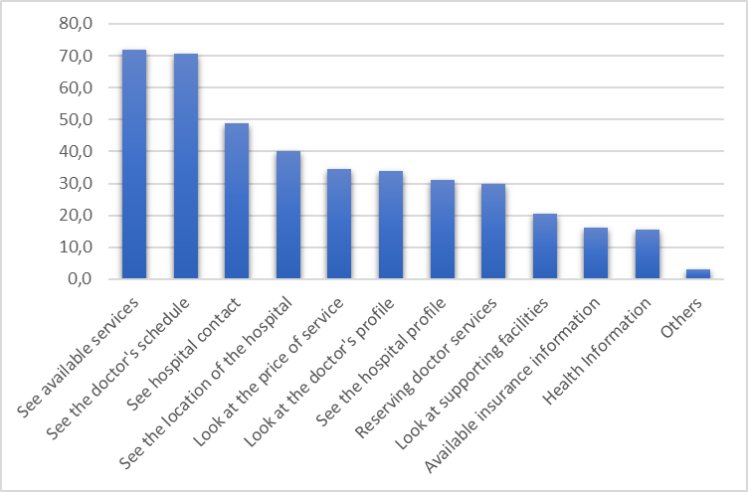
Graphic 2. Information needed in hospital website
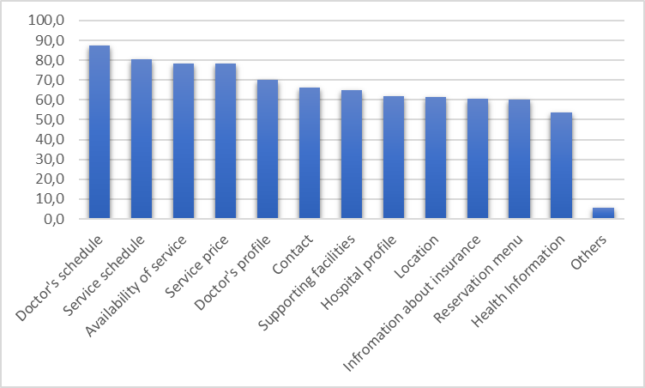

Graphic 3. Troubles encountered when vising hospital website
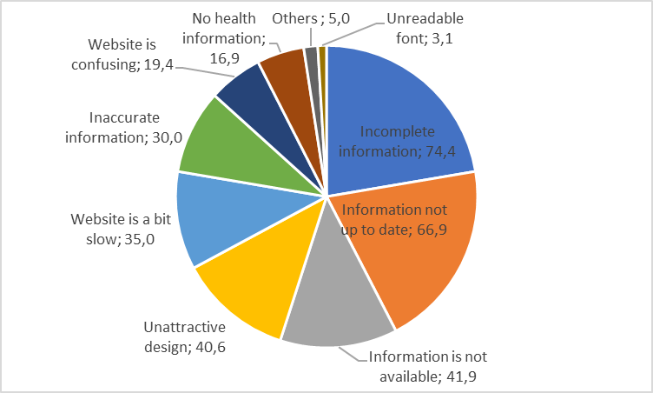
4 Discussions
The results showed that the majority of respondents visited the hospital website before they visited the hospital. The results of this study are confirmed by other studies conducted in China which state that the ease of use of the website and the usefulness of the website are closely related to the selection of hospitals and recommend hospitals that have websites with these criteria to others [13, 14]. The ease of use of the website is something that needs to be considered considering this is one of the factors that support the use of hospital websites [15].
In this study also found that the hospital website is also considered to help respondents in choosing a hospital because it can provide various information such as services available to health information. The results of the study are in line with a survey conducted in Indonesia that 51.06% of the Indonesian people use the internet to find out health information and 14.05% of the public use the internet to consult with health experts [16].
Various obstacles were still found by respondents when they visited the hospital website such as information that was not up to date or not available as well as a confusing website. Other studies conducted at hospitals in the city of Jember also found that there were still various obstacles such as incomplete information on poly / doctor service schedules, service rates [17].
This study contributes to practitioners being able to organize quality hospital websites considering the existence of a good website is a consideration by patients in choosing a hospital. The results of the study show various information needed by patients such as doctor's schedule, service schedule, available services and other important information. In addition, the hospital website also needs to be developed so that the information contained in it is not only complete but also up to date, interesting and easy to use, considering that these are obstacles that are often encountered by hospital website visitors.
This research does not focus on one particular city so that it cannot describe the specific characteristics in every city in Indonesia in describing the use of hospital websites. A research related to the use of hospital websites is needed in several cities, so there are variations in the use of hospital websites in various cities in Indonesia. In addition, further research is needed related to the existence of hospital websites with patient satisfaction.
References
[1] WHO Regional Office for South-East Asia. The Republic of Indonesia Health System Review. 2017. Epub ahead of print 2017. DOI: http://dx.doi.org/10.1016/j.pgeola.2015.01.001.
[2] Speziale G. Strategic management of a healthcare organization: Engagement, behavioural indicators, and clinical performance. Eur Hear Journal, Suppl. Epub ahead of print 2015. DOI: 10.1093/eurheartj/suv003.
[3] Ortiz E, Clancy CM. Use of Information Technology to Improve the Quality of Health Care in the United States. Health Serv Res. Epub ahead of print 2003. DOI: 10.1111/1475-6773.00127.
[4] Baker A. Book: Crossing the Quality Chasm: A New Health System for the 21st Century. BMJ. Epub ahead of print 2001. DOI: 10.1136/bmj.323.7322.1192.
[5] Grandinetti DA. Doctors and the Web. Help your patients surf the Net safely. Med Econ.
[6] Atkinson NL, Saperstein SL, Pleis J. Using the internet for health-related activities: Findings from a national probability sample. J Med Internet Res. Epub ahead of print 2009. DOI: 10.2196/jmir.1035.
[7] Lin B, James K, Vassar J, et al. The Internet and Hospital Marketing Strategy. Health Mark Q. Epub ahead of print 2001. DOI: 10.1300/J026v18n03_04.
[8] Radu G, Solomon M, Cm G, et al. The adaptation of health care marketing to the digital era. J Med Life.
[9] Sanchez PM. The Potential of Hospital Website Marketing. Health Mark Q. Epub ahead of print 2000. DOI: 10.1300/J026v18n01_04.
[10] Huerta TR, Hefner JL, Ford EW, et al. Hospital website rankings in the united states: Expanding benchmarks and standards for effective consumer engagement. J Med Internet Res. Epub ahead of print 2014. DOI: 10.2196/jmir.3054.
[11] Novan C, Nugroho E, Hidayah I. Evaluasi Implementasi Sistem Informasi Berbasis Web. 2015; 6–8.
[12] Khoirina, Fithrotu; Herdiyanti, Anisah Herdiyanti; Sustanto TD. Evaluasi Kebergunaan (Usability) pada Aplikasi Daftar Online Rumah Sakit Umum Daerah Gambiran Kediri. 2017; 06: 331–346.
[13] Wang SH. Web-based medical service: Technology attractiveness, medical creditability, information source, and behavior intention. J Med Internet Res. Epub ahead of print 2017. DOI: 10.2196/jmir.8114.
[14] Ford EW, Huerta TR, Diana ML, et al. Patient Satisfaction Scores and Their Relationship to Hospital Website Quality Measures. Health Mark Q. Epub ahead of print 2013. DOI: 10.1080/07359683.2013.844041.
[15] Cudmore BA, Bobrowski PE, Kiguradze T. Encouraging consumer searching behavior on healthcare web sites. Journal of Consumer Marketing. Epub ahead of print 2011. DOI: 10.1108/07363761111143187.
[16] Asosiasi Penyelenggara Jasa Internet Indonesia. Infografis Penetrasi dan Perilaku Pengguna Internet Indonesia Survey 2017. APJII, https://apjii.or.id/content/read/39/410/Hasil-Survei-Penetrasi-dan-Perilaku-Pengguna-Internet-Indonesia-2018 (2018).
[17] Farlinda S, Hikmah F, Viki I, et al. Pengembangan Website Rumah Sakit Paru Jember Sebagai Media Promosi Pelayanan Kesehatan Masyarakat. Pros Semnaskit 2015; 225–230.

