Digital Video Advertising Trend
A Consumer Behaviour Study in Industrial 4.0 Era

Arius Krypton
Communication lecturer, Vocational Education Program,
Universitas Indonesia

ABSTRACT:

On the industrial 4.0 era, organizations have incredibly moved their concentration towards clients as the substances making the interest for organizations' items and wellsprings of the incomes. The customer shapes and inﬂuence the present market patterns with their wants and inclinations; this requires readaptation of advertising and specialized marketing techniques from organizations. Best offer changes are based on pertinent research and shaped by buyer bits of knowledge, regularly dependent on examples of substance utilization. The principle focus of this research is to recognize digital video advertising trend by looking at advanced video media consumption habit of consumer. The author gathers and sort optional information which is chosen, gathered and formed precisely by plan necessities accessible on Consumer Barometer Research provided by Google. Identiﬁcation of the most signiﬁcant digital video advertising patterns to shape advanced promoting in the next years can be considered as the novelty element of this research. The outcomes are focused on advancement and consumer behavior and plan to highlight possible ways to produce digital video advertising and communicate to clients for a few future years.

Keyword: Digital marketing, digital video, consumer behavior, trend prediction, Indonesia.

1. Introduction

At the point when advertises reach TV as a standard item, it grabbed the eye of the majority rapidly; TV is these days at the focal point of pretty much every house lounge. The essential configuration communicate by means of TV is video and its varieties. Gigantic numbers of individuals nearly dependent on TV and its variant – from the advertisers' perspective, packed in one place – make TV the ideal channel for organizations to convey and send messages at the correct time and place. TV was, still is, and will for quite a while be a mass audience medium, as indicated by Draganska, Hartmann and Stanglein, TV ads is basically inﬂuencing the mental of a client who may buy whenever they want to in a period of time. However, new sources have resulted a various tasks performing lifestyle. Customers' consideration is separated between multiple media types and the computerized condition is 'kidnapping' an expanding number of individuals from TV to portable and gadgets associated with the Internet.

The attributes and characteristics of the digital video form make it ideal for the advanced condition, which offers a more extensive scope of focusing on alternatives, expansive outcomes, and a lot more focal points in correlation with TV. There are a few research contemplates reﬂecting on the digital video design that have been distributed in the course of recent years. Their motivations are to inspect the effects, positive and negative impacts of video types and to decide the capability of video in the advanced condition. For example, Brechman et al. recognize advanced video as a slanting, quickly developing arrangement offering new chances. Under observational research, the specialists by and large comprehend the testing of the advertisement review of pre-roll and mid-move spots and their effect on buyers. Numerous investigations have connected advanced video positions into a specific region. For instance, Malaga and Kopeelare have been trying varieties of video arranges as far as their application to training and instructing forms. These and other research articles conﬁrm that the video organize is drifting and has a wide size of utilization. Be that as it may, none of the referenced articles dig deeper. This reality has molded the space for the examination introduced in this article which has the capability of enhancing the current ways to organize the video type and get advertisers ready for future improvement and rising potential outcomes.
The fundamental target of this research is to distinguish digital video advertising patterns by looking at the advancement of purchaser's media behavior. Three fractional objectives have been set to help the accomplishment of the fundamental target:
1. To deﬁne the place and task of video in the digital video advertising condition.
2. To decide the ideal video promoting design dependent on clients behavior and inclinations.
3. To recognize the most signiﬁcant digital video advertising to shape advanced showcasing in the year 2019.
The endeavors of all organizations depend on accessible market potential outcomes and customers' wants. In this way, following patterns and early reception of new methodologies may be the essential factors in picking up an upper hand in the packed market.

- Methodology

Our study depends on two things which enable us to recognize and show the present and future patterns in digital video advertising: data mining and shoppers' bits of knowledge. Video is famous platform and the two things are important criteria for successful digital video advertising. The examination started with a diagram of the accessible hypothetical sources, as noted in the presentation, which uncovered the video arrangement's history what's more, its application in the advanced condition. Online sources added to recognizable proof of the video configuration's position in the blend of other advanced media organizes and demonstrated its huge decent variety and information based potential.
The video platform in the advanced age has a convincing potential to use information produced by watchers, which is its greatest benefit. This arranged and translated information was finished by preparing the optional information on customer bits of knowledge gathered from research polls in the Connected Consumer review gathered by Google Consumer Barometer.
- Digital Video Advertising

Video and sound clips were a piece of sites from the earliest starting point of the Internet. In any case, they were utilized so often because of the challenges in order and accessibility. Video publicizing designs in the advanced condition are entirely adaptable and versatile to the dynamic character of sites and their dispensable stock. A short outline of accessible video and video promotion configurations demonstrates that their choices rely upon the site where the digital video is distributed and on the potential outcomes which a specific advantage of a platform.

  - Video Types
Digital Video In-Stream Ad Format Guidelines, published by IAB in 2016 divide digital video advertising into several, which are: Video on page, video in rich media, incentivized video, video in standard banner, and the most widely used in social networks are video on feed. Digital video advertising is being used as a vehicle, adjusted to banner (for instance 150x150 pixels) the picture is not static but uses a video. In display digital video advertising is separated from the video being watch by the user and are shown independently.
The usual digital video advertising is shown during a video. Advertising launched before the video content is played is called a pre roll spot. Video launched while a user is watching the video content. There could be an unlimited number this type of ads and its is called a mid-roll spot. While a post-roll spot is an advertising launched after the video content has finished. Viewers can skip some of this advertising depending on the advertiser.
3.2. Video types (Suppliers point of view)

These are the three most basic approaches to buy video as a promoting design on the Internet:
1. nearby providers – neighborhood sites and entryways claim and produce their own video content and make a video portfolio which has a customary or an infrequent group of spectators. Publicizing arrangements are acquired based on routinely arranging connections between representatives (brokers on the two sides: sponsor and provider);
2. interpersonal organizations – worldwide informal communities, for example, Facebook, YouTube, Instagram, Snapchat, and so on. Enable organizations and people to transfer video content on their informal organization profiles and, by means of unpaid and paid channels, spread it to correctly focused on spectators;
3. automatic purchase (and RTB) – automatic robotized sell off frameworks are a substitute for arranging forms and permit the buy of video advertisement organizes legitimately through programming.
Each buy structure permits the buy of both in-show and in-stream advertisements. Which structure is liked relies upon individual standards and expectations.
- Data Mining as Consumer Behavior Pointer
Information mining speaks to the fate of computerized promoting. Each correspondence with customers creates a tremendous measure of information qualified for use in future crusades. Exponential innovation development, for example the new advancements consistently spreading everywhere throughout the world are making chances to increase aggressive advantage by applying new information based ways to deal with advertising correspondence. As indicated by Rud, it is these days conceivable to produce different sorts of information dependent on socioeconomics, personal conduct standards and mental or then again attitudinal methodologies. This information is accessible from inner databases, value-based databases, chronicled databases, or from outer sources. While standard pennants and rich media arrangements report (in harsh information) clicks, impressions, stay rates or perceptibility, video configurations can reveal considerably more about the shoppers come to. Distinctive video promotion position providers are equipped for detailing various information. Our concise outline beneath depicts information accessible to mine from video arranges paying little heed to provider.

Video as an advertising tools
Impressions means number of times video was seen. Clicks means the number of snaps on video group. Unique treats mean the number of extraordinary treats video advertisement came to. Real clients mean the number of genuine client that video hits.

Video utilization
3 Second video sees: the quantity of clients who saw at any rate three seconds of video group;
10 Second video sees: the quantity of clients who saw in any event ten seconds of video design;
Video rate watched: the normal percentage level of the video the client viewed;
Video viewed at 25/50/75/95/100%: how many times the video was viewed.

Video engagement (social network calculation)
Video likes, shares, and so on.: the occasions that video has informal organization communication;
Video mouse-over: the occasions/time spent on 'mouse-overing' the video.

This concise outline does not contain all information mining conceivable outcomes that video arrangements can offer. It ought to be underlined that all produced datasets are pertinent in future battles. By methods for information putting away what's more, preparing programming, it is, for instance, conceivable to target and show video promotion position just to customers who saw the past video for in any event half of the absolute video length. Promoters may likewise retarget customers just with the piece of the video which has not yet been seen. All the more critically, information is indicating information mining crosswise over different gadgets: Google and Facebook as of late discharged following advancements which are ready to finish clients work areas, mobiles or tablet gadgets. It is just a short time before TV will supplement the three previously mentioned gadgets in cross-stage following.

- Digital video advertising pattern
The third goal of the exploration has been proposed based on the Consumer Barometer device created and worked by Google. Customer Barometer gathers and procedures purchaser conduct information on the premise of surveys and causes us comprehend clients' conduct in the computerized condition in Indonesia. Video-related information is depicted beneath. The chose inquiries had a normal of 1,659 respondents and research was conveyed out in 2019.
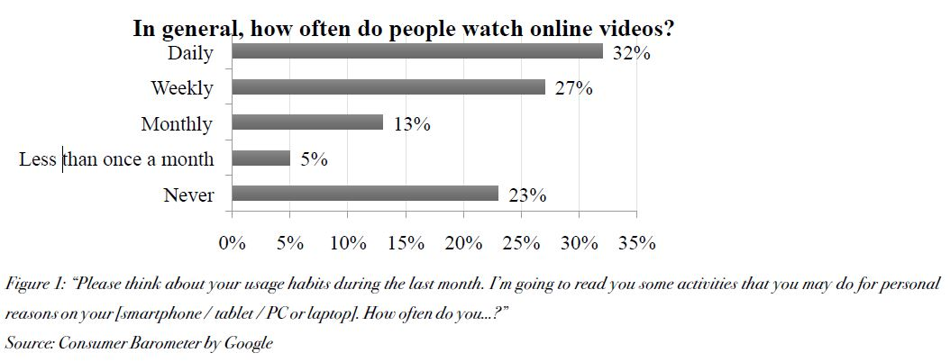

According to Figure 1, practically 60% of purchasers asked watch the video position on a portion of the accessible on the web stages at any rate once per week. Just 23% pronounce that they never watch video on the web (for the most part the more established fragment of the populace without advanced propensities and capabilities). In Figure 2, the sorts of destinations by means of which on the web recordings are gotten to ordinarily are talked about. According to Figure 1, practically 60% of purchasers asked watch the video position on a portion of the accessible online stages at any rate once per week. Just 23% proclaim that they never watch video on the web (generally the more established portion of the population).
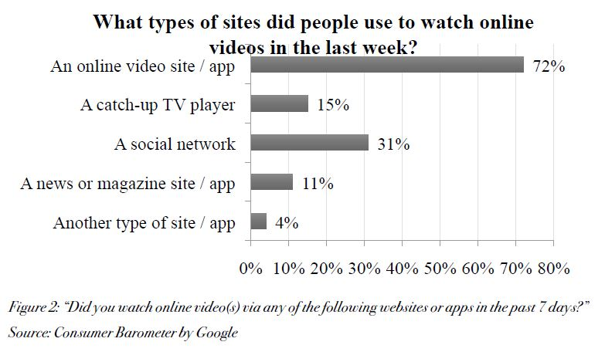

Particular video sites and applications and informal communities are the main stages for video utilization and the market predicts a constant pattern for these channels. The reason for this is sites and informal organizations make good conditions for video designs.
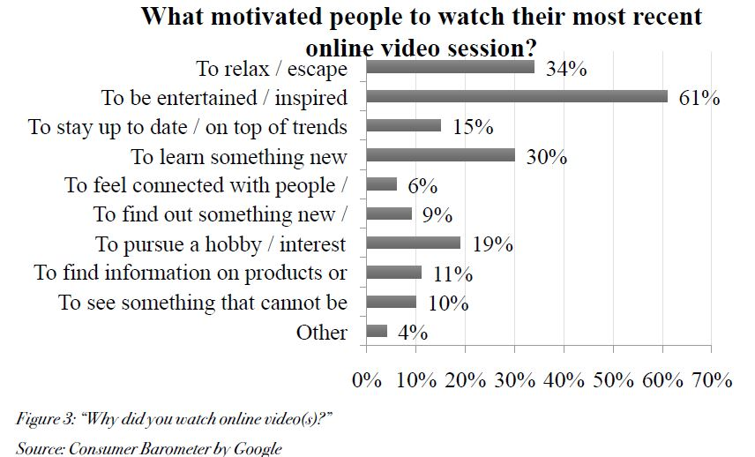
The main reason why consumer watches the video are to be entertained or be inspired.
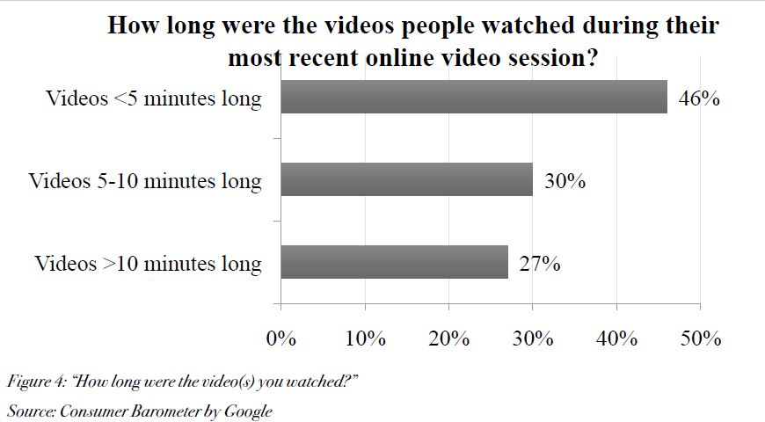
Most viewers watches videos shorter than 5 minutes. This time gets longer as they get used to portable devices. Figure 5 shows the focus of viewers.
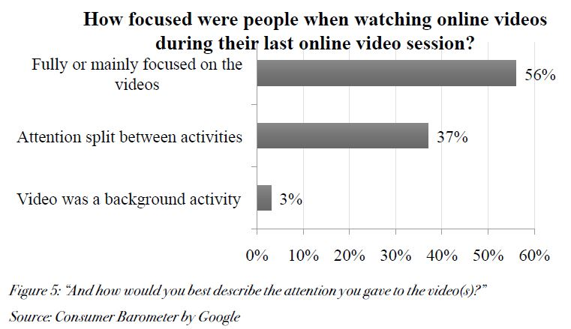
Figure 6 are discussion about pararrel devices used while viewing a video, in this case its TV.
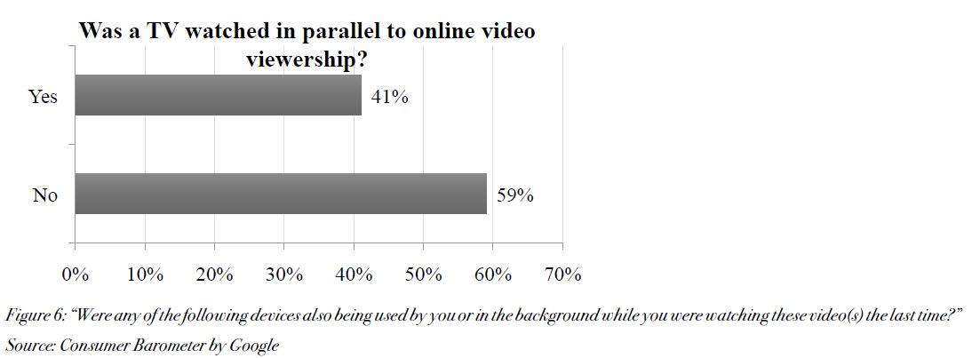
Right around a half of clients routinely watch online video while sitting in front of the TV. There are a lot more exercises customers can complete while sitting in front of the TV that help proclamations on TV use as a 'foundation commotion', the most critical of which are gadgets, for example, cell phones, which are utilized parallel to TV viewing. Though the TV as a medium offers the most reasonable condition for even video groups, at the same time utilized cell phones are situated vertically, which improves vertically-arranged substance utilization.

The chose information is utilized to investigate computerized video utilization and spotlight on changes in video utilization propensities. The auxiliary research on the gathered reactions affirms that the adaptability and dynamism of advanced video arrangements guarantee expanded intrigue and draw in purchasers who are moving from 'pre-served' TV video substance to on-request computerized video stages. The examined information demonstrates that utilization of video substance is day by day, and clients expend video content for the most part with the goal of diversion or instruction. The shorter recordings are favored because of the clients' longing to ingest a gigantic measure of data in a generally brief time spent on the web. The advanced video arrangement is by and large not by any means the only stage devoured at the time.
This ability, enhanced by the information based learning accessible from video, enables us to decide the correct organization with the correct conveyance strategy to the correct purchaser. In the event that the video provider determines that a client observed just half of the served video, he can serve just the staying half to finish the story the shopper was not ready to pick up at the principal endeavor. The length of the devoured piece of the video likewise demonstrates enthusiasm for accepting comparable recordings with comparative stories and innovativeness. Changing media utilization propensities are arranged towards the computerized condition and video particularly offers an immense territory to upgrade the presentation of showcasing correspondence. For publicists utilizing advanced video the biggest and most simple to utilize space are in-stream advertisements, which intrude on the as of now watched video content. In any case, this kind of video publicizing may be considered as meddling and may incite the accurate inverse impact to that proposed by the provider when showing the notice.
The figures above delineate the computerized video utilization propensities so sponsors ought to adjust to purchasers' inclinations and produce and serve engaging recordings, ideally once a day, with included an incentive for shoppers, supplementing stories from TV. Nonetheless, this ability can be connected in various video groups. The last piece of our examination distinguishes the most drifting organizations containing the components referenced previously.
Digital Video Advertising Trend
The pattern of advanced video started in European markets around 2016 is as yet 'drifting'. A portion of the advanced promoting patterns are really a couple of years old; be that as it may, the video pattern all things considered is as yet developing and is making its own subcategories. Because of customers' conduct and video utilization, there is a forecast for ceaseless development of advanced video and its business employments. Based on gathered data and information from the third, fourth furthermore, ﬁfth part, we can foresee the accompanying patterns in applying video designs in the computerized condition.
The examination results are upheld by exchanges with prestigious computerized showcasing experts, support on a few research activities managing advanced promoting related research questions and ceaseless perception of the advanced patterns being referred to. It tends not out of the ordinary that the pronounced advanced video patterns will stay substantial at any rate until the finish of year 2020. Because of dynamism of computerized innovations and the advancement of showcasing approaches, little updates may be required before the finish of the previously mentioned period.
Split message between a few gadgets. The exploration above demonstrates that clients' consideration while sitting in front of the TV is part between a few exercises and 41% of TV substance's purchasers are viewing on the web recordings in parallel. Be that as it may, online video isn't the main action clients are centered around while devouring TV content. Cell phones, tablets and compact PCs enable clients to separate their consideration between more gadgets and use TV just as a foundation clamor. The multi screen wonder makes space for multi-channel correspondence systems pointed towards the ﬁnal customer. These days it is conceivable to layout a story in a TV video business and convey the remainder of the story by means of the computerized condition. Consideration is progressively invigorated and promotion message conveyance diversiﬁed between more gadgets. Moreover, clients are flawlessly changing from online to ofﬂine and back once more, which will urge signiﬁcant exertion to have the option to follow customers' 'media venture' to be available, increasingly exact and happening continuously.
Little screen habit. As per examine by Nielsen, the cell phone turned into the third greatest stage for video in 2016, picking up 27 minutes' viewing for each day, and this time is as yet developing. Ooyala's Global Video Index report additionally sketched out expanded portable utilization in an explanation that since 2013, video perspectives have developed over 233% and clients are currently expending much longer recordings by means of their versatile or tablet gadget. Past research by Roettgers pronounces that 48% of all video seeing on PDAs is presently identified with clasps that are ﬁve minutes or more: a year prior, that number was still at 23%. Taking all things together, 30% of survey is of recordings that most recent 20 minutes or more.
Apathy to 'ﬂip over'. Standard computerized video arrangement has flat direction (to be precise, the angle proportion is 16:9). Be that as it may, versatile showcases are vertical and utilization of vertical angle proportion recordings is increasingly agreeable. The investigation by Grifﬁths discovered that vertical versatile video perspectives are multiple times higher than the association pace of even portable video, so we ought to hope to see more brands and distributors moving to a vertical-concentrated encounter on mobiles. 11 This pattern is bolstered by Figures 4 and 6 in the Chapter 5 of this article, where the most signiﬁcant of the proclaimed measurements is the expanding media utilization on cell phones.
Conclusion
At first, the video organization appeared to be the space just of TV because of its recognizable character and its capacity to arrive at a colossal number of buyers. In any case, buyers' continuous move towards the computerized condition and expanding utilization of the Internet substance have indicated advanced stages as appropriate channels for this dynamic configuration. The current computerized information the board choices in blend with buyers' consistently changing media utilization propensities speak to a space for new video showcasing techniques and methodologies.
Appropriately handled and thus put away information, produced from past showcasing exercises joined with learning of customer media utilization inclinations, offers customization focusing on choices in the advanced condition. Video is an indivisible piece of the advanced computerized showcasing procedures and ought to be viewed as an innate brand building group alongside standard and rich media designs. Speculations generally depict and assess conventional promoting groups; be that as it may, the time has come to consider the advanced video position as a powerful device with wide alternatives for hypothetical elaboration, particularly since online computerized video is influencing media utilization conduct and shaping future computerized advertising patterns. Organizations and advertisers likewise need to acclimatize correspondence diverts as per dynamic purchaser inclinations, which are going for computerized video utilization rather than increasingly customary pennant designs in the advanced condition or on TV.
This article has identiﬁed a few speciﬁc advanced video patterns which will shape the promoting business sector and correspondence with customers in 2019. This exploration may expand the hypothetical view of advanced showcasing configurations and guide organizations through the following year with proposals by which to build up progressively powerful and exact computerized advertising draws near.
References
ARLEN, G.: TV Binge-Viewing: Primarily A Solo Act. In Multichannel News , 2015, Vol. 36, No. 32, p. 17-18. ISSN 0276-8593.
BRECHMAN, J. et al.: Limited-Interruption Advertising in Digital-Video Content. In Journal of Advertising Research, 2016, Vol. 56, No. 3, p. 289-298. ISSN 0021-8499.
DRAGANSKA, M., HARTMANN, W. R., STANGLEIN, G.: Internet Versus Television Advertising: A Brand-Building Comparison. In Journal of Marketing Research , 2014, Vol. 51, No. 5, p. 578-590. ISSN 0022-2437.

GRIFFITHS, An.: Unruly's Video Advertising Prediction for 2019. Discharged on 22 nd December 2016. [online]. [2016-12-28]. Accessible at: <https://unruly.co/blog/article/2016/12/22/video-promoting forecasts 2019/>.
IAB TEAM: Digital Video InStream Ad Format Guidelines. Discharged on 8 th January, 2016. [online]. [2019-07-22]. Accessible at: <http://www.iab.com/wp-content/transfers/2016/01/DVAFG_2015-01-08.pdf>.
MALAGA, R. A., KOPPEL, N. B.: A Comparison of Video Formats for Online Teaching . In Contemporary Issues in Education Research, 2017, Vol. 10. No. 1, p. 7-12. ISSN 1940-5847.
NIELSEN COMPANY: Internal Report of Nielsen (the organization having some expertise in customer look into), 2016 . [online]. [2019-06-12]. Accessible at: Paid access by means of the organization's interface.
RADOŠINSKÁ, J.: New Trends in Production and Distribution of Episodic Television Drama: Brand Marvel-Netﬂix in the Post-Television Era. In Communication Today, 2017, Vol. 8, No. 1, p. 4-29. ISSN 1338-130X.
ROETTGERS, J.: More Than Half of All Video Viewing Now on Mobile, Tablet Viewing Flat (Report) . Discharged on 6 th December 2016. [online]. [2019-07-27]. Accessible at <http://variety.com/2016/advanced/news/versatile video-seeing details 1201934907/>.
ROWNTREE, L.: Expert Views on What will Become of Video Advertising in 2017 . Discharged on 22 nd December 2016. [online]. [2019-07-28]. Accessible at: <https://www.exchangewire.com/blog/2016/12/22/master sees will-move toward becoming video-promoting 2017/>.
RUD, O.: Data Mining. Brno : Computer Press, 2001.
SCOTT, D.: New Rules of Marketing and PR. Bratislava : Eastone Books, 2010.
STANTON, D.: 57% of TV Viewers Report Regular Binge Viewing – Up 12% in Just 10 Months. Discharged on 19 th July 2016. [online]. [2019-07-30]. Accessible at: <http://www.businesswire.com/news/home/20160719006011/en/>.

