**ANALYSIS FACTORS THAT CAUSED INTERNSHIP STUDENTS RECRUITED BY THE COMPANY**

**By: Istiadi, SE,MM,MSi**

**Program Studi Administrasi Perkantoran, Vocational Education Program, University of Indonesia**

**Abstract**

Recruitment is one part of the function of human resource management. In the era of industrial revolution 4.0, recruitment carried out by companies is not only done by employees from within the company or outside parties who have never known the company at all. Recruitment of prospective employees is even carried out on students who are apprentices in the company. The Internship Program is actually not only beneficial for students who are apprentices in the company but also a valuable opportunity for the company not only to be able to be assisted by students who are apprentices, besides that the company can better identify prospective employees who will be recruited.

This research conduct by quantiative approach used descriptif analysis that used quesionaire where the sample consist of 9 from 15 user ( supervisor and HR staf of the company ).

This study aims to determine what factors are the cause of an internship student so that he can be recruited to become an employee of the company. This research is conducted by looking for information from users or companies that use student internships in their companies and then recruit them to become employees of the company.

***Keywords***: *Management of human resources, recruitment, internships, students, employees*

**INTRODUCTION**

Human resources are a very important element in the development and continuation of the running of the company. The sustainability of a company in its environment is determined by the human resource capabilities of the company.

This is where the role of the Department of Human Resources of the company which is now sometimes referred to as the Human Capital Department has an important role in obtaining superior resources.

According to Schultz, human capital is defined as a form of capital embedded in the knowledge and skills that people acquire through education and training and is a product of deliberate investment that yields returns.

One of the most important functions so that companies can run their businesses to get profits is the quality of human resources in the company. The quality of high or low company human resources is determined by how the company recruits prospective employees who will work in the company. That is, it can recruit prospective employees in accordance with the qualifications needed in certain parts of the company. So that it can be said that the recruitment function in the management of human resources plays a very important role in getting qualified employee candidates to be able to run the company in an era of increasingly fierce competition. The source of withdrawal of prospective employees can come from within and also from outside the company. One source from outside the company which is sometimes used as a strong consideration for being recruited as an employee is students who have or are interning in the company.

Accoding to Silva, internships have proven a popular work-integrated learning experience that facilitates the transition of students from higher education to employment and contributes to their career development.

Internship benefited not only for the student but also for the company and the economy, especially the goverment. Goverment helped by the existence of internship because can lower the potencial of unemployment. It means that teh existence of internship very needed by the goverment to support the higher education that provided by university, especially the vocational higher education in the nation.

Student internships in the company are usually slow to have emotional closeness with the company.

In the writing that the writer conveyed, the author will elaborate further on why the company recruits students who are apprentices in the company to become employees or company staff.

**Recruitment**

According to Bangun (2012) recruitment is a process of finding employment to fill the vacancy in a particular company.

In the recruitment terminology, our employees are familiar with 2 types of recruitment: first is internal recruitment, which is recruiting prospective employees from within the company itself, for example is the process of promotion of an employee to occupy a higher or level position within the company. An assistant manager is promoted or promoted to fill the vacant position of a Manager above. Or it could be that internal recruitment comes from the transfer of employees from one part to another. Internal recruitment is usually done by companies when there are not too many human resource needs. But if a lot of human resources are needed, usually the supply of prospective workers is done through external recruitment.

While the recruitment externally recruits prospective employees to occupy certain positions from an employee and prospective recruited employees from outside the company.

For this reason, an HR manager must accurately estimate or estimate the human resource needs of each department accurately every year or a certain period of time. Errors in estimating resource requirements Human companies result in inequality in fulfilling human resources within the company. Which in turn will cause the overall performance of the company to be low or down. Today, in the era of industrial revolution 4.0. various ways can be used by companies to recruit competent human resources so that the company can operate optimally so that it can compete competitively in this era of industrial revolution 4.0 competition.

According to Bontis and Serenco (2007) Employee capabilities are one of the most important measures affecting firm performance and have been found to reflect an employee's perception of her/his knowledge, skills, experience, network, ability to achieve results, and room for potential growth .

In recruiting Human Resources to occupy certain positions there are various methods used. The methods commonly used are closed methods and open methods. Closed methods are usually used to recruit candidates who will fill fairly senior or high positions. It is said that the recruitment method is closed if the recruitment carried out by a company is not disseminated to the general public, so those who know only the needs of the company's employees are only limited or internal circles of the company.

While the open method is a method of recruiting prospective employees by disseminating information on the needs of prospective employees within the company to parties outside the company through various available communication media, including existing social media. Usually open methods are used to recruit prospective employees in certain positions if there is no person from within the company who can fill the position

The Strategic human capital focuses on the valuable characteristics of people that can provide a strategic resource to the firm. The importannce of human capital: Roles of social capital and coordination that drive unit performance.

**Internship**

Intercourse is the work practice of students within the company with the aim that students get a variety of work experience directly in the company according to their educational background. Internships are useful not only for students who are looking for work experience, directly in the company before they graduate from university but also provide benefits for the company because they get personnel assistance for a particular field of work. Not only that the existence of student internships in the company provides benefits for companies to be able to recruit easily apprentice students who have good qualifications and dedication for the company. There are several reasons why student internships can be one of the targets of recruitment of company human resources that are quite effective. There are at least 3 main reasons why student internships are one of the targets of the company's HR receptors, namely:

**1**. Few companies for a few months can learn and recognize the personality of the student, so that it becomes a material consideration for whether the student is eligible to be recruited by the company

2. Few companies can recognize the level of work ability of the student concerned. So that the company does not need to pass a special exam for prospective employees who will be recruited.

**3.** For apprentice students who will be recruited as prospective employees, there is no need to provide specific outreach or orientation because they already know the conditions or company culture**.**

There is a consensus on the importance of internships in companies in achieving a complete and comprehensive education during university studies (according to Collet et al., 2015; Rae, 2007; Rouvrais et al.,2018)

**Research Question**

The research questions underlying this paper are:

- What factors have caused internship students to offer to work in the company

- How is the contribution of the ability, skill, and attitude factors in influencing the acceptance of an employee in the company

**METHODOLOGY**

This research is carried out by using a quantitative approach with descriptive methods.

Respondents from this study were supervisors or staff of the human resources company where the student was an intern. The apprentice students who are the object of assessment from the supervisor and staff of this HR department are office administration and secretarial students. This study deliberately attempts to further classify the factors that influence the recruitment of internship students into the 3 main components of the competency element which consists of skills. , knowledge and attitude are added by factors related to soft skills. Even though there were 15 samples distributed to respondents, only 9 respondents filled out and returned their answers. This research conduct by quantiative approach used descriptif analysis that used quesionaire

**DISCUSSION**

Through this research the author succeeded in collecting data which became the main consideration in recruiting internship students in his company to become prospective junior employees. The factors that the author carefully covers the factors that are directly related to the competency factors which include skill, knowledge and attitude.

1. **Skill Aspects**

Knowledge aspect is a factor that sufficiently determines someone can be recruited into the company. Skill can be said as a person's capacity or ability to perform tasks in a particular job. Ability can also be interpreted as a current assessment of what a person can do with a job. To be accepted as an employee a candidate usually has to go through a certain ability test in accordance with the field of work. In some fields of work ability test is an absolute requirement that must be mastered by a prospective worker. For example, for the profession of an airplane pilot, he must be able to drive an airplane without any lack. But in other types of work the work ability is sometimes not too high priority because a new employee usually has to be educated and trained so that he can carry out the tasks as desired by the company. This means that if there are deficiencies related to its ability it is still understandable, as long as this is still within the limits of reasonableness.

1. **Daily skills in general**

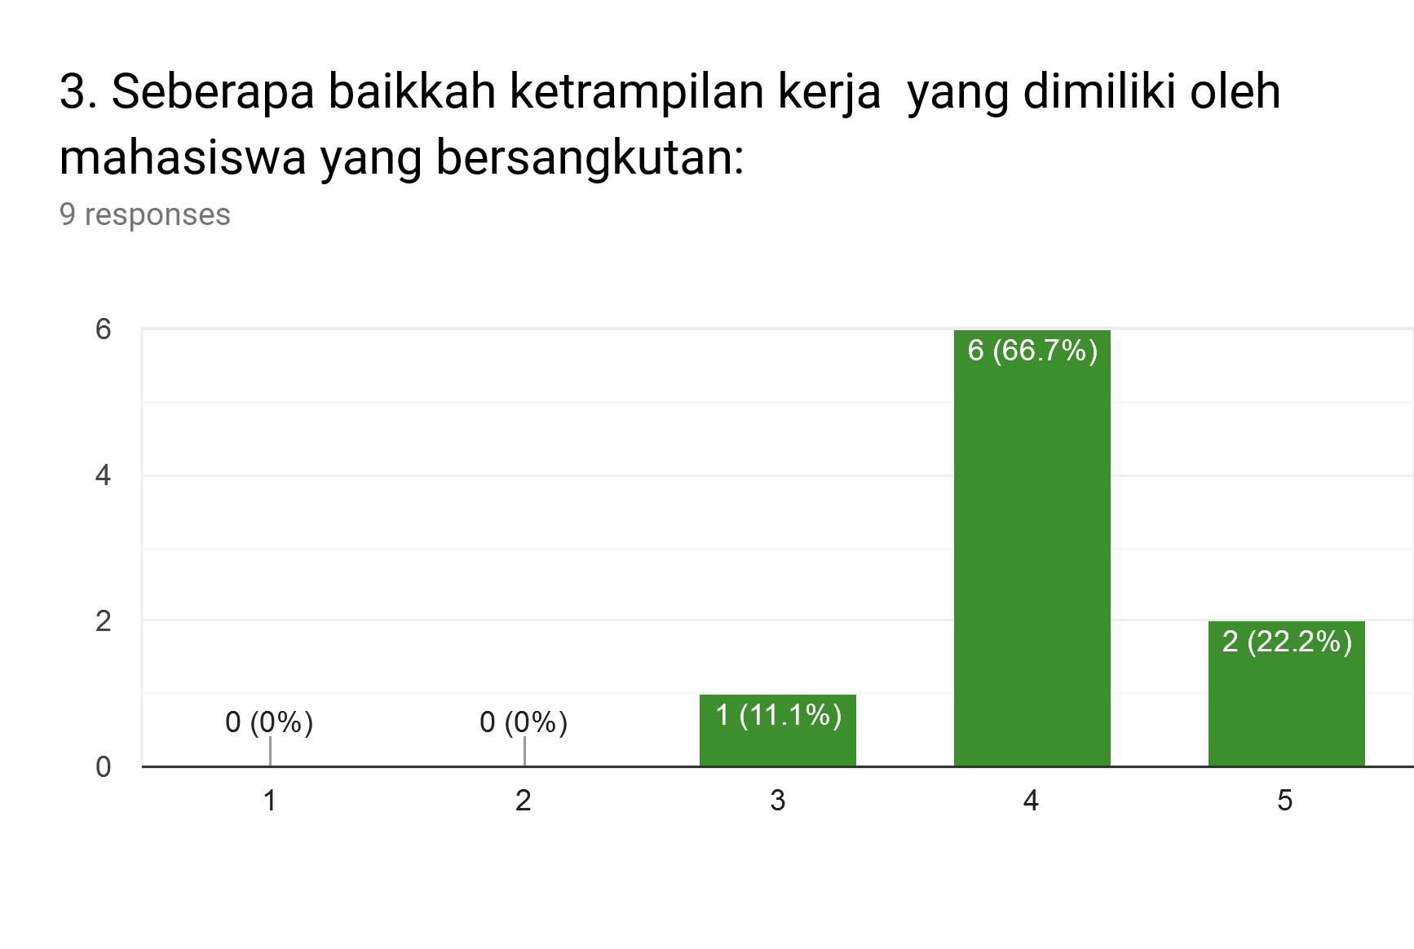

**Figure 1. Degree of daily skill**

From the picture 1. above, you can see the work skill factors of the students who were recruited by the apprenticeship company, showing that they in general or majorities have good work skills and can even be said to be in a very good category. There is only one person in the moderate category. This can be said to be reasonable considering the sample taken was selected people from the Office Administration Study Program who were offered an offer to work in the company, where of course the company already knew perfectly the work skills of the internship students.

1. **Ability to use information technology**

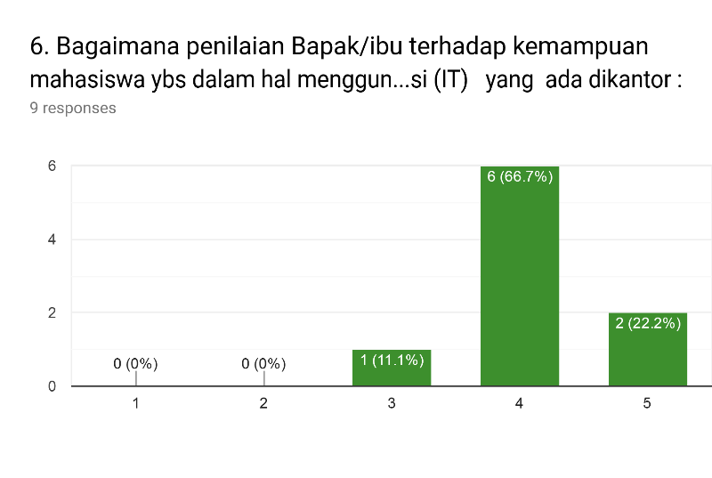

**Figure 2. Degree of Information Technology Capability**

From the picture above, we can see that the ability to use information technology facilities in work from students given comments by supervisors or the HR department stated that 66.7% of students who were received directly turned out to have good IT skills and even 22.2% were assessed very good information technology capabilities. While those who are given a moderate assessment are only 1 person.

1. **Ability to carry out office administration tasks**

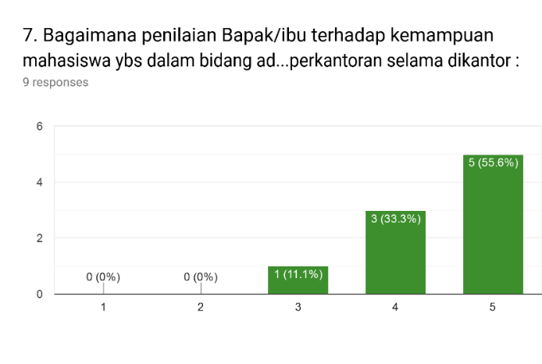

**Figure 3. Degree of office administration skill**

The natural ability of the office administration field of the students offered to work after the internship showed the majority of the 9 respondents stated to be very good. This can be said to be reasonable, remembering that the student is a student in the Department of Administrationn

**2. Knowledge Aspect**

The knowledge aspect of a person also plays an important role whether he is accepted by a certain institution. Knowledge includes individual insights into the field of work as well as insights on various things about the company that will be entered. Knowledge can also mean one's insight into various aspects that occur in their environment. An employee is not only required to have good ability towards a job, but also required to have good knowledge.

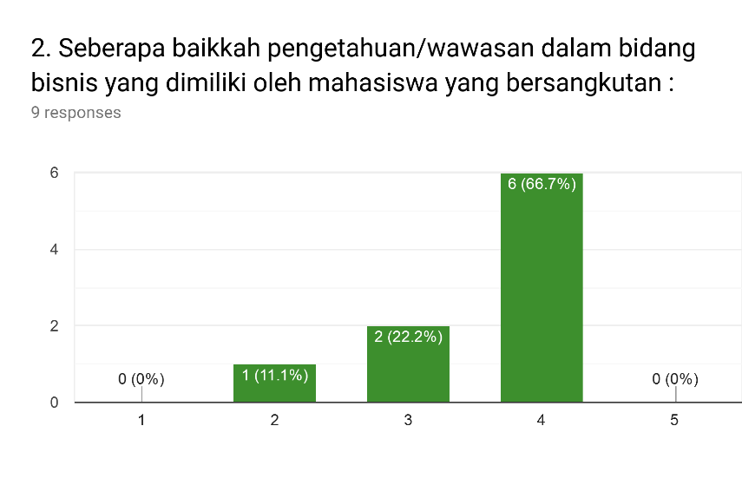

**Figure 4.Degree of Knowledge**

**3. Attitude Aspect**

The attitude in general is a behavior that is shown by someone when the person interacts with other people, whether with a boss or subordinate or even with people who are equal hierarchically in the company. For certain types of work, attitude or commonly called attitude even becomes a very important thing to be assessed rather than other elements such as skill and knowledge. This is reasonable considering that a person's attitude is difficult to correct if the assessment turns out to be of less value, different from skill or knowledge.

1. **Everyday attitude**

The everyday attitude of an employee within the company is a very important aspect, even often noticed by a boss. The attitude of a person who can be well received in his environment is an advantage in itself which gives a positive impact on the person concerned.. 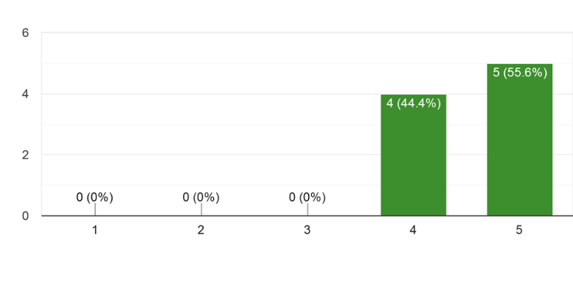

**Figure 5. Degree of Daily Attitude**

From the picture above we can see the apprentice students who got an offer to work at the company get a good and very good rating for all the students. So that it can be said that a person who has a good attitude especially very good will certainly be very liked by his environment. This also means that the internship students offered to work in companies are those who also have a good or very good attitude.

In addition to attitude factors in general, some elements of attitudes that are also examined relating to attitudinal factors are:

1. **Ability to adapt to colleagues**

The ability to bear adaptation with co-workers is a factor that is quite important to be considered by the HR department of the company because adaptability will be very decisive in carrying out their duties properly. A person who has good self adaptability can easily get along with other people in the company so that the impact is also positive for the company

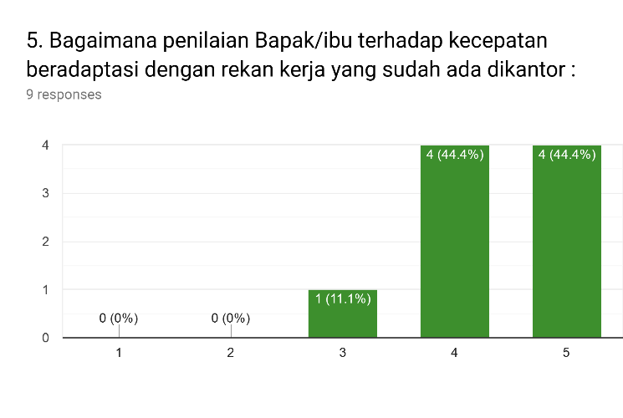

**Figure 6. Degree of Speed of Adaptation**

From the picture above we can see that from the aspect of adaptability to coworkers, children offered at work in their internships are children who are mostly quick to adapt to other colleagues in the company. This adaptability is certainly a separate capital for an employee considering that not everyone can quickly adapt to the work environment.

1. **Dress / appearance**

Appearance is a very important factor in working. Appearance reflects the personality of the person, because through his appearance both daily and at certain times a person can judge the personality of that person. One that is assessed by a boss or supervisor of student internships is how the student looks or how to dress when at the office. If the appearance is neat in accordance with the standards set by the company, this will provide a positive image not only for the student intern but also contribute positively to the company.

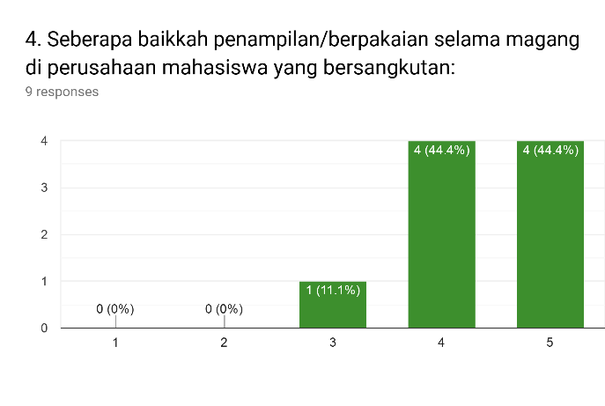

**Figure 7. Degree of daily performance**

From the picture above we can we see the internship students seen from their appearance showing a good and very good judgment on the eyes of their supervisor or supervisor, so it is only natural that they are offered to join the apprenticeship company.

1. **Attitude when making mistakes and given advice**

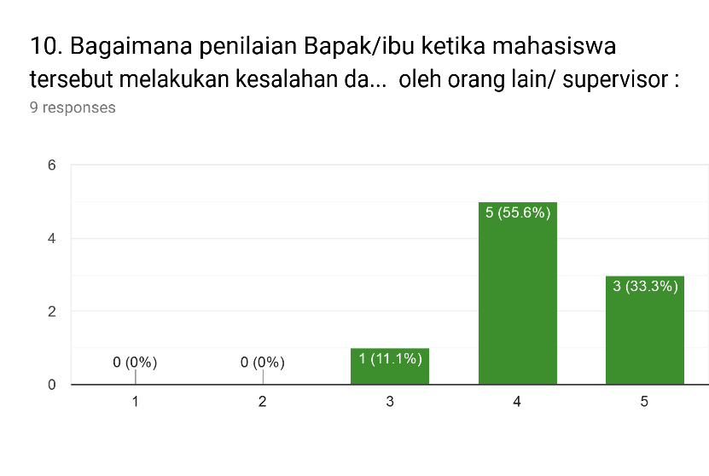

**Figure 8. Degree of recognize the false and given advice**

The attitude of admitting mistakes and being prepared to accept input from others is a positive attitude that many people do not have. Usually people are difficult to give input when making certain mistakes in work, thus causing recurring errors. From the picture above we can see the internship students have a positive attitude that is dominant enough in acknowledging mistakes and it is easy to accept input from their supervisors so that they can be said that they are not difficult people to advise when making mistakes.

1. **The spirit of learning**

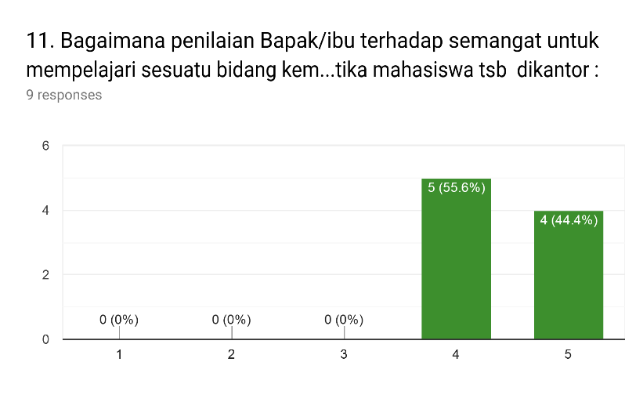

**Figure 9. Degree of spirit to learn**

From the picture above, it can be seen that the majority of the 9 internship students recruited by the apprenticeship companies are those who have a good spirit of learning even some of which can be said to be very good or very high. So that they get a positive rating.

**CONCLUSION**

1. From the description presented above, the author can take some conclusions as follows:

a. There are several main factors that influence an internship student can be recruited as an employee. These factors are factors of skill or skill and factors of attitude or attitude. For these factors both skill and attitude, students offered a job get good and very good ratings. This is reasonable considering that skills or skills are factors that are very much considered by the company.

b. Aspect Knowledge or knowledge is the only factor that can be tolerated by a company when an apprentice student is recruited by an company.

**Bibliographies**

Farmaki, Ann, ***Tourism and hospitality internships: A prologue to career intentions?,*** Journal of Hospitality, Leisure, Sport & Tourism Education, Volume 23, November 2018, Pages 50-58

Harris, Christopher M., Patrick M. Wright, Gary C. McMahan, ***The emergence of human capital: Roles of social capital and coordination that drive unit performance***. First published: 14 September 2018 https://doi.org/10.1111/1748-8583.12212, April 2019 Pages 162-180

Maley, Jane F., ***Preserving employee capabilities in economic turbulence***, First published: 27 September 2018, April 2019, Pages 147-161

Prof. Bangun , Manajemen Sumber daya Manusi, Erlangga, jakarta 2007