Beginner Voters Outlook on New Media Advertisements of Partai Berkarya and The New Order Values Among Students: A Social Media Technological Adaptation Study of Indonesian Political Advertisement
Hardika Widi Satria¹ and Naldo ²

^{1,2,} Vocational Education Program of Universitas Indonesia, UI Campus Depok, Indonesia.

Abstract. Research aims: this article aims to examine the outlook of beginner voters of Indonesian students towards the advertisements of Partai Berkarya and its value of the new order which lies in the social media advertising message. Methodology: This study uses quantitative method based on questionnaire. This study employs Lasswell’s Communication Model. Findings: This research argues that the speaker of advertisement communication effects the attitude and beliefs of the audience (beginner voters in Indonesia). Practical Implications: This article provides a discussion on the current political campaign situation analysis of Partai Berkarya who fight for votes from beginner voters in Indonesia using advertisement of the new order image or value through technology alteration in social media. It provides several suggestion and recommendations for the industry of advertising in Indonesia. This study can be an insightful lesson-learned that can be used to create another better political advertisement campaign in Indonesia. Theoretical Implications: This study expands the existing literature on communication studies particularly in advertising by providing a theoretical support of Indonesian communication political and advertising cases. It illustrates how the theoretical political communication approach could help the advertising business creating more creative message in their advertisement. This study expands the existing literature on youth perspective toward political ads in new media in the age of industrial revolution 4.0. It illustrates how the theoretical approach could help the political party creating better message that tailored to the youth value behold.

Keywords: Advertising, Political Party, Lasswell Communication Model, Social Media, The New Order, Political Advertisement, Youth, Technological Adaptation, Political Marketing

Introduction
General elections play an important role in the democratic system of a government’s country. Election in the democratic system is a way to elect people's representatives for the parliament as well as one form of fulfilment of human rights in the political field and their sovereignty. As one of democratic country in the world, Indonesia has an interesting history particularly in The New Order under President Soeharto which lasted 32 years. Nowadays in the reform era, a new party emerged conveying New Order message called Partai Berkarya and led by the youngest child of President Soeharto, Hutomo Mandala Putra. The Deputy Secretary General of Partai Berkarya, Arifin (2019) states their target in the election year of 2019 to introduce the party to the public at once gaining the votes of new voters particularly millennial generation who were not born at the time of New Order under President Soeharto’s rule. Ministry of Internal Affairs of the Republic of Indonesia (2018) proclaim there are 14 million new voters out of a total of 196, 5 million who have the right to vote in the 2019 Election. This number is quite large and can contribute significantly to the victory of candidates for President and Vice President in the presidential election and election of members of the parliament. For this reason, Partai Berkarya target new voters as one of the voting sources in the 2019 election through their political advertisement message in social media.
Russo & Amnå (2016) explain political behaviors interaction between personality and environmental factors. People's desire to conform to social norms plays a central role in explaining reactions to political conversations. Recently the medium of conversations took place social media and the politician also use it in term of campaign using social media advertising. Social media advertising has assumed increasing focus in recent years in the domain of marketing. Advertising through social media has overtaken the traditional channel of advertising in various dimensions (Natarajanet al., 2013). Unlike adult voters, youth are likely to form attitudes even without adequate knowledge, or their knowledge may lead them to adopt cynical attitudes that prevent participation (L.R. Sherrod et al., 2004). Advertising as one of the branches of communication science plays an important role in political communication primarily as a form of persuasive information on the target communicant. Soukup (2014) on the general area of political communication cuts across almost all of communication study. The very name of the subject area gives a sense of what it encompasses, but with something so broad, definition poses a challenge. It is therefore a challenge to Partai Berkarya to effectively set up the New Order value in social media advertising message, so it conveys to the youth.
Partai Berkarya as a new party keep up with the transformation of communication technology as the form of communication shift from analogue to digital in the millennium era to disseminate the ideas and New Order values to the youth using social media. There are 5 digital platforms used by Partai Berkarya to advertise with the youth such as Website, Instagram, Facebook, You Tube and Twitter. This type of communication can also be classified into digital social media marketing communications. People increasingly look at social media applications as an important part of their daily life and more likely to move their interactions to the virtual platforms (i.e. Facebook, Instagram, LinkedIn and Twitter) (Alalwan et al., 2017). Given differences in the potential audience of web ads compared to other online (and offline) communications, it might expect that online political ads could be used for both engaging the base and persuading undecided voters. The analysis suggests that the campaigns pursued a diverse communication strategy that targeted different messages to different audiences, reaching far beyond core supporters (Ballard et al., 2016). The use of social media advertisement may lead to the speed up of the New Order values amongst youth and increase the level of acceptance the idea amongst them, but it may also lead to rejection amongst them. When people connect in social media, they share content with virtual friends and acquaintances, they are all storytellers and the sharing of stories is how they perform socialities (Lund et al., 2018). On the other hand, Guilbeault (2018) argues digital marketing drives online disinformation with digital ad revenues as their primary source of profit, social-media companies have designed their platforms to influence users on behalf of marketers and politicians. In the logic of digital marketing, certain demographics are more valuable than others.
Students appear to overtake working professionals in using social media. Similarly, the way social media advertisements are perceived by students and working professionals are not the same and cannot be generalized. The current study contrasts the difference between students and working professional towards social media advertisements (Natarajan et al., 2013). While some Asian countries (e.g. China and Vietnam) have their own domestic social media platforms, social media users in Indonesia tend to use international networks, such as Facebook, Twitter, and WhatsApp, to communicate. Moreover, it is predominantly the young part of the population that uses social media. Social media has most likely played a significant role in these historical developments, it also represents an important change in the political process in democracies around the world. This holds true not only for typical Western democracies, but also for young democracies that can be characterized by relatively weak institutions, such as Indonesia (Johansson, 2016). It is argued that the dissemination of information through social media advertisement plays a vital role as youth need access to information to make decisions. Studies on social media and politics show the emergence and rapid expansion of social media represent a paradigm shift in the role information communication plays in the political process. Analogue media still constituting an important element in the political process but have some fundamental limitations.
Politicians need to identify the potential electorate among different users on the network site. Moreover, politicians might be interested in early identifying “swing voters” who are likely to change allegiance in subsequent elections. Therefore, determining the political orientation of users on social network sites is crucial for targeting political messages, especially during election campaigns (David et al., 2016). Dawkins (2017) connect personality to the intensity of campaign mobilization efforts and argue that the composition of a person's personality shapes the way one assesses the costs and benefits of participating in the political process. Political marketing bears several similarities to the marketing of goods and services. Consumers choose among brands just as voters choose among candidates or parties. Consumers display brand preferences (party loyalty and party identification) and are exposed to mass media (campaign advertising) and direct sales (“get-out-the vote” efforts), which may rely on various emotional appeals and social influences. (Gad, 2014). Political marketing of Partai Berkarya in social media in sum is the connection between the personality of Hutomo Mandala Putra as the chairman and the proposed New Order values conveying to the youth electorate. The political marketing process can be studied using Lasswell Communication Model. Lasswell (1948) developed 5 components which is used as an analysis tool for evaluating the communication process and components. Lasswell’s model who is saying something, which channel is used to convey the messages, who the message is aimed at and what effect the message has.
2 Literature Review
2.1 Political Advertisement

Political advertisement is important for effective campaigns. Voters are often informed about a candidate’s position on issues from advertisements rather than the news (Patterson & McClure, 1976; Zhao & Bleske, 1995). Patterson and McClure (1976) argue that the impact of political advertising is more conspicuous for moderate or less interested voters than attentive ones. Political advertisement on TV channels become the foremost means of communication by the parties to persuade ambivalent voters, and to make sure that they turn up and vote in their favour on the Election Day (Saleem, et.al., 2013). However, a greater turn over or an unexpected shift in votes on an Election Day ultimately also insures the success of an ad (Tedesco, 2002, p. 38). Kruse (2001) claim that a voter is going to collect its information from either television talk shows or advertisement before stamping a ballot paper.
Public Disclosure Commision (2019) declare political advertising includes any advertising displays, newspaper ads, billboards, signs, brochures, articles, tabloids, flyers, letters, radio or television presentations, digital or social media advertising, or other means of mass communication, used for the purpose of appealing, directly or indirectly, for votes or for financial or other support in any election campaign. It is intended to reach a large audience through any of the methods described above as well as periodicals, sample ballots, web sites, e-mails, text messages, social media, and other online or electronic formats enabling the exchange of communication.

Political advertisements can either paint a favorable image of the candidates by focusing on their character or stance on issues or they are employed to negatively portray their opponents. Political ads may undertake a variety of forms depending on what is the main message they want to convey. Shyles (1984) identified two different types of political ads: image ads that highlight the personal qualities of the candidate and issue ads that underline political issues. Character or image ads relay a candidate’s qualities such as leadership, honesty, trustworthiness, competence, and compassion (Kaid & Johnston, 1991). Conversely, issue ads often contain information about a candidate’s stance on policies or issues and attempt to differentiate candidates from their opponents. Issue ads are likely to enhance a candidate’s image ratings, whereas image ads can generate greater recall of information (Kaid & Sanders, 1978), especially when the candidate is not well known (Schleuder, 1990). Image ads mainly used source credibility and ethical appeals, whereas issue ads more often relied on emotional than logical language that is usually equally conveyed by the candidate or an anonymous announcer (Johnston & Kaid, 2002).

In this digitalized era, internet advertising is rapidly becoming a medium of choice for governments, political parties, corporations, activists, and others to win support, sell products, budge stubborn prejudices, and otherwise shape the public’s perceptions, beliefs, and behaviour. There is change in mass communication, political campaigns’ advertising efforts have also increasingly focused on online media (Kaye & Kaid, 2012). Online advertisements present a unique empirical that individuals will be repeatedly exposed to acceptable messages.
2.2 Political Marketing
The theory and practice of political and marketing are grounded in the concept of exchange. O’Cass (1996) focuses on “a linkage between the marketing exchange process and the marketing concept as a means of creating and facilitating effective exchanges,” and “exchange value between any social entities”. Newman (2002) focuses on “the application of marketing principles in response to the needs and wants of selected people and groups in a society”. On the other hand, Lees-Marshment (2001) considers applying “marketing to the whole behaviour of a political organization at the beginning through to end of an electoral cycle (not just the elections campaign)”. Butler, Collins, and Fellenz (2007) refer to Henneberg's definition of commercial marketing: [Seeking] to establish, maintain and enhance long-term voter relationships at a profit for society and political parties, so that the objectives of the individual political actors and organizations involved are met. This is done by mutual exchange and fulfilment of promises.

The application of marketing principles to politics presumes often that somehow or to some point a political organization will observe and acknowledge its environment, the public or other peers, and will start behaving in an organized manner to develop some sort of market intelligence and will begin to fulfil the expectations and needs of these voters or groups for a “profit” with numerous communication and media channels available (Newman, 1999). Political marketing provides important benefits to citizens by giving information about candidates, parties, policies, motivate political participation, and promote accountability. It is in the same way a set of managerial processes relying on systematic knowledge of, engagement with, and responsiveness to, citizens who are the “consumers” of what is offered by political marketers. Given this perspective, competition drives politicians to respond to citizen demands and preferences by providing essential political information in a manner that reduces the costs of obtaining it and help to motivate citizens to participate in politics.

2.3 Social Media
Social media is a form of digital media which provides a place for political marketers to create a political marketplace where candidates, government officials, and political parties can use social media to drive public opinion in the desired direction. Social media has today become a very powerful tool for expressing opinions, views, and ideas and has become an influential tool of opinion creation. According to Palmer and Koening-Lewis (2009), social media is an online application platform which facilitates interaction, collaboration, and sharing of content. All the existing approaches have pinpointed the social dimension of web 2.0 technologies that “refer to a collection of social media through which individuals are active participants in creating, organizing, editing, combining, sharing, commenting, and rating web content as well as forming a social network through interacting and linking to each other” (Chun, Shulman, Sandoval, & Hovy, 2010). In the present era of electronic revolution when the social media has become the means of all communication, political parties are also considering social media for their marketing and advertising purpose.

The component of social media has evolved as an important tool for advertisement in the election and become a potent platform for expressing opinion worldwide, for example 2008 US Presidential elections (Smith, 2009), New Zealand general election 2011(Cameron, Barrett, & Stewardson, 2015), 2010 Korean elections (Kim, 2011), and in 2010 Swedish election (Larsson & Moe, 2012). Campaigns are fundamentally about contrasts and contrasts are what candidates strive to create between themselves and their opponents in order to frame the choices voters have on Election Day. Campaigns always will be fundamentally about contacting voters, communicating with them, trying to persuade them to vote a certain way, and getting those voters to the polls. Technology has made this easier over the years and the great shift toward new media, which can be defined as any interactive form of communication on the Internet based, including social media.
2.4 Lasswell Communication Model
Harold Lasswell is an American political scientist and communication theorist. He developed the model of communication in 1948, which is regarded as "one of the earliest and most influential communication models (Muth, Finley & Muth, 1990). Lasswell model is also well known as “5W” model.

Fig. 1. Lasswell Communication Model

There are a lot of controversy in the study of the model, but it explicitly divides the communication process into five parts or elements and correspondingly limits to five research areas. It can effectively describe the communication process and provide a very good point of view to study the new media communication. As the process by which a message gets transmitted from a communicator to receivers to affect those receivers’ behaviour, viral marketing entails a communication process among individuals. Lasswell’s classic formula of communication theory— “who says what, how, and to whom” or “who says what in which channel to whom”—also may apply to viral marketing; its dimensions more formally can be called source, content, channel, and receiver, respectively. This model contains the primary elements of communication and offers a framework for a schematic representation of communication activities. This study combines elements from Lasswell’s communication model and marketing, adopt it as a theoretical foundation.
2.5 The New Order
The New Order is the term coined by the second Indonesian President Suharto when he came to power in 1966. The term itself is used to characterise his regime to contrast his rule with his predecessor, President Sukarno knownly with The Old Order. President Suharto immediately began to reverse many of Sukarno’s policies. The term "New Order" over time has become synonymous with the President Suharto years from 1966 to his downfall in 1998. Domestically, the support of the army enabled Suharto to achieve a political stability that had been lacking under Sukarno. But the major policies initiated by the new regime, which Suharto designated as the New Order, had to do with economic rehabilitation. Successful negotiations secured a rescheduling of Indonesia’s foreign debts and attracted aid through a group of donor countries. The complex regulations governing economic activity were simplified. In 1967 a new foreign investment law provided a framework for new private capital investment.
The New Order reign under President Suharto is designed to be a dynasty with the involvement of his children in map out the development of the country. Suharto family is given another name which is Cendana family. It refers to the street name in Menteng where they are live. The practice of corruption, collusion and nepotism were flourished thriving during the New Order with the support of repressive and oppressive methods under the command of President Suharto. In contrast to the 2014 presidential election, the Cendana group together with Partai Berkarya under the command of Hutomo "Tommy" Mandala Putra began to dare to speak out loudly carrying jargon in public which contained the romance of the success of his father during the New Order to be presented again. The big family of Cendana even appeared in a photo with full formation in the public space stating their support to fall back to the New Order era by promoting the success story of President Suharto and Partai Berkarya itself.
Towards the 2019 presidential election, the issue of the New Order was suddenly sticking out again. This was due to the statement of the daughter of President Soeharto, Titiek Soeharto. She considers that in the Soeharto era it was better than the President Jokowi. She also proposes to back to new order value in some occasion including in social media. Social media seems to be a field of hyper-reality warfare that has positioned all those involved in the position of all opponents.
3 Methodology
3.1 Research Approach and Design (Quantitative)
This study is a quantitative method which emphasize objective measurements and the statistical, mathematical, or numerical analysis of data collected through polls, questionnaires, and surveys, or by manipulating pre-existing statistical data using computational techniques. Quantitative research focuses on gathering numerical data and generalizing it across groups of people or to explain a phenomenon (Babbie, 2010; Muijs, 2010). Descriptive research was conducted to gather data that describe events and then organizes, tabulates, depicts, and describes the data collection (Glass & Hopkins, 1984). The method of collecting data used in this study is a survey which is one of the research methods commonly used to improve quantitative data (Bovee & Arena, 1992: 188)
In this research, researcher spreads questionnaire using a random sampling technique. In this technique, each member of the population has an equal chance of being selected as subject. The entire process of sampling is done in a single step with each subject selected independently of the other members of the population. Survey is an investigation that is held to obtain facts from the symptoms of existing symptoms and look for information factually, both about the institution, social, economic, or politics of a group or an area (Nazir, 1998: 29). In other words, the sample units contacted are adjusted to certain criteria applied based on the research objectives.

Population is a region of generalization consisting of; object or subject that has certain quantity and characteristics determined by the researcher to be studied, and then withdrawn conclusion (Ruslan, 2005: 133). Population can also be interpreted as the unit to be studied, or the total number of people who are suitable to be used as a respondent or which is quite relevant to a study (Lawrence, 2000: 249). The data used in this study is primary data, namely data collected directly by researchers who are given directly to the selected sample to answer the problem or purpose of the study. The population itself is limited to student and beginner voters and at the end of survey period 87 respondent’s data were collected ranging from their personal information up to their point of view of Partai Berkarya advertisement in social media.
In distributing the questionnaire researcher uses online survey by providing google form: https://docs.google.com/forms/d/e/1FAIpQLSd7YQU33r8mtes701WOiL7mz0siAdEyje1wMT_S2H7OkmxUlA/viewform?usp=sf_link
4 Result and Discussion
Researcher tried to gather data from many sources by surveying, literature study, online sources study, etc. The objective is to explore more about what is the outlook of student and beginner voters towards advertisement of Partai Berkarya and new order value specifically in social media.
4.1 Descriptive Statistics
Respondent General Information
The data used in this study is primary data, namely data collected directly by researchers who are given directly to the selected sample to answer the problem or purpose of the study. In this study carried out through distributing questionnaires to 87 respondents (Sekaran, 2012). After being collected, 87 respondents who were explained as follows:
Table 1. Respondent Gender
Gender | Total Respondent | Percentage (%)
Male | 54 | 62,1
Female | 33 | 37,9
Total | 87 | 100

Table 2. Respondent Age
Age | Total Respondent | Percentage (%)
17 – 19 years old | 26 | 29,9
20 – 22 years old | 55 | 63,2
> 22 years old | 6 | 6,9
Total | 160 | 100

From table 1 and 2 above we can see the composition of gender and age of the respondents. There are 54 male (62,1%) and 33 females (37,9%). Afterwards the respondent age is ranging from 17-19 years old (29,9%), 20-22 years old (63,2%), and >22 years old (6,9%). The vast majority respondents are male and the most respondents of this study are between 20-22 years old.

Table 3. Respondent Education Background
Educational Background | Total Respondent | Percentage (%)
Senior High School | 45 | 51,7
Vocational Higher Education | 36 | 41,4
Bachelor Degree | 6 | 6,9
Total | 160 | 100

Table 4. Respondent Ethnicity Race Background
Ethnicity Race | Total Respondent | Percentage (%)
Java | 35 | 40,22
Sundanese | 16 | 18,39
Minangkabau | 9 | 10,34
Bataknese | 8 | 9,19
Betawinese | 7 | 8,04
Acehnese | 1 | 1,14
Chinese | 2 | 2,29
Minahasa | 1 | 1,14
Balinese | 1 | 1,14
Sasak | 1 | 1,14
Arab | 2 | 2,29
Melayu | 2 | 2,29
Bugis | 2 | 2,29
Total | 87 | 100

Table 3 and 4 describe educational and ethnicity race background of the respondents. It shows that senior high school and vocational higher education student form the most educational background of the respondent with 51,7% and 41,4%. Further, Java is the most ethnic race with 40,22%, followed by Sundanese and Minangkabau respectively 18,39% and 10,34%.

Table 5. Respondent Social Media Platform
Social Media Platform | Total Respondent | Percentage (%)
Facebook | 54 | 21,01
YouTube | 53 | 20,62
Twitter | 57 | 22,17
Instagram | 85 | 33,07
WhatsApp | 3 | 1,16
Line | 3 | 1,16
Weibo | 1 | 0,38
LinkedIn | 1 | 0,38
Total | 257 | 100

Table 6. Respondent Most Social Media Usage
Social Media Usage | Total Respondent | Percentage (%)
YouTube | 4 | 4,59
Twitter | 11 | 12,64
Instagram | 69 | 79,31
WhatsApp | 3 | 3,44
Total | 87 | 100

Respondents use Instagram as their preferably social media platform with 33,07%, followed by Twitter 22,17%, Facebook 21,02% and YouTube 20,61%. It is inline with the usage of social media where Instagram set in the first place with 79,31% and followed by Twitter 12,64%. If we look at the average time spend in social media, 3-4 hour per day is the most average social media consumption, followed by >4 hour with 28,7% and 1-2 hour with 27,6%.
Table 7. Respondent Average Social Media Time Spend Per Day
Average Social Media Consumption | Total Respondent | Percentage (%)
<1 hour | 5 | 5,7
1-2 hour | 24 | 27,6
3-4 hour | 33 | 37,9
>4 hour | 25 | 28,7
Total | 87 | 100

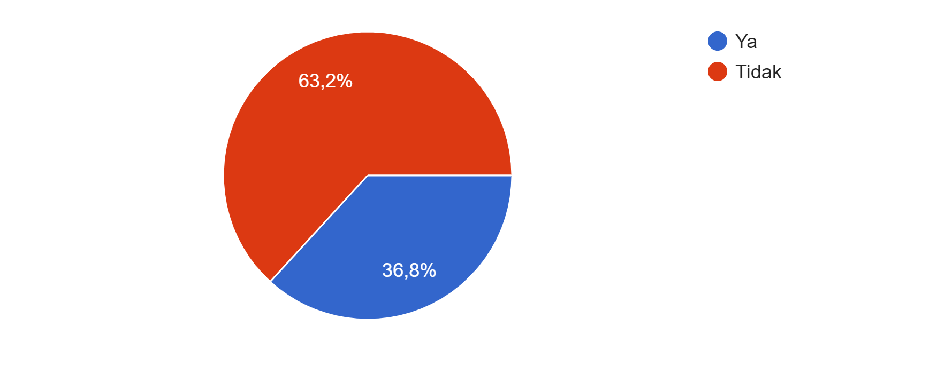
Fig. 2. Following Political Account/Political Party Account on Social Media

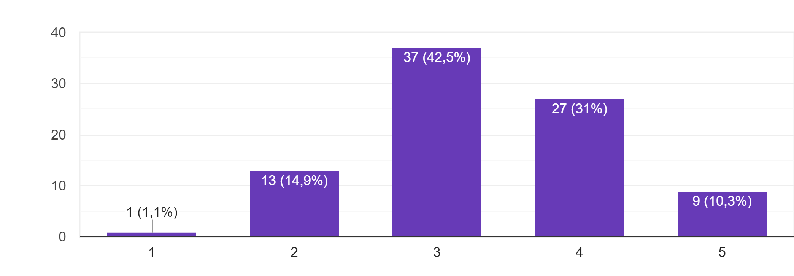
Fig. 3. How Important is Politics to You?

In term of using social media, respondents tend to not to follow account something to do with politics, whether its political account or political party account with 63,2%. The rest 36,8% in the other hand follow something that has to do with politics. When it comes to assess the important of politics to them, Likert scale are used with value (1= very not important, 5= very important). It looks that politics is quite significant to them where almost respondent’s response are 3 and 4 respectively 42,5% and 31%. 81,6% of the respondents then claim has been exposed to political ads during their time spend on social media.

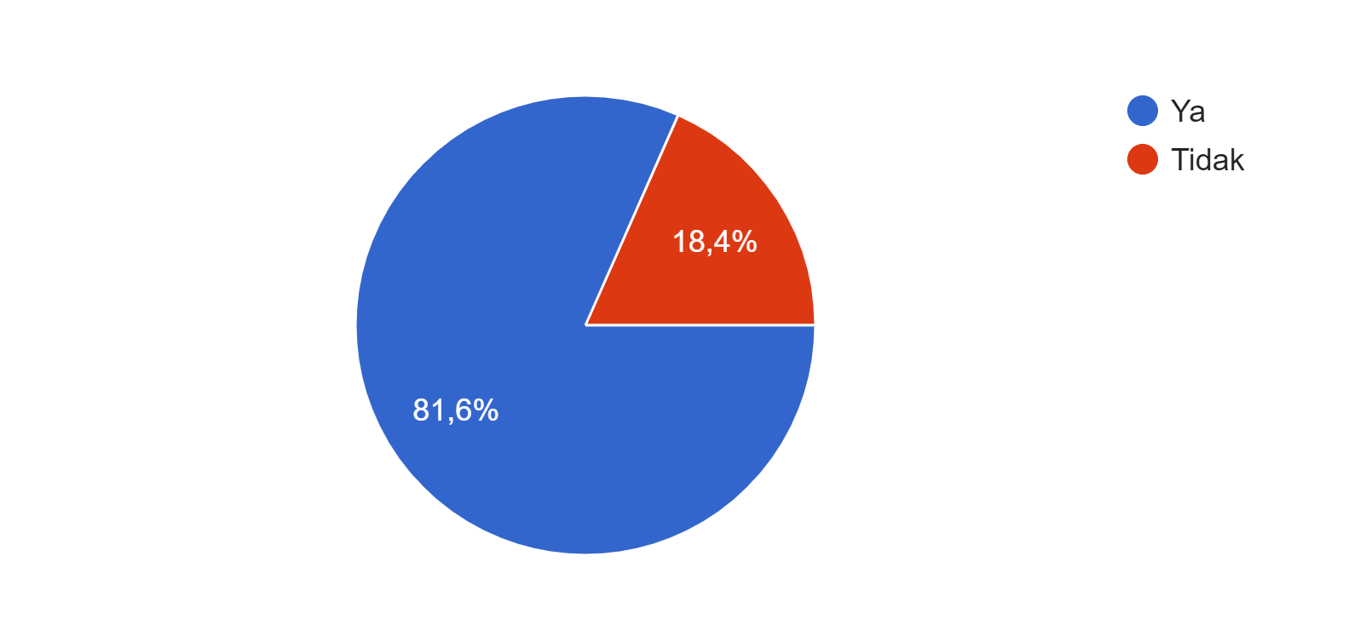

Fig. 4. Have you ever seen a political ad / political party on your social media feeds?

Partai Berkarya and Ads

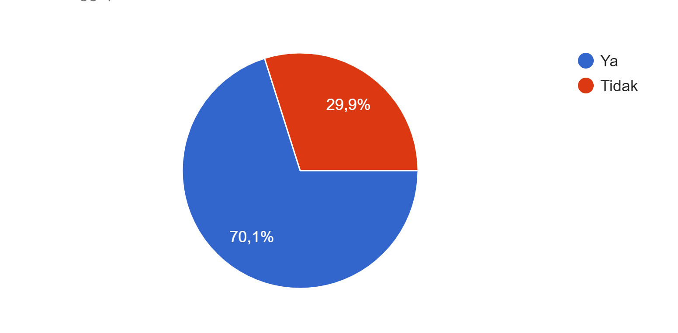
Fig. 5. Do you know Partai Berkarya?

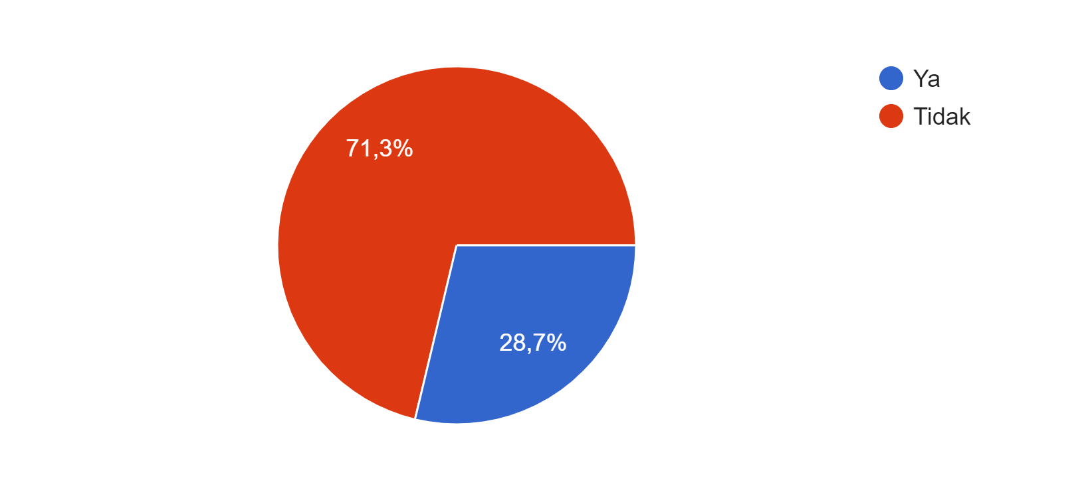
Fig. 6. Have you ever seen Partai Berkarya ads on social media?

Figure 5 and 6 describe more about Partai Berkarya in the mind of the respondents. It turns out that 70,1% of them know the party compare to 29,9% that does not know. Many of the respondents as much as 71,3% states never seen Partai Berkarya ads on their social media and only 28,7% reveal they have seen the ads on social media. Furthermore table 8 tell us where on social media they have seen the ads. While 41,84% claim never seen the ads on social media, the ads itself still can be seen on Instagram as much as 22,44%, YouTube 14,28%, Twitter 11,22% and Facebook 10,20%. If it sums there are 58,14% ads of Partai Berkarya on the social media distribute in four social media platform mentioned above.

Table 8. Where on social media have you seen the advertisements of Partai Berkarya?
Social Media Platform | Total Respondent | Percentage (%)
Facebook | 10 | 10,20
YouTube | 14 | 14,28
Twitter | 11 | 11,22
Instagram | 22 | 22,44
Never seen | 41 | 41,83
Total | 98 | 100

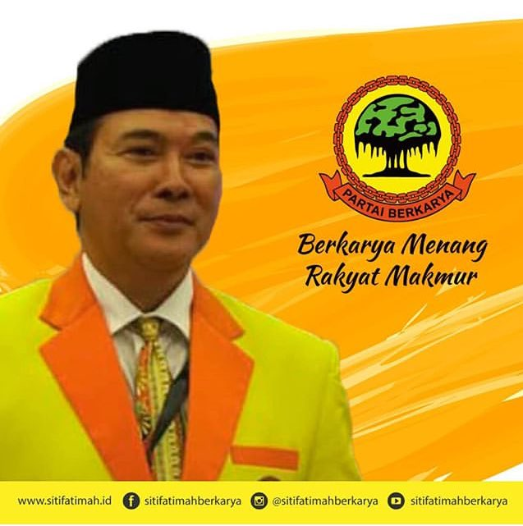
Fig. 7. Partai Berkarya Ads on Facebook
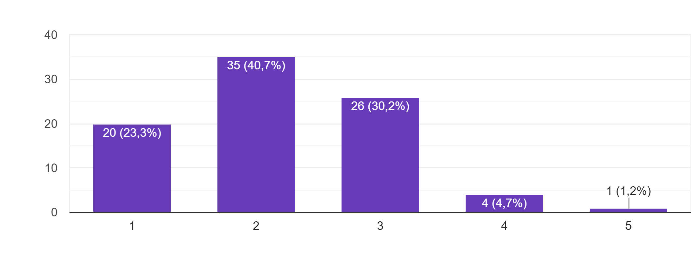
Figure 7 suggests the valuation of the respondents toward attractiveness of the ads, particularly on Facebook ads. The valuation itself use Likert scale to measure the attractiveness (1= very unattractive, 5= very attractive). The result shows that the Facebook ads of Partai Berkarya considered unattractive with response 1 and 2 jointly together form 64% of unattractiveness valuation toward Partai Berkarya ads on Facebook.
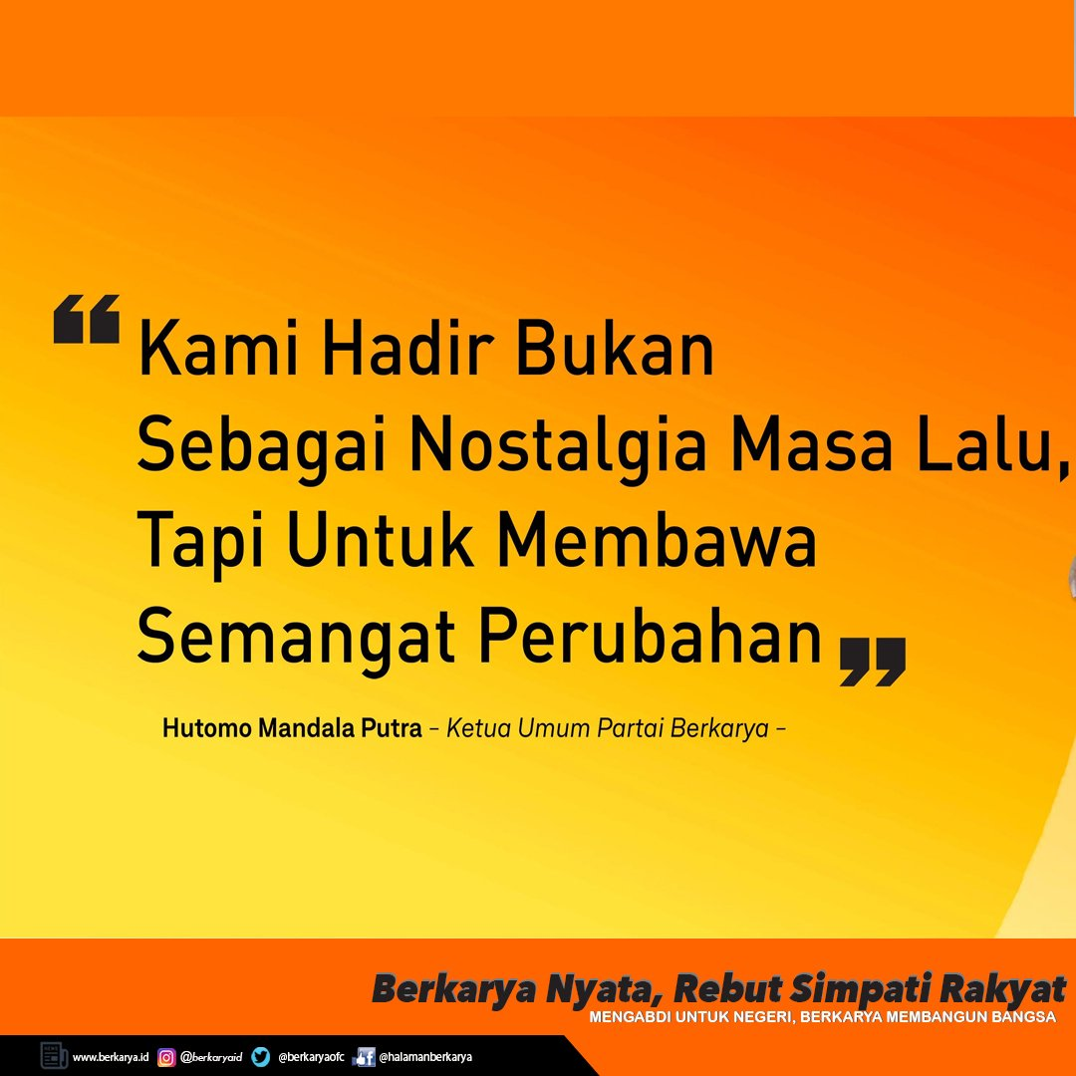
Fig. 8. Partai Berkarya Ads on Instagram 1
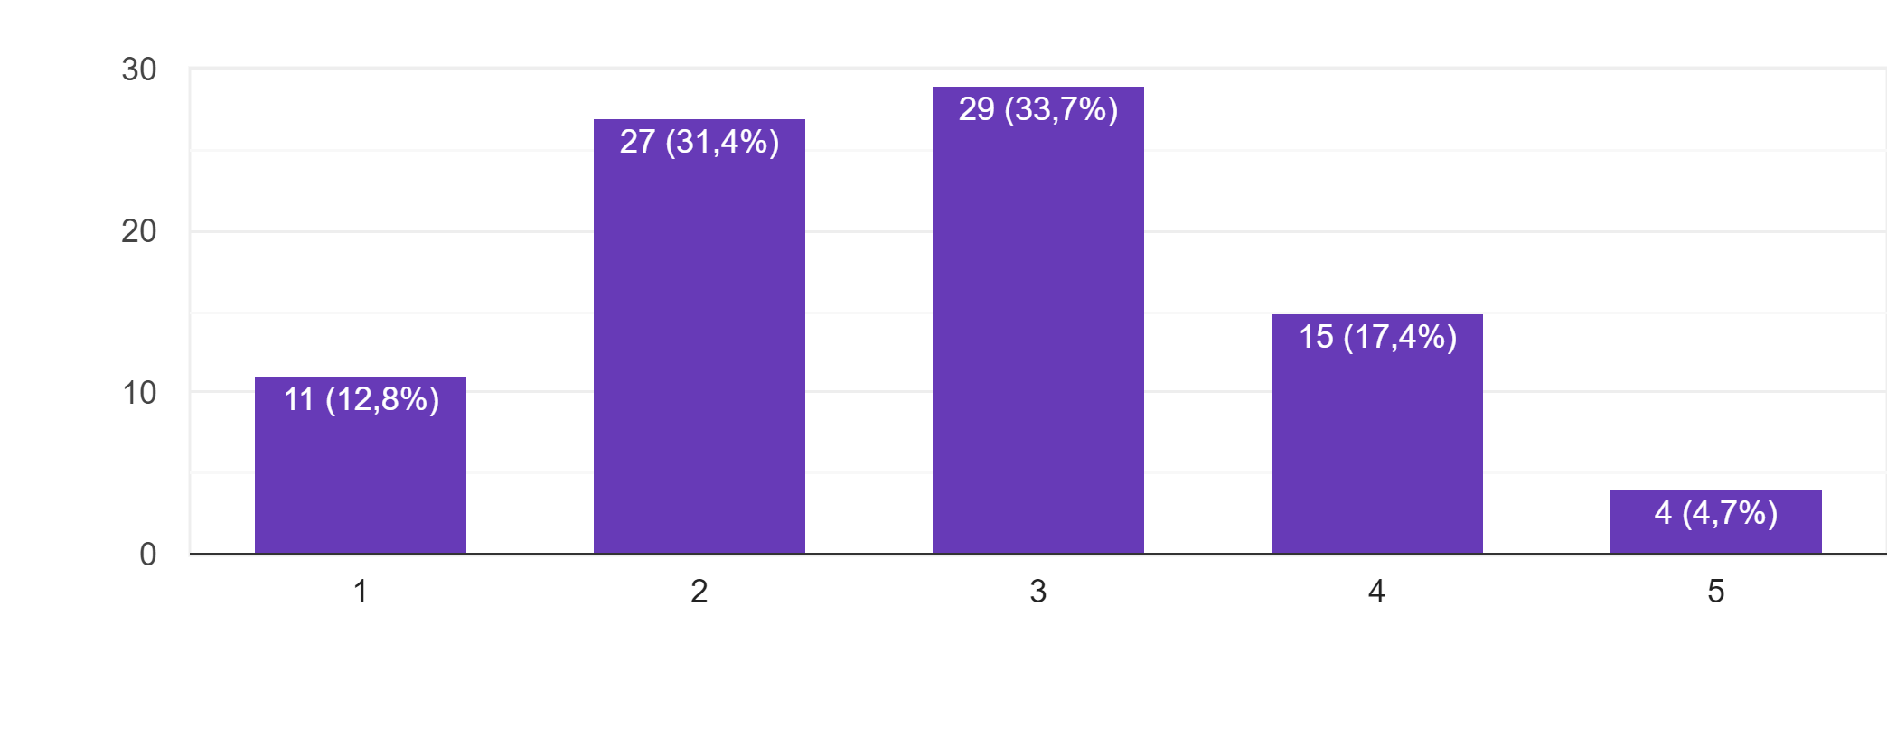
Figure 8 suggests the valuation of the respondents toward attractiveness of the ads, particularly on Instagram ads. The valuation itself use Likert scale to measure the attractiveness (1= very unattractive, 5= very attractive). The result shows that the Instagram ads of Partai Berkarya considered almost attractive with response 2 and 3 form a major significant number respectively 31,4% for response 2 and 33,7% for response 3. It has better valuation compared to the previous ads on Facebook even though it only present copy of words.

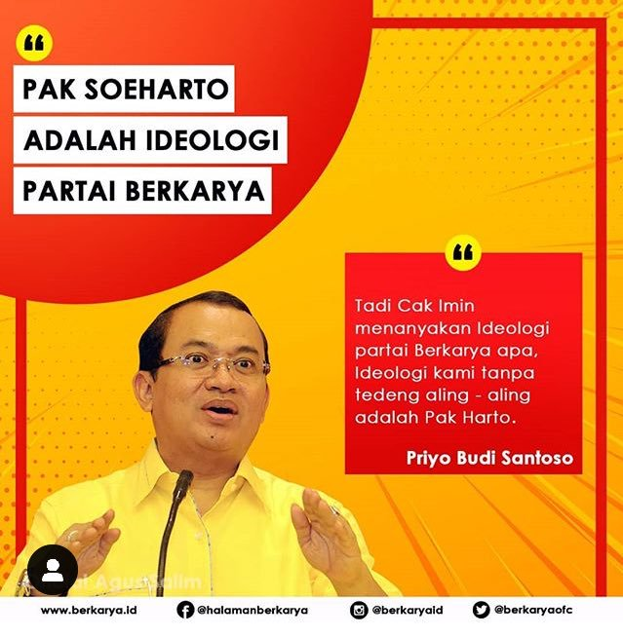
Fig. 9. Partai Berkarya Ads on Instagram 2
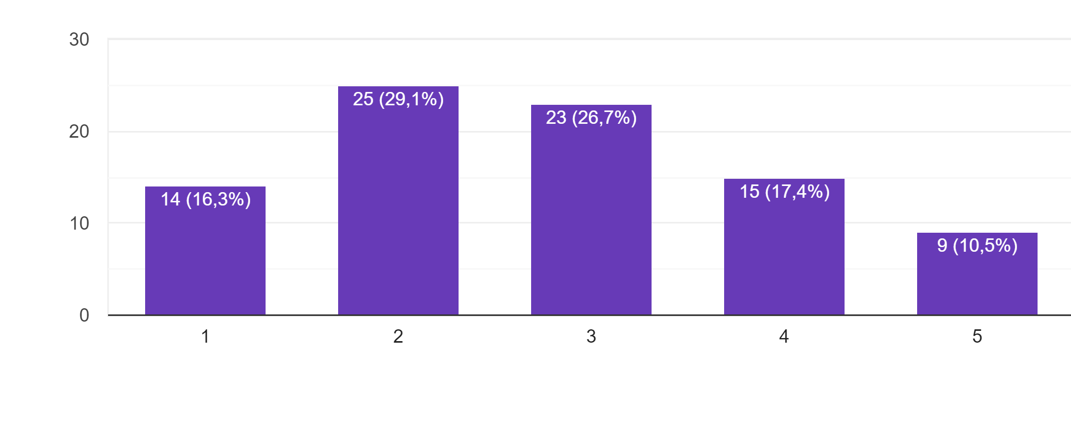

Figure 9 suggests the valuation of the respondents toward attractiveness of the ads, particularly on Instagram ads. The valuation itself use Likert scale to measure the attractiveness (1= very unattractive, 5= very attractive). The result shows that the Instagram ads of Partai Berkarya that contain quotes from another politician considered diverse where 16,3% assume it is very unattractive, 29,1% less unattractive, 26,7% indifferent, 17,4% less attractive and 10,5% very attractive. It has better valuation compared to the same ads on Instagram before when there is quotes from another politician involved.

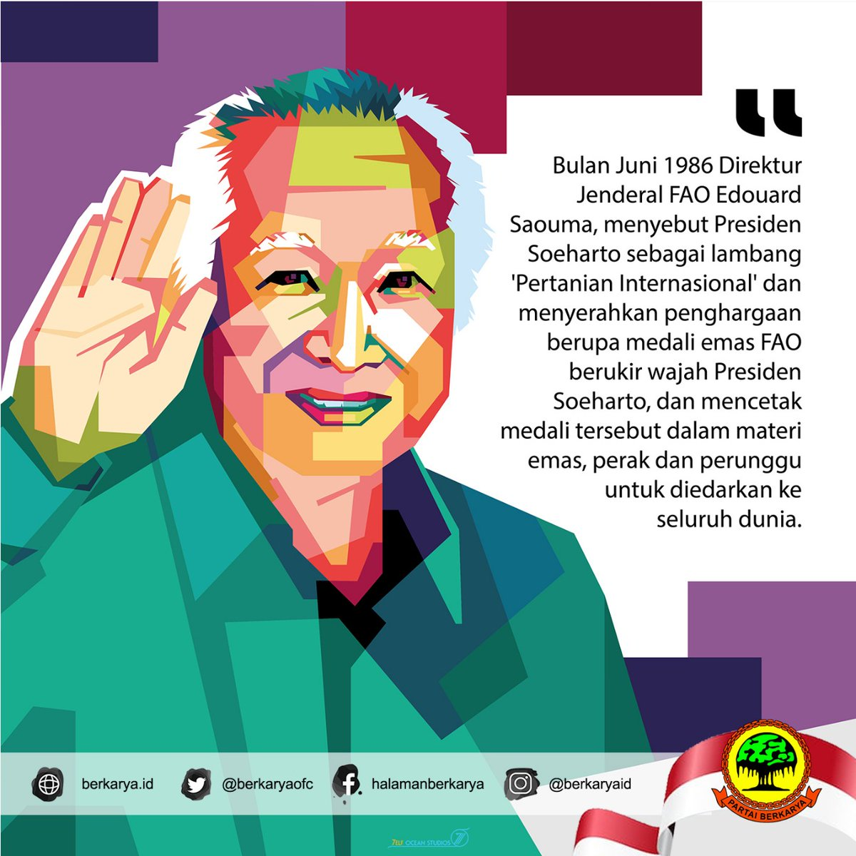

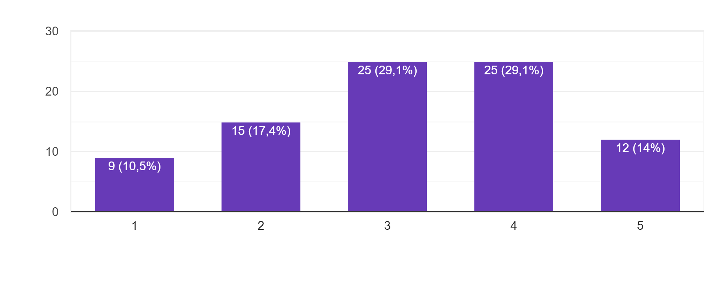
Fig. 10. Partai Berkarya Ads on Twitter

Figure 10 suggests the valuation of the respondents toward attractiveness of the ads, particularly on Twitter ads. The valuation itself use Likert scale to measure the attractiveness (1= very unattractive, 5= very attractive). The result shows that the Twitter ads of Partai Berkarya that made using WPAP illustration technique tend to consider as attractive where 43,1% jointly form less attractive and very attractive responses followed with 29,1% assume it indifferently. It has better valuation to the respondents where its design meets the state of the art in the eyes of beginner voters’ taste.

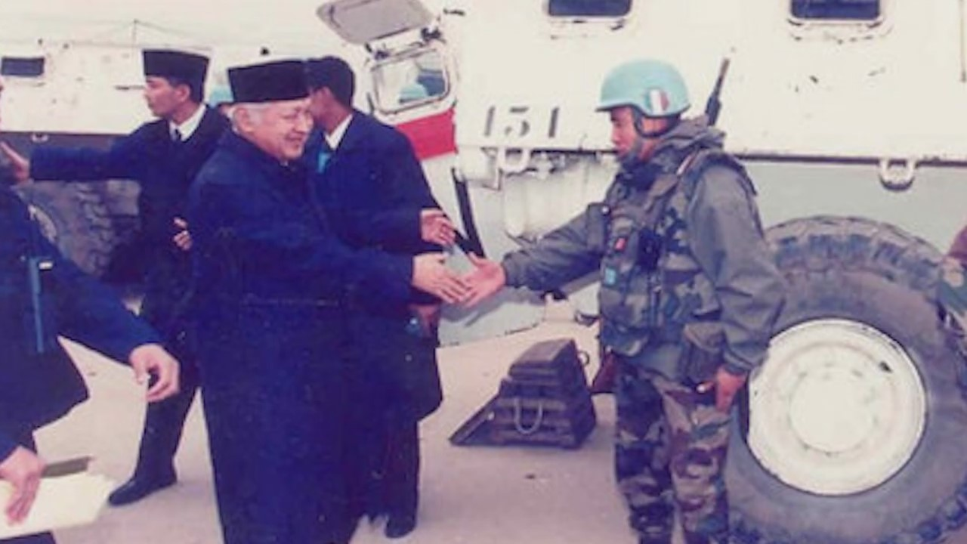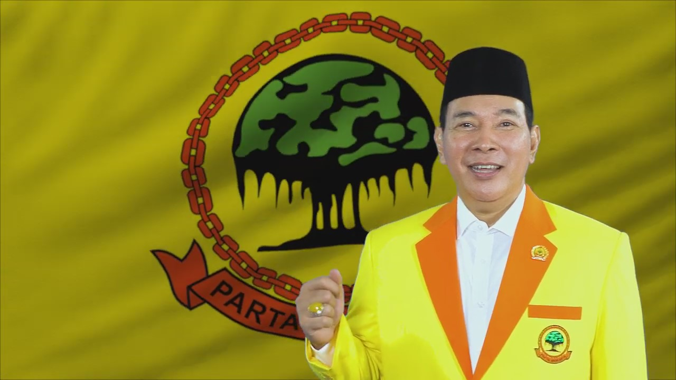
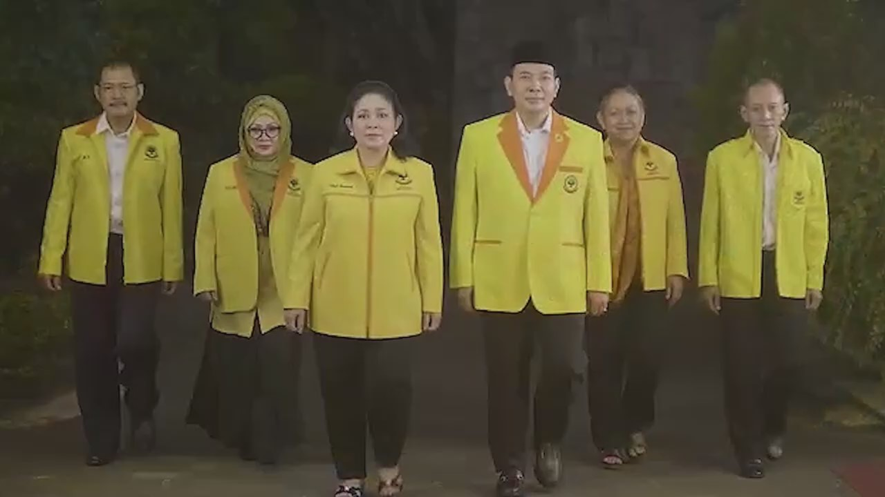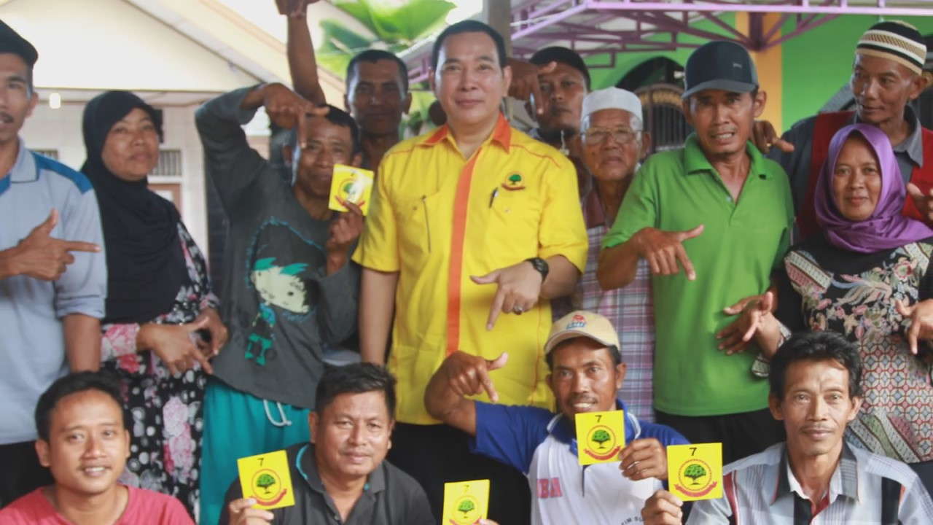
Fig. 11. Partai Berkarya Ads on YouTube (sequences)
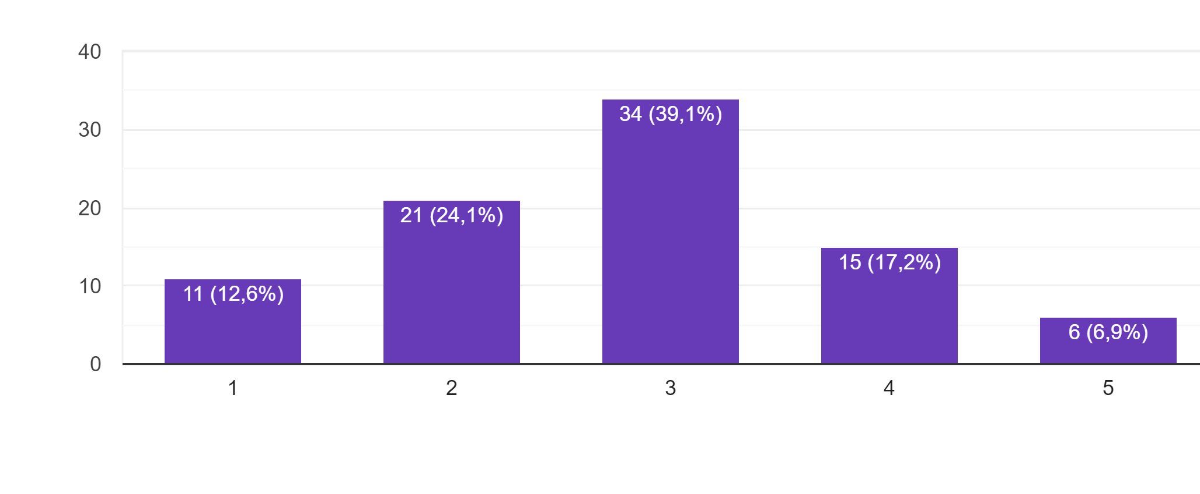
Figure 11 suggests the valuation of the respondents toward attractiveness of the ads, particularly on YouTube ads. The valuation itself use Likert scale to measure the attractiveness (1= very unattractive, 5= very attractive). The result shows that the YouTube ads of Partai Berkarya that contain story of the new order value and its greatness up to the probation of Suharto’s family back to the politics tend to consider as unattractive where 36,7% jointly form very unattractive and less attractive responses followed with 39,5% assume it indifferently. The ads seem to be not appealed in the eyes of beginner voters when it backs to the glorify new order era.

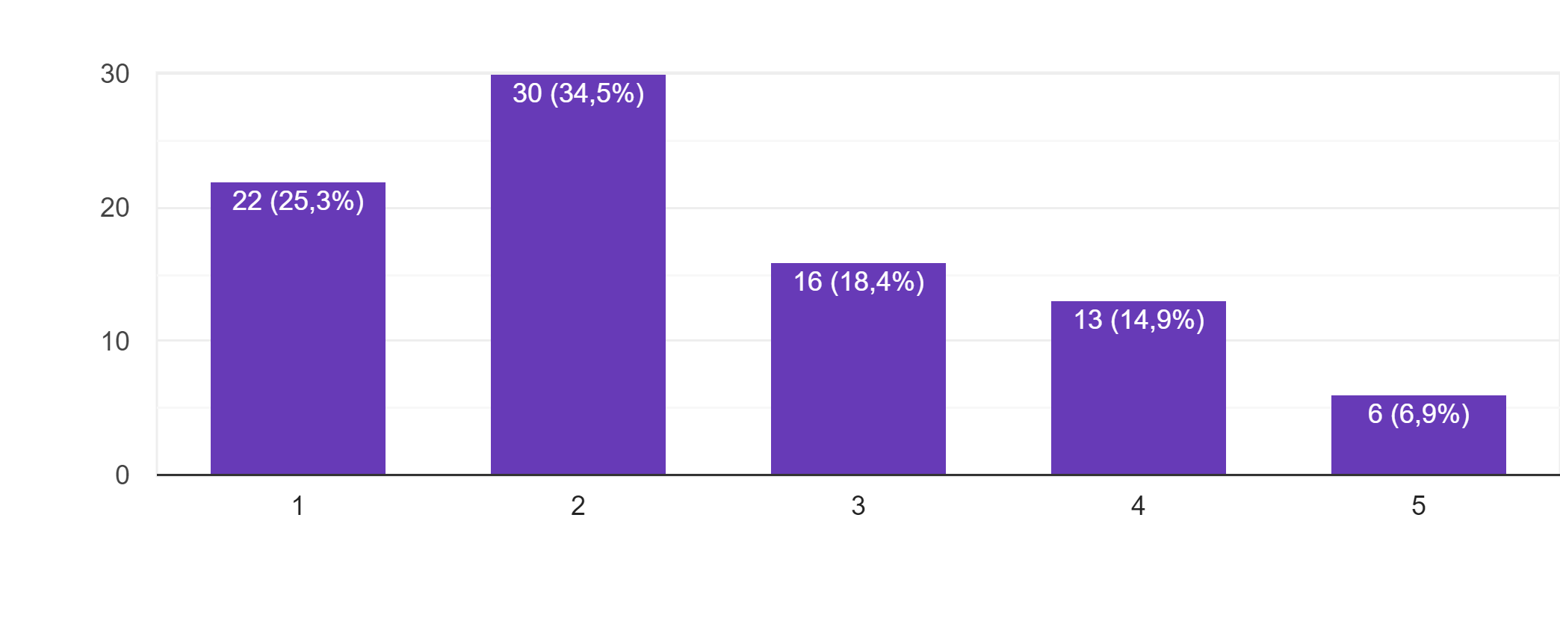
Fig. 12. Willingness to Comment on Partai Berkarya Ads

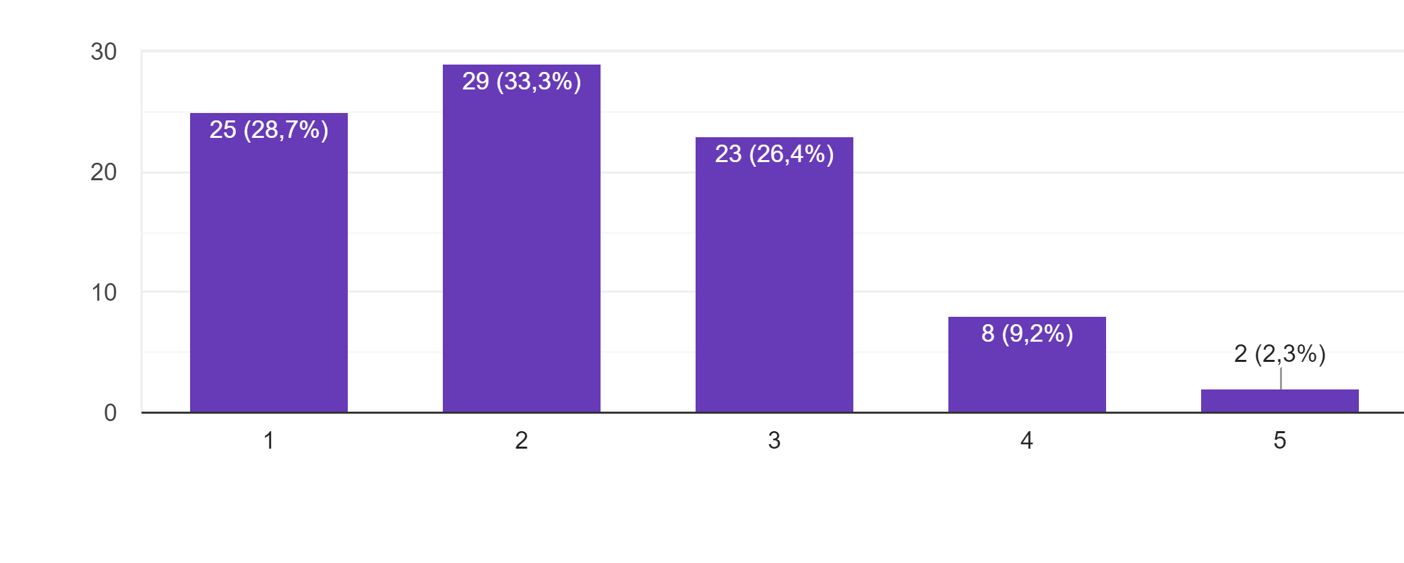
Fig. 13. Willingness to Like/Love on Partai Berkarya Ads?

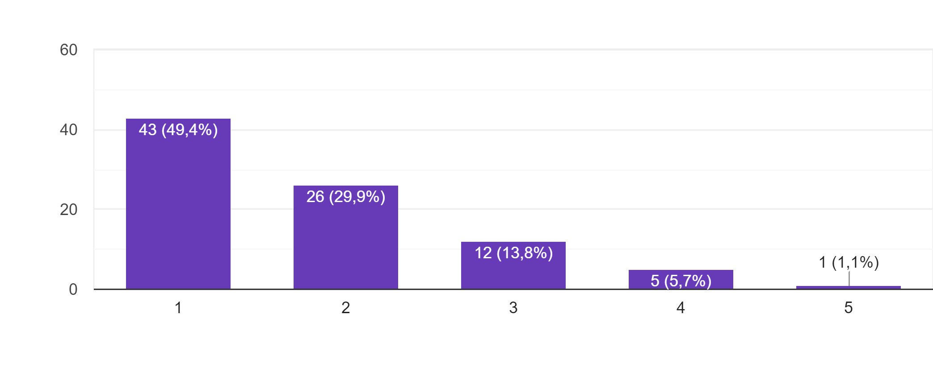
Fig. 14. Willingness to Share on Partai Berkarya Ads
Figure 12, 13 and 14 sequentially describes the willingness beginner voters to comment, like/love and share content of Partai Berkarya ads on their social media. It suggests the valuation of the respondents toward the willingness to comment, like/love and share the ads content. The valuation itself use Likert scale to measure the attractiveness (1= absolute no, 5= absolute yes). The result shows that the willingness behaviour to comment, like/love and share content of Partai Berkarya ads amongst beginner voters tend to consider as negative result where 59,8% respondent aspire not to give a comment on the ads, 62% not to give a like/love on the ads, and 79,3% will not to share the ads on their social media. Beginner voters seem to form a negative behaviour when it comes to the attitude of using social media such as; comment, like/love, and share the content of the Partai Berkarya ads.

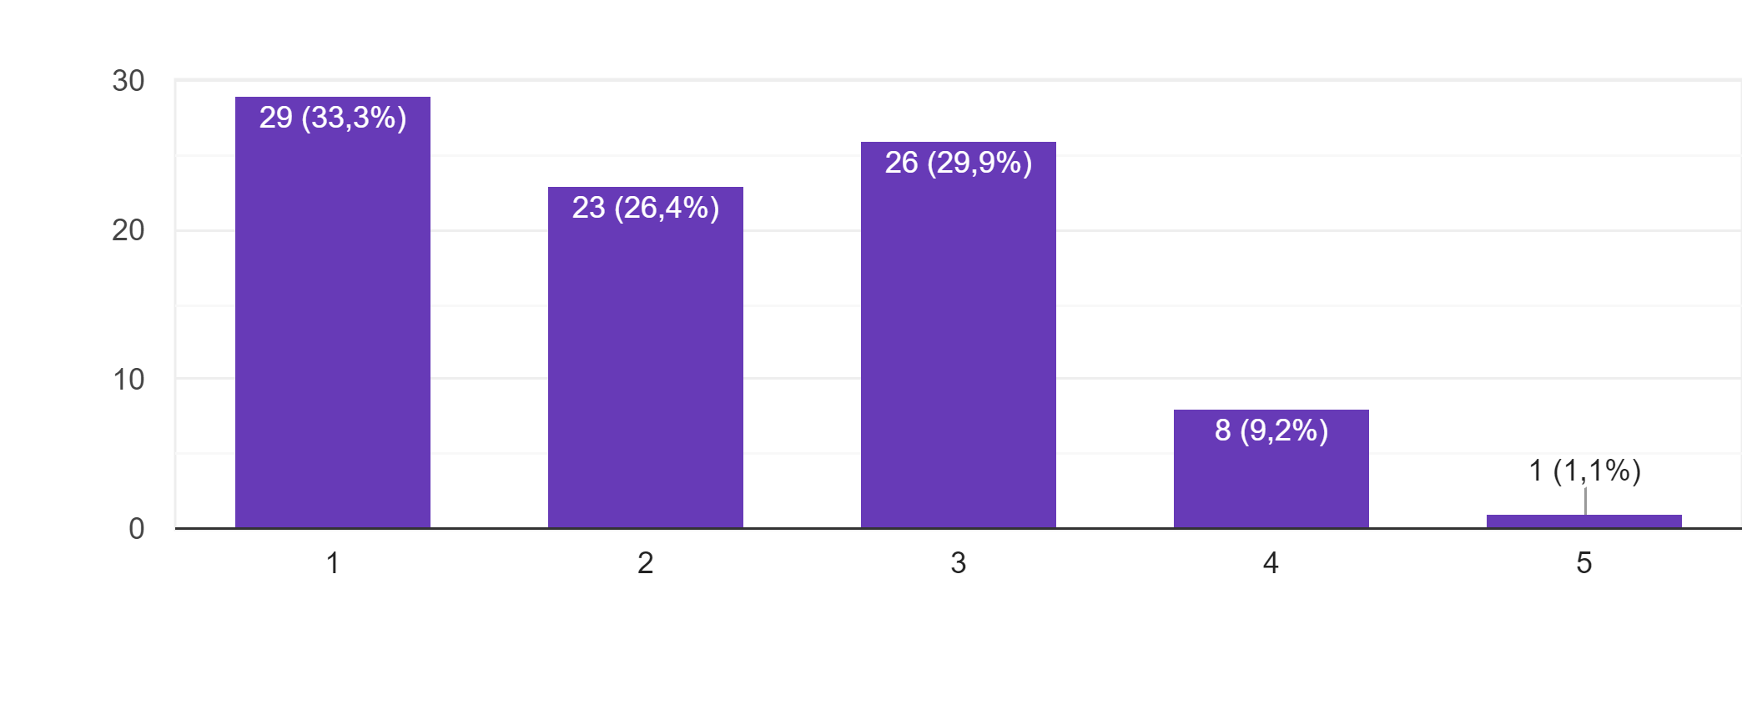
Fig. 15. Willingness to Vote on Partai Berkarya at 2019 Election?

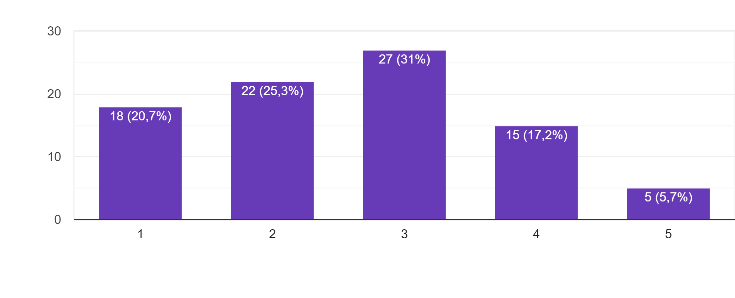
Fig. 16. Creativeness and Novelty of Partai Berkarya Ads
Figure 15 and 16 sequentially describes the willingness beginner give a vote on Partai Berkarya at 2019 election and the perspective of creativeness of Partai Berkarya ads on beginner voters. It suggests the valuation of the respondents toward the willingness to give a vote and consideration of ads creativeness. The valuation itself use Likert scale to measure the acceptance (1= absolute no, 5= absolute yes). The result shows that the willingness of beginner voters to give a vote for Partai Berkarya in the 2019 election tend to consider as negative result where 59,7% respondent aspire not to give a vote for Partai Berkarya at the election and 46% of them found that the ads are considered not creative and less novelty. Beginner voters seem not to give a vote for Partai Berkarya although some of its ads are considered attractive to beginner voters like in Twitter.

The New Order Value
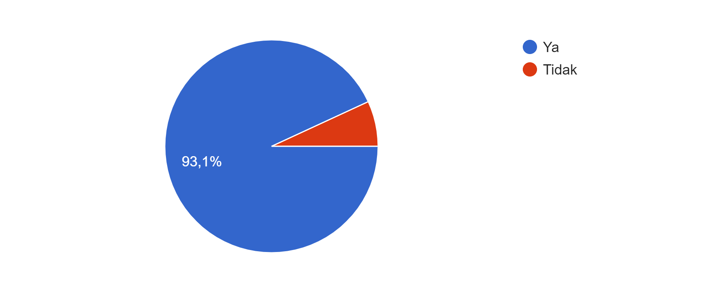
Fig. 17. Do You Know the New Order?

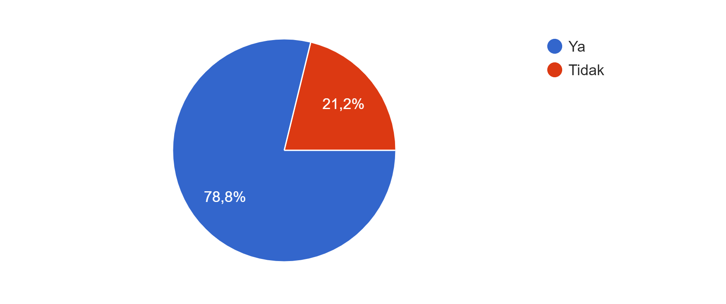
Fig. 18. High Willingness to Know the New Order
Figure 17 and 18 sequentially describes more about the new order value amongst beginner voters. It shows that 93,1% of the respondent claim to know the new order and 78,8% aspire to know more about the new order. Beginner voters seem to curious about new order since it has to do with political and the future of the country.

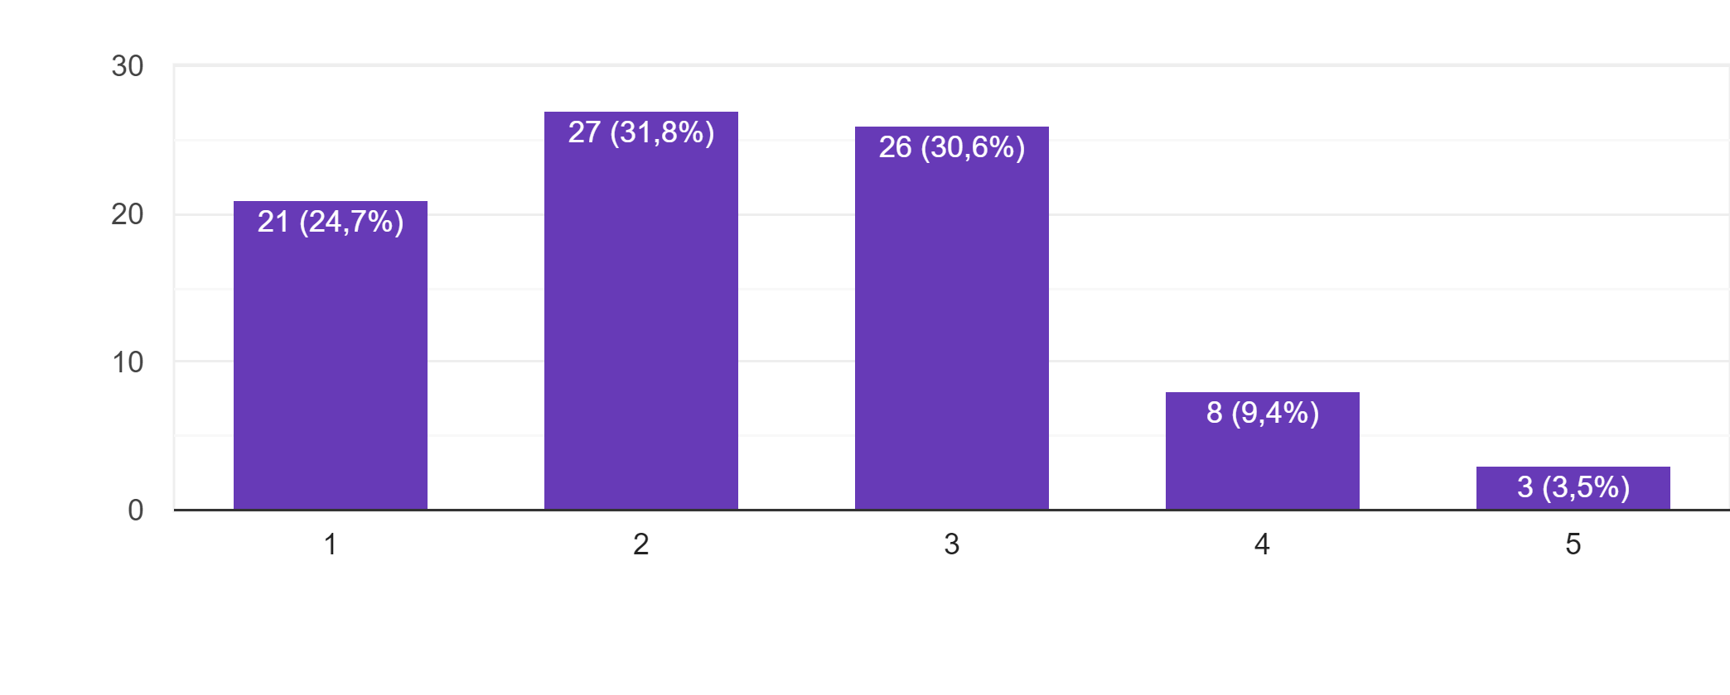
Fig. 19. Do You Support New Order Value in Partai Berkarya?

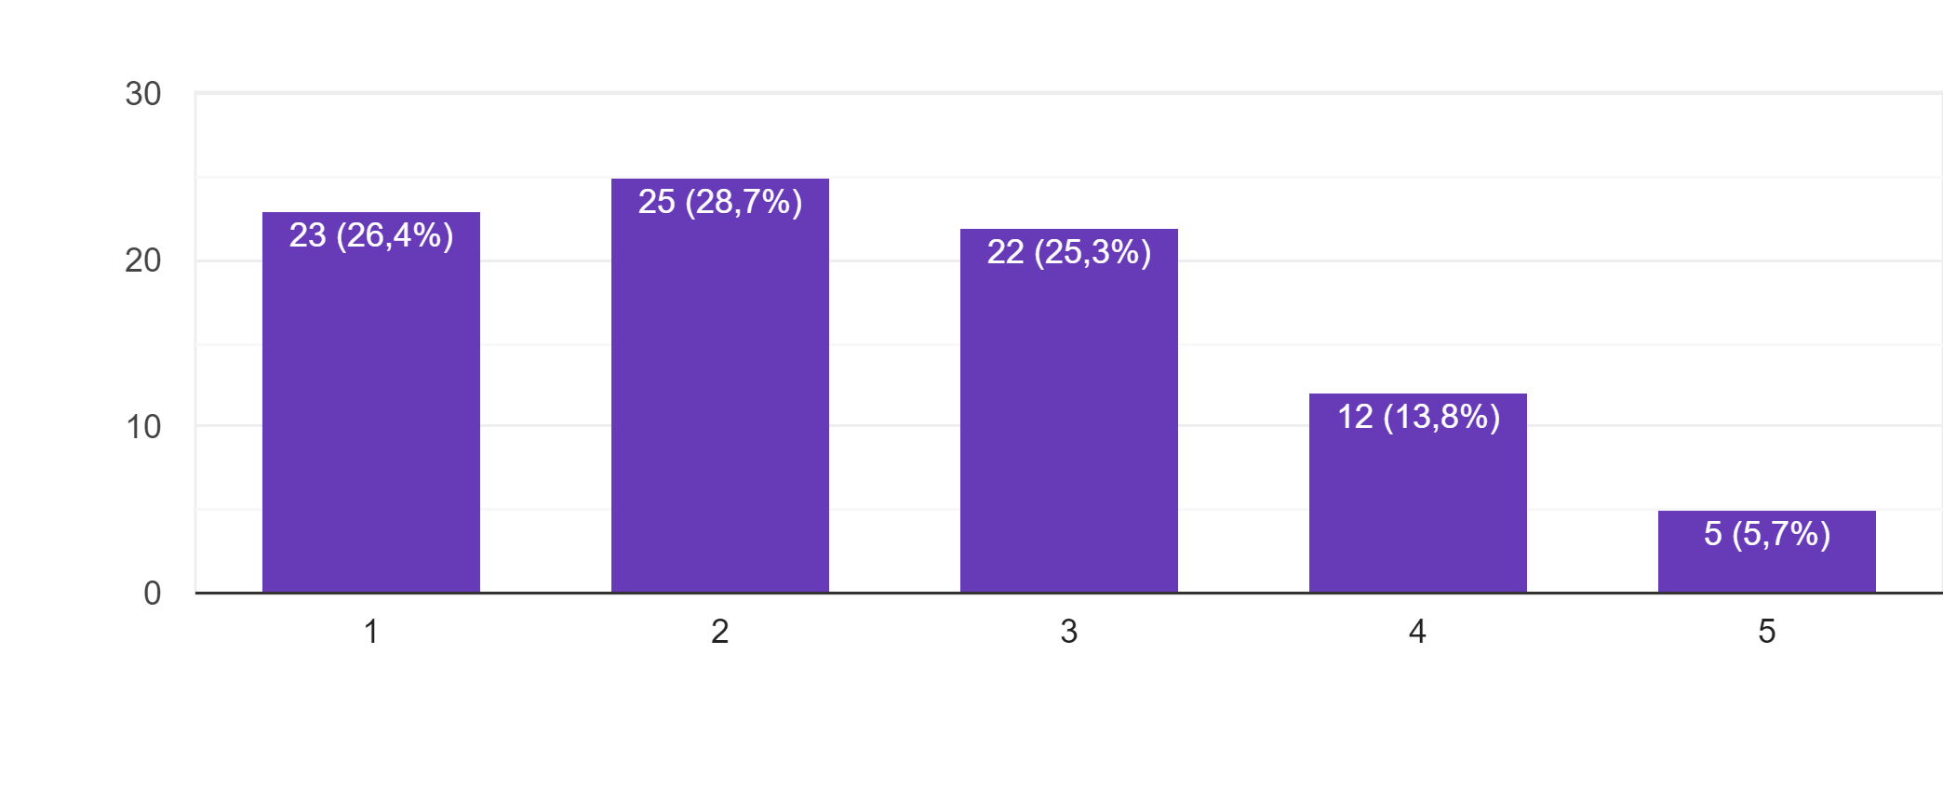
Fig. 20. Do You Believe Indonesia Will Get Back Its Greatness if Practicing New Order Value?
Figure 19 and 20 sequentially describes the attitude of beginner voters on supporting new order value in Partai Berkarya and their point of view on the discourse to get back to practicing new order value today situation. It suggests the valuation of the respondents toward the attitude of supporting new order value particularly in Partai Berkarya and personal point of view on practicing new order value on current political situation. The valuation itself use Likert scale to measure the acceptances (1= absolute no, 5= absolute yes). The result shows that the acceptance of beginner voters to support new order value in Partai Berkarya is consider as negative result where 56,5% respondent aspire not to support new order value in Partai Berkarya and 55,1% of them believe that practicing back new order value to the current situation is not good for Indonesia and lead to the backward.
4.2 Conclusion
Beginner voters look to act negatively towards political advertisement and political marketing of Partai Berkaya which relies heavily on the new order values. All new order values and figures in Partai Berkaya seem does not contribute much to the political marketing of the party. The communication model that distribute evenly to social media platform such as Facebook, Instagram, Twitter and YouTube fail to convey the political message that lies throughout political ads in the social media targeting to the beginner voters. The idea to introduce the party to the public at once gaining beginner voters such Deputy Secretary General of Partai Berkarya, Arifin (2019) once said seem to unsuccessful.
Beginner voters hold their own value which look very different to the value Partai Berkarya has proposed throughout their message in political ads in social media. The social norm of beginner voters seems react differently to the norm build by Partai Berkarya, thus the conversation in the social media of Partai Berkarya assumed insignificant when it comes to the willingness of coment, likeability content and sharing the content in the social media. The personality of the Partai Berkarya leader also plays a pivotal part as Lasswell communication model says “who says what in which channel to whom with what effect”, hereupon the key message delivered by all the leaders (Suharto family) in social media in aiming beginner voters do not contribute positively to the result since the effect to the beginner voters do not shift much after exposure by Partai Berkarya ads. We may assume that beginner voters form their attitude even without adequate knowledge but from the point of view political marketing it is clearly that Partai Berkarya fail to recreate a persuasive information of new order throughout ads in social media in order to gain support and vote from the beginner voters.
References
A.A. Alalwan et al., Social media in marketing: A review and analysis of the existing Literature, Telematics and Informatics 34 (2017) 1177–1190
Aaron Gazley et.al., Like it or not: differences in advertising likeability and dislikeability within Asia, Asia Pacific Journal of Marketing and Logistics Vol. 24 No. 1, 2012 pp. 23-40
Anders C. Johansson, Social Media and Politics in Indonesia, Stockholm School of Economics Asia (2016) Working Paper No. 42
Andrew O. Ballard, et.al., Campaigning Online: Web Display Ads in the 2012 Presidential Campaign, American Political Science Association (2016), pp. 414-419
Arthur Beckman, The Journal of Political Philosophy: Volume 26, Number 1, 2018, pp. 24–46.
Cristian Andrei (2018) The Political Marketing of Broken Trust, Journal of Political Marketing, 17:2, 176-192, DOI: 10.1080/15377857.2018.1447764
David E. Broockman and Donald P. Green Polit Behav, Do Online Advertisements Increase Political Candidates’ Name Recognition or Favorability? Evidence from Randomized Field Experiments, (2014) 36:263–289
Douglas Guilbeault, Digital Marketing in the Disinformation Age, Journal of International Affairs, Vol. 71, No. 1.5, Special Issue: Contentious Narratives: Digital Technology and The Attack On Liberal Democratic Norms (2018), pp. 33-42
Esther David et al., Utilizing Facebook pages of the political parties to automatically predict the political orientation of Facebook users, Emerald Insight (2016) Vol. 40 No. 5 pp. 610-623
J.-K. Hsieh et al. Exploring the disseminating behaviors of eWOM marketing: persuasion in online video Jung-Kuei Hsieh · Yi-Ching Hsieh · Yu-Chien Tang Published online: Electron Commer Res (2012) 12:201–224
James Farr, Jacob S. Hacker and Nicole Kazee, Revisiting Lasswell, Policy Sciences, Vol. 41, No. 1 (Mar, 2008), pp. 21-32
Khaled A. Gad, The Impact of Political Advertising through Social Networking Sites on Egyptians’ Political Orientations and Choices, International Journal of Business and Social Research (IJBSR), Volume -4, No.-2, February, 2014
Kotler, Philip. 1972. A generic concept of marketing. The Journal of Marketing, 36, 46–54.
L.R. Sherrod et al., Youth’s political views and their experience of September 11, 2001, Applied Developmental Psychology 25 (2004) 149–170
Lees-Marshment, Jennifer, Brian Conley, and Kenneth Cosgrove. 2014. US political marketing trends and implications. Pp. 289–305 in Jennifer Lees-Marshment, Brian Conley, and Kenneth Cosgrove, eds., Political Marketing in the United States. New York: Routledge.
Michail Vafeiadis, Ruobing Li & Fuyuan Shen (2018) Narratives in Political Advertising: An Analysis of the Political Advertisements in the 2014 Midterm Elections, Journal of Broadcasting & Electronic Media, 62:2, 354-370, DOI: 10.1080/08838151.2018.1451858
N.F. Lund et al., The power of social media storytelling in destination branding, Journal of Destination Marketing & Management 8 (2018) 271–280
Paul A. Soukup, S.J., Political Communication, Communication Research Trends, Volume 33 (2014) NO. 2 — 3
R. Dawkins., Political participation, personality, and the conditional effect of campaign mobilization, Electoral Studies 45 (2017) 100-109
S. Russo, E. Amnå., When political talk translates into political action: The role of personality traits, Personality and Individual Differences 100 (2016) 126–130
Saleem et.al., Political Advertisements & Voters Behaviour in 2013 General Elections of Pakistan: Exposure vs Impact Analysis, JRSP, Vol. 52, No. 1, January-June, 2015.
Saiful Mujani and R. William Liddle, personalities, parties, and voters, Journal of Democracy Volume 21, Number 2 April 2010
Safiullah et.al., Social media as an upcoming tool for political marketing effectiveness, Asia Pacific Management Review 22, (2017), pp. 10-15
Samuel D. Bradley, James R. Angelini and Sungkyoung Lee, Psychophysiological and Memory Effects of Negative Political Ads: Aversive, Arousing,and Well Remembered, Journal of Advertising, Vol. 36, No. 4 (Winter, 2007), pp. 115-127
Scammell, Margaret. 2014. Consumer Democracy: The Marketing of Politics. New York: Cambridge University Press.
Terri L. Towner & David A. Dulio (2012) New Media and Political Marketing in the United States: 2012 and Beyond, Journal of Political Marketing, 11:1-2, 95-119, DOI: 10.1080/15377857.2012.642748
Thamaraiselvan Natarajan, et.al., Examining Beliefs Towards Social Media Advertisements Among Students and Working Professionals: An Application of Discriminant Analysis, Australian Journal of Basic and Applied Sciences, 7(8): 697-705, 2013
Wahyu PRASETYAWAN, Image Construction in Politics: Political Advertisement in the 2009 Indonesian Election, Sojourn: Journal of Social Issues in Southeast Asia, Vol. 27, No. 2 (October 2012),pp. 310-327
https://www.pdc.wa.gov/learn/publications/political-committee-instructions/political-advertising, access 31 July 2019, 16.05 pm
https://www.britannica.com/place/Indonesia/Indonesia-from-the-coup-to-the-end-of-the-New-Order#ref988582, access 30 July 2019, 15.55 pm

