The University Public Relations Unit Communication Strategy in Facing the 4.0 Era
Mareta Mdulidiyanti¹, Pijar Suciati² , Sri Rahayu³

¹Public Relations Studies, Vocational Education Program,
Universitas Indonesia
²Public Relations Studies, Vocational Education Program,
Universitas Indonesia
³Creative Advertising Studies, Vocational Education Program,
Universitas Indonesia

Abstract. Public relations is a strategic function in organization. The 4.0 technology era brings a lot of changes in public relations job. Public Relations in univeristy has a different character with other company. In the 4.0 era public relations should adapt with new media which is a user generated content. This paper will explain about the improvements of industry 4.0 and its impact to public relations roles especially for Public Relations in the university. Technology in 4.0 brings some opportunities to Public Relations to expand and improve their services to their public. As we know, Public relations have a responsibility o maintain corporate image and reputation. They should know how to utilize new tools. Their knowledge about technology are very important in this post human era. The failure to cope these challenges will result to the decrease of the university image and reputation. This paper explores how public relations in Universitas Indonesia (both the university & the faculty PR Officer/Head) can take benefit of the new tools. It will explain the requirements that make public relations take benefit from. In order to achieve the reasearch findings, descriptive method used in this paper. We explain the strategy of university PR and also its implementation in the faculties. The result is that PR in Universitas Indonesia has already tried to adapt and deal with the 3.0 technology. The tries to utilize social media monitoring and utilize Chabot to maintain relationship with public, maintain corporate image and reputation. All those tecnology will be function properly if we make a good workflow that serve the public’s needs. Finally, University PR practitioners should aware of this and prepare to utilize all technology to support they task everyday and correctly. Form the discussion we can conculde that PR practitionners in Universitas Indonesia has already tried to adapt to 4.0 era. Their effort can be seen from the shifting in the communication platform used and they actually do an evaluation of it. The improvement should be made on keyword manegement of Universitas Indonesia social media monitoring and chatbot.

Keywords: Public relations, PR in 4.0 Era. Technology for Public Relations, chatbot, social media monitoring
1 Introduction
Public relations is a strategic communication process that builds mutually beneficial relationships between organizations and their publics [1]. The definitions meand shows that Public Relations is a management function that is responsible for building good relations and image with its public. In communication, the key to create and effective, efficient and mutual understanding is the function of public relations. Effective means the results meet/match the expectation while efficient means achieving goals with the minimal cost, time and personnel. The Newcomb’ ABX Model explained that a communication process will run smoothly if booth parties have the same understanding of an object. If the understanding is not the same or the opposite, then the communication links beetween two sides will no be harmonious and effective [2]

PR in university or higher education has different character with PR in other industries. The are a uniques ways and challenges for university PR professional although the the fundamentals of public relations at colleges and universities are similar to those at other organizations and company. In university has a wide range topic from many faculties, so it makes PR should understand every of the faculty perspective and contribution in the field of expertise. Piers on Pijar Suciati 2017 said making time to meet in advance and stay in touch regularly ensures everyone is better prepared for breaking news opportunities [3]

In the previous study said that in Indonesia almost all Public Relations officials from Public Relations in State Universities complained about the not optimal role and function as a manager of communication and information to the public. The complaints are also come from the meetings held by the Public Relations Association of Indonesia (Perhumas) and the Government Public Relations Coordination Agency (Bakohumas).

However. Today world is welcoming the period of sophisticated technology known as the industrial era 4.0. Technology is projected to dominate all human life’s aspec. Revolution technological concept and internet based communication will happend in this era. Human will be able to communicate via the internet that allows interaction and information exchange. Futhermore, the information exhange not only between human and humans, and humans to machine but also between machines themselves [4]
Industry 4.0 has four main components that are Cyber-physical systems (connections between the real world and virtual world), Internet of Things (IoT), Internet of Services (IoS) and Smart-factories [5]. In the last several years behind public relations need to improve into two ways comversation in the social media, website and chatbot.
social media does not feel personal to customer. So some public relations choose chatbots to becomes an option to make customer engagement, which one is a public relations role. The main research question is “What strategy that university public relations takes to face the 4.0 era?
2 . Literature Review
A. Public Relations in University

As we know, PR refers their work to the institution’s mission and vision. PR building plans that connect the university’s goals with the needs and interests of the public [3]. Public relations are connectors, and trusted partners, deep listeners and strong advocates. They work and stand for something, both at the decision-making side and they also representing the university to the public [6].

Some literature shows that university or higher education public relations practitioners/officers do not fully understand their roles [7,8]. Hale said there is possibility of why this condition result of role conflict or role ambiguity with the emergence of higher education/university marketing, branding and advertising trends and strategies (Hale, 2001). Experts in the field argue that public relations officers will be able to achieve a “seat at the table” where they can influence stakeholder relationships when they perform both roles. Public relations shoudl implement the managerial role in such a way that top management will understand their value and demand it when making organizational decisions [9]

B. Revolution Technology to 4.0 Stage in Public Relations

In public relations, we can divide this industrial evolution into division according to industry 1.0 to 4.0 [12]
- In industry 1.0
In 1,0 era, public relations rely on the mass production of newspaper lines. They send their news release to the mass media office such as television, radio, newspaper to give the information (oneway). They also make a campaign and distribute to the mass media. to achieve their goals in serving the stakeholders. In 1.0 era, public relations implementing the one-way communications or calles as One to Many communication. Public relations can reach a lot of attention from their campaign or news releases through mass media.
- In industry 2.0
Public relations in this era realize that they cannot make a generic news release to get public attention from all stakeholders. They start to think that they have to reach the customer in various ways. Start in this era, public relations do a stakeholder mapping and compose their writings in specific way. It is because every stakeholder need unique treatment and special communication from public relations.
- In industry 3.0
When the 3.0 era was comming, public relations facing the global change of the information. Stakeholder do not talk anymore to the corporate or public relations, they talk through the internet.People talks each other via the social media platform such as Facebook, Instagram, Twitter, etc. Social media are being utilized on an ever-increasing basis by corporations and other organizations. Most of companies and isntitutions are using social networking sites. [10] With social networking sites we can a space to interact with key publics and to allow them to engage each other on topics of mutual interest. Public relations can post organization profile frequently via some aplications that provide photos of event, video and many other file categories to engage the stakeholders into dialog communication.
Jo and Kim (2003) [11] in Binsar (2018) [12] found that interactivity and multimedia-oriented Web sites have a significant positive effect on relationship building and reputation, especially when that interactivity is high. Public relations should pay attention to the quality and credibility of information eventhough online public relations will save money and time because those two aspects are the most important aspect in regards to relationship building [11]
- In Industry 4.0
It is the era of using the Internet of Things (IoT) and Internet of Service to reach their stakeholders. Machine will be able to show a learning improves so machine can handle many tasks including public relations tasks. It impacts public relations roles in many ways. Public relations in university faces the new generation that we called millennials. The fast growth of the social media makes word of mouth (WOM) process no longger from people mouth in the real world but WOM is happened in the internet world. Today, PR in university is responsible for developing interactive communication channel emerged untill providing the conseling, making communication policy decisions, evaluating program results, and planning public relations programs [13]

C. Public Relations & Communication Strategy

Public Relations (PR) is always related with the effort in creating public understanding through knowledge. PR is a communication process that is applicable to all types of organizations in both the commercial and non-commercial, public sector (government) and private sector [14]. Public relations is an effort that is planned and sustainable for creating, maintaining a goodwill and mutual understanding between an organization and its public.

Communication Strategy is a combinantion of a communication plan and communication management to achieve corporate image goals [15]. Communication program should answer “Who Says What in What Channel To Whom With What Effect?”

However, every type of company develop the different contribution of communication management strategy[16]. Botan [2] called a company strategy as a “Grand Strategy" while "Strategy" is positioned at the level of execution /policy campaign.
3 . Methodology
This is a despriptive research where the variable indicator is the answers to the verbal or written question. According to Neuman [17], descriptive research can give us a complete picture about the situation, social phenomenon and a relationship. This metdologhy provide us a possibility to examine only one variable or more [18]

Qualitative approach with case study is used in this research. Qualitative reaseacrh implement based on natural condition to collect data from informant without any introversion [19]. The result of this qualitative research could be applied to the similar situations and circumstances [20]. This reseacrh use case study strategy. Case study needs an intensive research, use some data sources and limited by time and research location. The case could be an organization, group of people, community, phenomenon, proces, issues and campaign program [21].

The primary data collection were conducted in qualitative approach, which involved interview methods with Universitas Indonesia Public Relationss. We involve media relations officer, protocol head and one of faculty PR member. Whereas, the interview scope is all about how the PR prepare for the 4.0 era, what kind of program they learn to run to face this revolution industry.

A qualitative content analysis was chosen to analyse the interview result through a text. Content analysis is a technique that use in compressing large amounts of data from the interviews, field notes, and various types of sources into systematic and fewer categories of text which is based on specific rules of coding [22]. Previous studies have already shown that content analysis is a very useful method for researcher to discover and describe the focus of individual, group, institutional, or social attention (Weber, 1990). This research placed a content analysis as a crucial process which is categorising some key words from the given texts into certain themes.

4. RESULT & CONCLUSION
There are 2 big UI PR activities that in line with 4.0 characteristic. This findings comes from in depth interview with 3 interviewees that consist of 2 university’s PR practitioners
- Chatbot on Website
Chatbot application has been implemented by one of the faculties at UI, Vocational Education Program. The Vocational Education Prgram Public Relations provide chatbot on their website to make a two ways communication with their public.

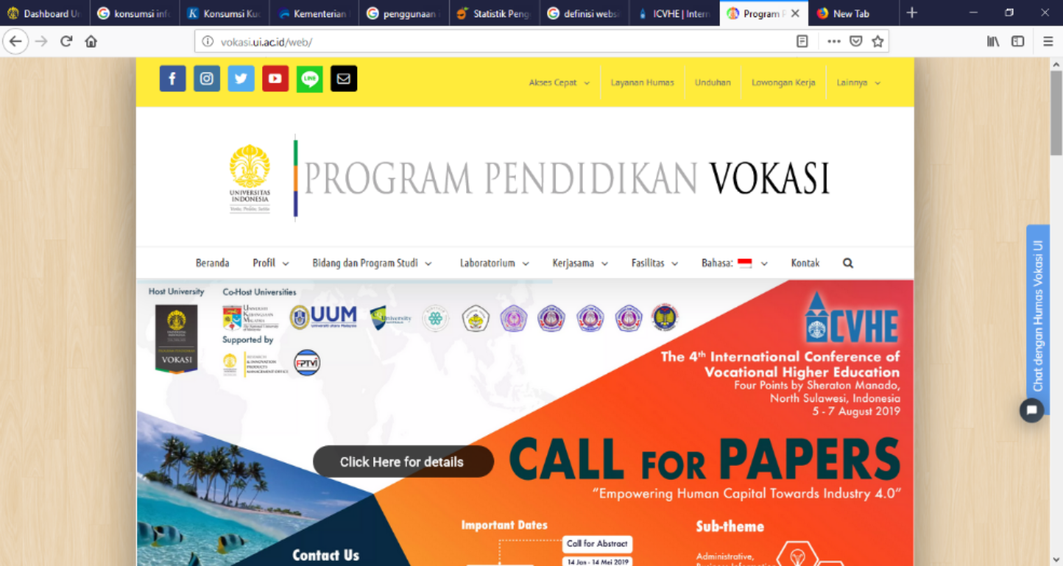

Picture 4.1 Chatbot on Website
The chatbot can gather and answer the web visitor question automaticly. Today, the chatbot can answer 5 question keyword such as : study program at vokasi, Graduate student academic tittele, tuirion fee. Then, when visitor come back to visit the website in the other time, chatbot will recognize and greet the visitor with metion his/her name. It makes the visitor feel special. When a web visitor ask the question outside the list, the question will be answeres by the online admin (manually). When the admin is offline, the question will send automaticly to the public relations email and will be answered in 1 x 24 hours.

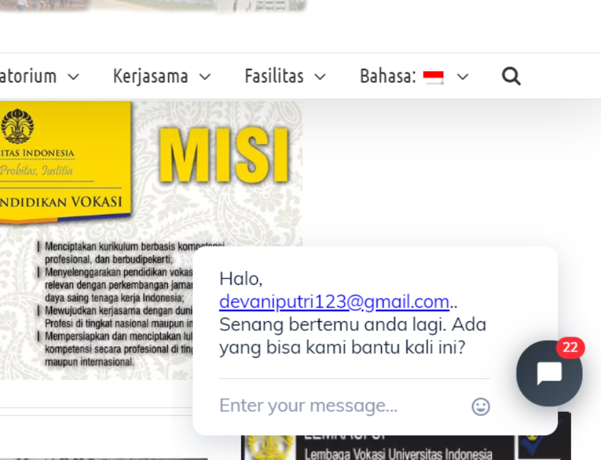

Picture 4.2 Greetings from chatbot
When the admin is offline, the question will send automaticly to the public relations email and will be answered in 1 x 24 hours.
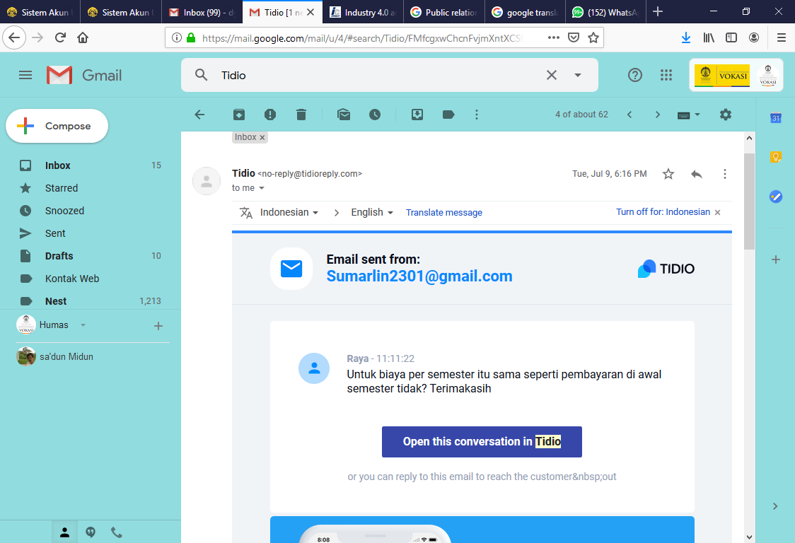
Picture 4.3 Email from Chatbot System
Chatbot is a computer program that operated by intelligent conversation with user. Chatbot communicate through voice media or text in short conversation. Chatbot is designed to stimulate inteactive conversation to human. Chatbot is a computer program, not a robot in phisical appearance (not like a human) so the dialogue is done by typing some texts and chatbot will respond automaticaly. The person who creates and develops a chatbot program is called the masterbot [23]
- Social Media Monitoring & Analythics
Social media monitoring is one of Public Relations focus in Universitas Indonesia to uderstand their public. Public relations create a social media monthly report that consist of : total mention, total sentiment for university, mention and sentiment for each faculty/program in Universitas Indonesia, word clound of the month. Public relations division is hired a social media consultant as a third party to do the social media monitoring. Social media monitoring applied on Facebook, Twitter, Instagram and YouTube.. The social media performance becomed the Key Performance Indicator for univerisity’s PR and also for all facuties PR.
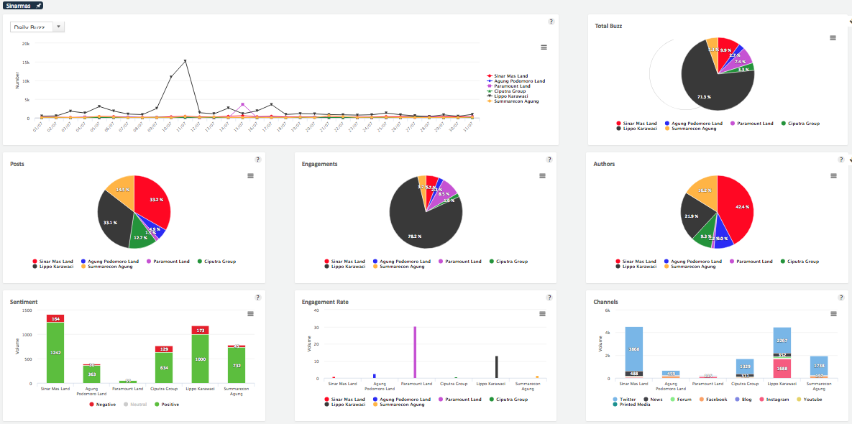
Picture 4.4. Social Media Monitoring Report View
Reffers to Sonar Platform as one of social media monitoring consultant in Indonsia said there are 3 step of social media monitoring such as: Social Listening, Social Anlythics and Social Intelegence. In Universitas Indonesia, Social Media monitoring still focus on social listening and analythics but
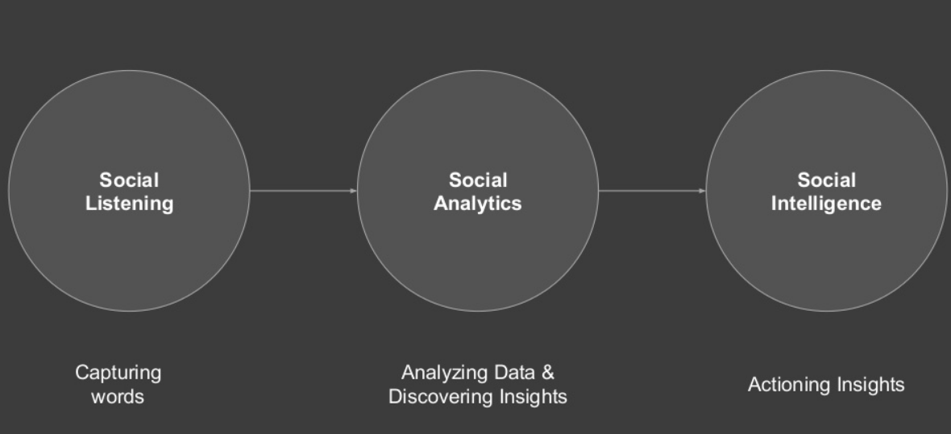
Picture 4.5 Social Media Monitoring Step
Sonar Platform defines social media listening as the process of listening to what customers are saying on social media about you, your competitors or about the problems you’re trying to solve in order to identify engangement opportunities. In the other hand, Social media analythics is how you bring the data together from your engangment and listening activities to report on outcomes and tell a story. To put it simply and more a quantitative analysis to measure the performance of your social media [24]. This corresponds to the previous study that said monitoring includes listening, interpreting, and taking action on what people are saying or otherwise conveying [25]. In the previous reseach, Rappaport [25] said company should set the topics to be monitored that suits to their products, management features and brand image.
“Choosing a listening solution depends, naturally, on its fit with organizational or brand objectives for listening, the listening budget, and how the listening responsibility is staffed”. [25].
PR division in Indonesia face the problem about the data accuration that caused by the various number of keywords that must be monitored. So, that sometimes there are keywords that are wrong or not included in the monitoring system. It makes the monitoring result will be not accurate. Another problems is related to cost. The University has a maximum quota mention from their consultant. Once the montly quota is over so they can not monitor for the next day.
Form the discussion above we can conculde that PR practitionners in Universitas Indonesia has already tried to adapt to 4.0 era. Their effort can be seen from the shifting in the communication platform used and they actually do an evaluation of it. This is consistent with what Anton Binsar [12] said about the character of Industry 4.0 where IoT becomes popular and world of mouth (WOM) process no longer from people mouth in real but happened in the internet. Universitas Indonesia Public relations unit have proven their efforts through achieving The Best Social Media Management Award 2018 among universities in Indonesia. However, they need to improve the keywords method becomes more reliable so the monitoring result will be accurate. Before implement the social media monitoring, they can try to search from general search engines, particular social medium such as Twitter Search, but also real-time dashboard overviews of social media such as provided by Addict-o-matic [26]
Likewise with chatbot, UI PR division needs to make some improvement on keyword variations and the chatbot ability so the chatbot will be able to answer most of question form the customer. For the next several years, it will be good if the chatbot can act as a customer service that have a feature to building a warm relationship and do a complaint handling. This reasearch suggest that if PR want to use chatbot, they should design it very carefully. The good conversation flow should be created based on the university audience needs. They have to make a answer guidlines so the application will give the best answer. The success of developing and maintaining this chatbot will result in good brand image and reputation [12].
5. Acknowledgement
I’d like to show my gratitude to the my co authors, Pijar Suciati and Sri Rahayufor sharing their knowledge with me during this research process. I am also very grateful to Vocational Education Program, Universitas Indonesia for allowing me to join this conference and funding this research. Any errors and imperfections in this research and paper are my own and hopefully not tarnish the reputations of these esteemed persons mentioned.

6. References
[1] All About PR. (n.d.). Retrieved April 4, 2018, from https://www.prsa.org/all-about
pr/
[2] Botan, C. (2006), “Grand strategy, strategy, and tactics in public relations”, in Botan, C. and Hazleton, V. (Eds), Public Relations Theory, Lawrence Erlbaum, Mahwah, NJ, pp. 223
[3] Suciati, Pijar., et all (2017). “Public Relations for Vocational Higher Education in Indonesia”. Scholar Summit Proceeding 2017. Universitas Indonesia.
[4] Cooper, J., & James, A. (2009). Challenges for Database Management in the Internet of
Things. IETE Technical Review, 26(5), 320. doi: 10.4103/0256-4602.55275
[5] Roblek, V., Meško, M., & Krapež, A. (2016). A Complex View of Industry 4.0. SAGE Open, 6(2), 215824401665398. http://dx.doi.org/10.1177/2158244016653987
[6] Charlie Melichar and Joseph A. Brennan. The Future of Higher Ed PR: Proving the power of strategic public relations. https://www.insidehighered.com/blogs/call-action-marketing-and-communications-higher-education/future-higher-ed-pr
[7] Broom, G. M., & Dozier, D. M. (1990). Using research in public relations: applications to program management. Upper Saddle River, NJ: Prentice- Hall, Inc.
[8] Hale, D. (2001). Public relations' uncertain future. In J. E. Ross & C. P. Halstead (Eds.), Public relations and the presidency: Strategies and tactics for effective communications (pp. 13-15). Washington, DC: Council for Advancement and Support of Education
[9] Broom, G. M., & Dozier, D. M. (1990). Using research in public relations: applications to program management. Upper Saddle River, NJ: Prentice- Hall, Inc.
[10] McCorkindale, T. (2012, August 20). Can you see the writing on my wall? A content analysis of the Fortune 50’s Facebook social networking sites. Retrieved April 1, 2018, from https://instituteforpr.org/can-you-see-the-writing-on-my-wall-a-content-analysisof-the-fortune-100s-facebook-social-networking-sites/
[11] Jo, S., & Kim, Y. (2003). The Effect of Web Characteristics on Relationship Building. Journal of Public Relations Research, 15(3), 199–223. https://doi.org/10.1207/S1532754XJPRR1503_1
[12] Binsar, Anton., Ummi Salamah (2018). Anticipating the Post Human Era in Public
Relations. 2nd Indonesia International Graduate Conference on Communication (Indo-IGCC) Proceeding
[13] Toth, E. L., Serini, S. A., Wright, D. K., & Emig, A. G. (1998). Trends in public relations roles: 1990–1995. Public Relations Review, 24(2), 145–163. https://doi.org/10.1016/S0363-8111(99)80048-4
[14] Jeffkins, Frans (2003). Public Relations. (Haris Munandar, Penerjemah). Jakarta:Erlangga
[15] Effendy, Onong (2005).Ilmu Komunikasi & Praktek. Bandung: PT Remaja Rosdakarya
[16] Dolphin, R.R. and Fan, Y. (2000), “Is corporate communication a strategic function?”,
Management Decision, Vol. 38 No. 2, pp. 99-106.
[17] Newman, Lawrence. (2003). Social Research Methods: Qualitatibe and Quantitative Approches. London: Allyn and Bacon
[18] Ruslan, Rosady. (2003). Metode Penelitian Public Relations dan Komunikasi. Jakarta:
Raja Grafindo Persada.
[19] Kasali, Rhenald. (2008). Riset Kualitatif dalam Public Relations & Marketing Communications. Jakarta: Penerbit Bentang
[20] Kountur, Ronny. (2003). Metode Penelitian:Untuk Penulisan Skripsi dan Tesis. Jakarta: Peberbit PPM
[21] Irawan, Prasetya. (2007). Penelitian Kualitatif dan Kuantitatif untuk Ilmu-IlmuSosial. Depok: DIA FISIP UI
[22] Maulidiyanti, Mareta. (2016). Communication Strategy for New Public Transport System (Case Study: PT Mass Rapid Transit (MRT) Jakarta Communication Strategy). The First International Conference on Vocational Higher Education (ICVHE) Proceeding.
[23] Huang, M.-H., & Rust, R. T. (2018). Artificial Intelligence in Service. Journal of Service Research, 21(2), 155–172. https://doi.org/10.1177/1094670517752459
[24] Roesli, Aristama. (2019). Social Media Analytics of Sonal Platform. Presented on Media Monitoring Session. Vocational Higher Education Universitas Indonesia. www.sonarplatform.com.
[25] Rappaport, S. D. (2010), “Listening solutions”, Journal of Advertising Research, Vol. 50 No.2, pp. 197-213
[26] Zhang, B. and Vos, M. (2014), Social media monitoring: methods, benefits and
difficulties for international companies. Corporate Communications: an International Journal, Vol. 19, Issue 4, pp. 371–383.

